Energy Unit Study Guide
Brodnax
Nonrenewable Energy
Key Terms

- Coal- a solid fossil fuel that was formed in stages out of the remains of land plants that were buried 300-400 million years ago and subjected to intense heat and pressure over many millions of years.
- crude oil- oil as it comes out of the ground
- liquefied natural gas (LPG)- very low temperature and high pressure in order to be transported across oceans
- liquefied petroleum gas (LPG)- stored in pressurized tanks for use mostly in rural areas that are not served by natural gas pipelines
- natural gas- the vapor form of petroleum
- net energy- The usable amount of high-quality energy available from a given quantity of an energy resource
- nuclear fusion- one atom splits into two and releases energy
- oil sand- deposits of rock or sediment that contain a heavy oil- or tar-like fossil fuel substance called bitumen
- petrochemicals- products of oil distillation and are used as raw materials in industrial organic chemicals, cleaning fluids, pesticides, plastics, synthetic fibers, paints, medicines, etc.
- petroleum- a thick liquid containing hydrocarbons that we extract from underground deposits in sedimentary bedrock and separate into products such as gasoline, heating oil, and asphalt.
- shale oil- sedimentary rock that contains an organic solid called kerogen
- tar sand- deposits of rock or sediment that contain a heavy oil- or tar-like fossil fuel substance called bitumen

- How does today’s energy usage in the U.S. compare to the world?
➢ The US produces 9% of the world’s oil
➢ The US imports 60% of its oil
➢ The US has about 2.4% of the world’s oil reserves
➢ Most of the oil drilling in the US occurs in the Gulf of Mexico near Louisiana and Texas and in Alaska’s North Slope region

- Define net energy.
The usable amount of high-quality energy available from a given quantity of an energy resource

- Why is a net energy ratio less than 1 bad?
The higher the ratio, the greater the net energy. When the ratio is less than 1, there is a net energy loss.
Energy resources with a low net energy will need government (taxpayer) subsidies.

- Oil:
Source: | How is it extracted and processed? | Location: Which countries have the largest supply? | How Long Will Current Supplies Last? | Advantages and Disadvantages
Petroleum & Crude Oil | Wells are drilled deep into the earth or seafloor (as far as 7 miles down) to reach the pores and cracks where the crude oil and natural gas (vapor form of petroleum) are accumulated. The oil gets pumped to the surface and transported to a refinery by pipeline, truck or ship. | Saudi Arabia  Canada | 93 Years | 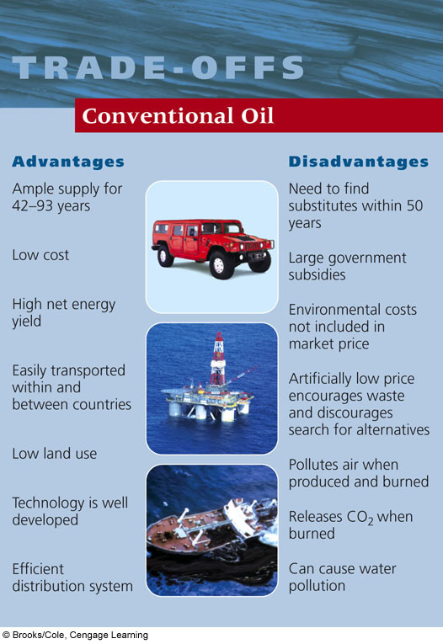

- How are petrochemicals used?
Used as raw materials in industrial organic chemicals, cleaning fluids, pesticides, plastics, synthetic fibers, paints, medicines, etc.

- Who is OPEC? List the contributing countries.
Organization of Petroleum Exporting Countries: Algeria, Angola, Indonesia, Iran, Iraq, Kuwait, Libya, Nigeria, Qatar, Saudi Arabia, the United Arab Emirates, and Venezuela.

- How much of the US energy comes from fossil fuels? 87% From oil? 33%
- How much of the world’s oil do we (US) use? 60% How much do we produce? 9%
- What is oil sand/tar sand and who has a lot of this?
Oil sands, or tar sands, are deposits of rock or sediment that contain a heavy oil- or tar-like fossil fuel substance called bitumen.
Canada

- What are the chief environmental issues associated with this type of oil production?
High cost, low net energy, severe land disruption, severe water pollution

- How is shale oil produced?
Oil shale is sedimentary rock that contains an organic solid called kerogen. When retorted (heated), the kerogen breaks down into synthetic crude oil and hydrocarbon gas.

- What is natural gas? Which gases make it up?
Natural gas is the vapor form of petroleum. It is a mixture of gases, 50-90% of which is CH4 (methane). It also contains heavier hydrocarbons like ethane (C2H6), propane (C3H8), and butane (C4H10).

- Natural gas:
Source: | How is it extracted and processed? | Location: Which countries have the largest supply? | How Long Will Current Supplies Last? | Advantages and Disadvantages:
Natural Gas | Tapped | 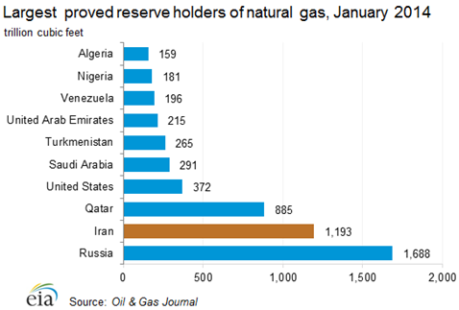 |  | 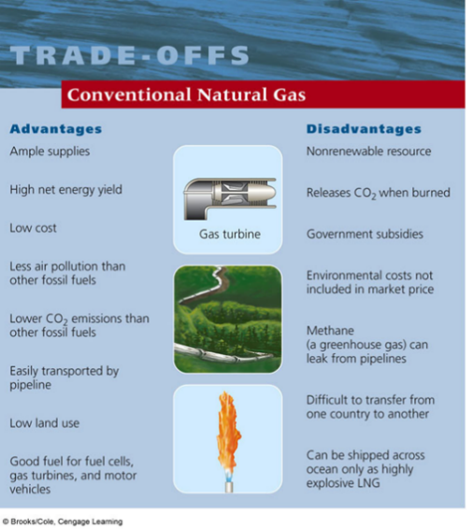

- What is coal and where does it come from?
A solid fossil fuel that was formed in stages out of the remains of land plants that were buried 300-400 million years ago and subjected to intense heat and pressure over many millions of years.
- What are the 3 largest coal burning countries in order?
China, US, and India

- List the types of coal from least to greatest energy (heat) content.
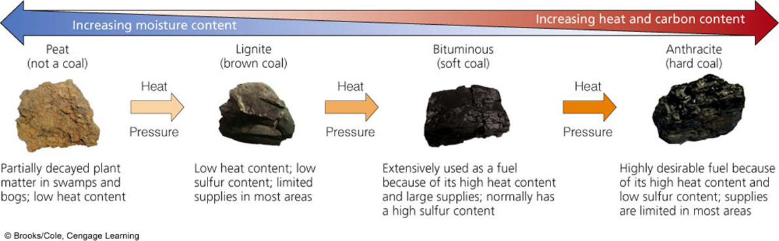

- How is China’s coal consumption affecting the environment?
Severe air pollution
o Sulfur released as SO2
o Large amount of soot particulates
o CO2 (25% of world’s CO2 emissions and 40% of U.S. CO2 emissions comes from burning coal)
o Trace amounts of Hg
- Coal:
Source: | How is it extracted and processed? | Location: Which countries have the largest supply? | How Long Will Current Supplies Last? | Advantages and Disadvantages:
Coal | Formed in stages out of the remains of land plants that were buried 300-400 million years ago and subjected to intense heat and pressure over many millions of years. | US, Russia, India, China |  | 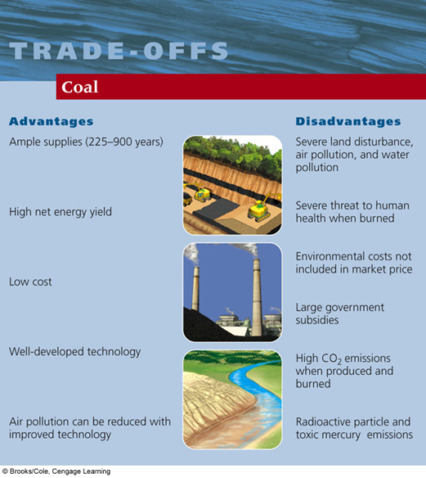

- The parts of a nuclear reactor (explain each component’s role):
  - Fuel rods: Large numbers of the pellets are packed into closed pipes
  - Fuel assemblies: fuel rods grouped together and placed in the core of a reactor
  - Control rods: moved in and out of the reactor core to absorb neutrons, thereby regulating the rate of fission and the amount of power produced
  - Coolant: usually water, circulates through the reactor’s core to remove heat, which keeps fuel rods and other materials from melting and releasing massive amounts of radioactivity into the environment
  - Containment shell: thick, steel-reinforced, concrete walls surrounds the reactor core for protection.
- List the steps of the nuclear fuel cycle:
1. Mine the uranium
2. Process the uranium to make the fuel
3. Use it in the reactor
4. Safely store the radioactive waste
5. Decommission the reactor (an old nuclear power plant must be safely retired; it cannot be simply boarded up and abandoned)
Each step in the nuclear fuel cycle adds to the cost of nuclear power and reduces its net energy yield. The current nuclear fuel cycle is extremely inefficient, using or wasting 92% of the energy content of its nuclear fuel.
- What countries are large nuclear power users?
Russia, US, China, India
- Two major nuclear disasters (list place, year and what happened)
1. Three Mile Island
▪ Worst Commercial Nuclear Power Plant Accident in the U.S.
▪ March 29, 1979 near Harrisburg, PA, U.S.
▪ Nuclear reactor lost its coolant water b/c of mechanical failures and human error
▪ Led to a partial uncovering and melting of the radioactive core
▪ Unknown amounts of radioactivity escaped
▪ People fled the area but no human casualties
▪ Increased public concerns for safety
• Led to improved safety regulations and evacuation plans in the U.S.

2. Chernobyl
▪ Worst Nuclear Power Plant Accident in the World
▪ April 26, 1986 in Chernobyl, Ukraine
▪ Series of explosions caused the roof of a reactor building to blow off
▪ Partial meltdown and fire for 10 days
▪ Huge radioactive cloud spread over many countries and eventually the world
▪ 350,000 people left their homes
▪ Effects on human health, water supply, and agriculture
• Increased frequency of birth defects and mental retardation in newborns
• Higher incidences of leukemia, thyroid cancer and immune system abnormalities in children exposed to the radioactive fallout
- List 3 advantages and 3 disadvantages of nuclear power.
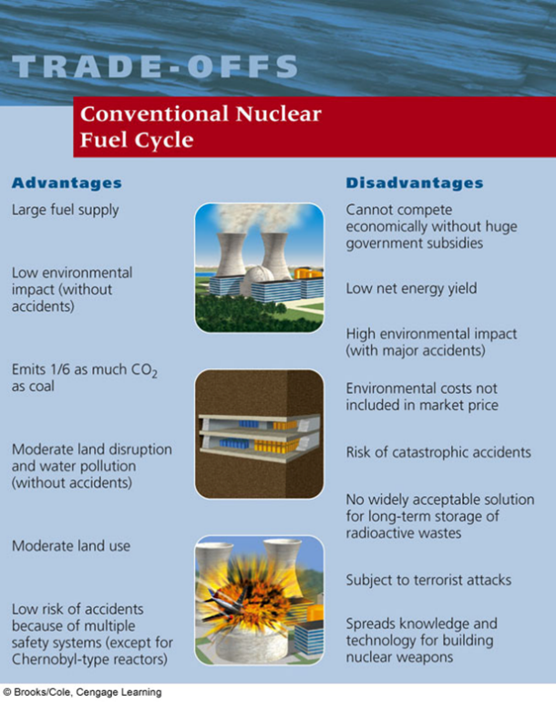
Energy Efficiency and Renewable Energy

Key Terms

- active solar heating system- absorbs energy from the sun by pumping a heat-absorbing fluid (water or antifreeze) through special collectors usually mounted on the roof. Some of the heat can be used directly. The rest can be stored in a large, insulated container filled with gravel, water, clay for release as needed
- biofuels- liquid fuels produced from plants and plant wastes
- cogeneration- combined heat and power systems (CHP): 2 useful forms of electricity (like steam and electricity) are produced from the same fuel source.
- combined heat and power systems (CHP)- 2 useful forms of electricity (like steam and electricity) are produced from the same fuel source.
- energy conservation- a decrease in energy use based primarily on reducing unnecessary waste of energy
- energy efficiency- the measure of how much work we can get from each unit of energy we use.
- geothermal energy- taps the heat stored in the earth’s soil, underground rocks and fluids in the earth’s mantle
- passive solar heating system- absorbs and stores heat from the sun directly within a well-insulated structure without the need for pumps or fans to distribute the heat
- photovoltaic (PV) cells- Solar energy can be converted into electrical using PV cells
- solar cells- PV cells, convert solar energy into electrical usage

- How much energy in the U.S. is wasted?
84%
- How much energy could we potentially save if we improved our energy efficiency?
43%
- Explain how a cogeneration system works. How energy efficient is this system?
Some companies and industries are using cogeneration systems, or combined heat and power systems (CHP): 2 useful forms of electricity (like steam and electricity) are produced from the same fuel source.
❖ For example, the steam produced from generating electricity can be used to heat the plant or nearby buildings, rather than wasted to the environment as heat loss.
❖ The efficiency of these systems are as high as 80%, compared to 35% for coal and nuclear plants
- List inefficient energy sources and possible solutions for each.
Inefficient energy source | Possible solution(s)
Incandescent light bulbs | Replace incandescent bulbs with fluorescent or LED bulbs
Furnaces | Use fuel cells to power vehicles and to provide heat and electricity to buildings
Leaky buildings | Improve Insulation
Coal and nuclear power plants | Use wind and solar cell farms for electricity
Internal combustion engines in cars | Improve fuel efficiency of vehicles; improving miles per gallon

- What is green architecture?
The 13-story GA Power building in Atlanta uses 60% less energy than conventional buildings of its size.
o The largest surface of the building faces south to capture solar energy
o Each floor extends out over the one below it, which blocks out the high summer sun to reduce A/C costs and also allows the low winter sun to warm the rooms, decreasing heating costs
o Energy-efficient fluorescent bulbs light up work areas instead of whole floors

Green (living) roofs are also used in many urban buildings. Benefits include:
✓ Saving energy through insulating; keeping building cool in summer
✓ Improving air quality
✓ Reducing storm water runoff and water pollution
✓ Providing a habitat for birds

Other Green Architectural Designs include:
▪ Recycling wastewater, collecting rainwater, using waterless urinals and composting toilets
▪ Natural lighting, passive solar heating, motion-sensors for lights
▪ Cogeneration, efficient insulation, recycled building materials
- Explain how the Georgia Power building in Atlanta is “green.”
The 13-story GA Power building in Atlanta uses 60% less energy than conventional buildings of its size.
o The largest surface of the building faces south to capture solar energy
o Each floor extends out over the one below it, which blocks out the high summer sun to reduce A/C costs and also allows the low winter sun to warm the rooms, decreasing heating costs
o Energy-efficient fluorescent bulbs light up work areas instead of whole floors

- Describe 5 ways of making a building “green.”
✓ Saving energy through insulating; keeping building cool in summer
✓ Improving air quality
✓ Reducing storm water runoff and water pollution
✓ Providing a habitat for birds
▪ Recycling wastewater, collecting rainwater, using waterless urinals and composting toilets
▪ Natural lighting, passive solar heating, motion-sensors for lights
▪ Cogeneration, efficient insulation, recycled building materials
- Label ways to improve energy efficiency in a house or building:
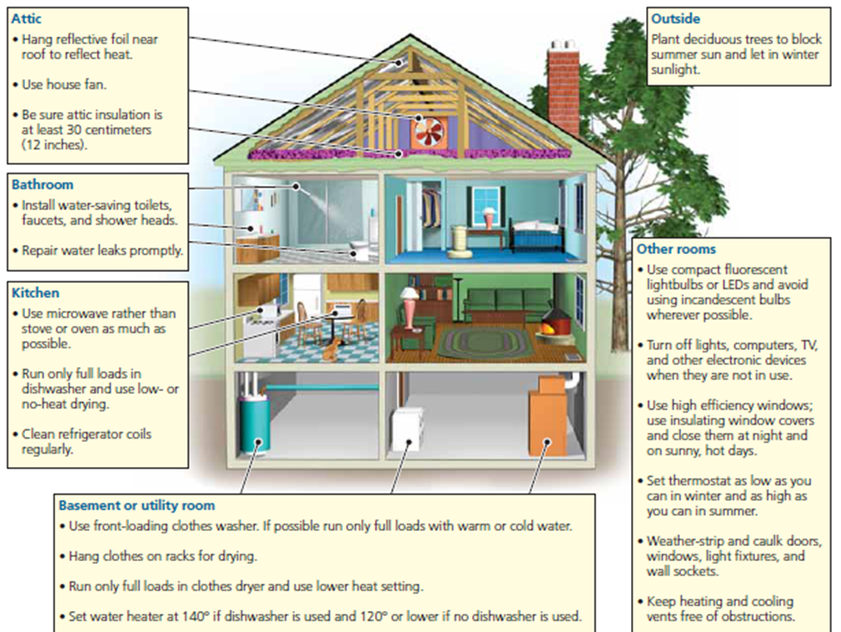

- Fill in the chart regarding renewable energy sources:
Directly From Notes

