Energy Unit Study Guide
Brodnax
Nonrenewable Energy
Key Terms

- coal
- crude oil
- liquefied natural gas (LPG)
- liquefied petroleum gas (LPG)
- natural gas
- net energy
- nuclear fusion
- oil sand
- petrochemicals
- petroleum
- shale oil
- tar sand

- How does today’s energy usage in the U.S. compare to the world?

- Define net energy.

- Why is a net energy ratio less than 1 bad?

- Oil:
Source: | How is it extracted and processed? | Location: Which countries have the largest supply? | How Long Will Current Supplies Last? | Advantages: | Disadvantages:
Petroleum & Crude Oil

- How are petrochemicals used?

- Who is OPEC? List the contributing countries.

- How much of the US energy comes from fossil fuels? _________ From oil? _________
- How much of the world’s oil do we (US) use? _______ How much do we produce? _______
- What is oil sand/tar sand and who has a lot of this?

- What are the chief environmental issues associated with this type of oil production?

- How is shale oil produced?

- What is natural gas? Which gases make it up?

- Natural gas:
Source: | How is it extracted and processed? | Location: Which countries have the largest supply? | How Long Will Current Supplies Last? | Advantages: | Disadvantages:
Natural Gas

- What is coal and where does it come from?

- What are the 3 largest coal burning countries in order?

- List the types of coal from least to greatest energy (heat) content.

- How is China’s coal consumption affecting the environment?
- Coal:
Source: | How is it extracted and processed? | Location: Which countries have the largest supply? | How Long Will Current Supplies Last? | Advantages: | Disadvantages:
Coal

- The parts of a nuclear reactor (explain each component’s role):
  - Fuel rods:
  - Fuel assemblies:
  - Control rods:
  - Coolant:
  - Containment shell:
  - Water-filled pools & Dry-casks:
- List the steps of the nuclear fuel cycle:
1.
2.
3.
4.
5.

- What countries are large nuclear power users?

- Two major nuclear disasters (list place, year and what happened)
1.

2.

- List 3 advantages and 3 disadvantages of nuclear power.
Energy Efficiency and Renewable Energy
Key Terms

- active solar heating system
- biofuels
- cogeneration
- combined heat and power systems (CHP)
- energy conservation
- energy efficiency
- geothermal energy
- passive solar heating system
- photovoltaic (PV) cells
- solar cells

- How much energy in the U.S. is wasted?

- How much energy could we potentially save if we improved our energy efficiency?

- Explain how a cogeneration system works. How energy efficient is this system?

- List inefficient energy sources and possible solutions for each.
Inefficient energy source | Possible solution(s)
Incandescent light bulbs
Furnaces
Leaky buildings
Coal and nuclear power plants
Internal combustion engines in cars

- What is green architecture?

- Explain how the Georgia Power building in Atlanta is “green.”

- Describe 5 ways of making a building “green.”

- Label ways to improve energy efficiency in a house or building:
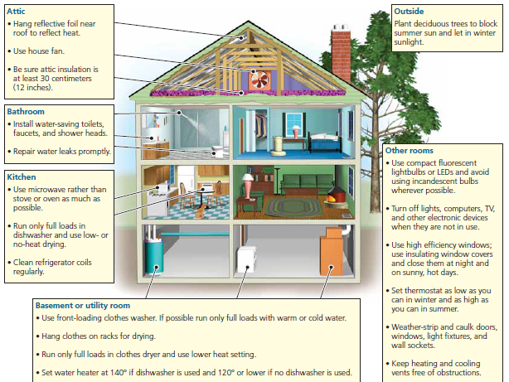
- Fill in the chart regarding renewable energy sources:
 | Description | Best Used For | Best Locations | Advantages | Disadvantages
Passive Solar
Active Solar
 | Description | Best used for | Best Location | Advantages | Disadvantages
Solar Thermal
Solar Cells (PV Cells)
Hydroelectric

Tidal Power
Wind
 | Description | Best used for | Best Location | Advantages | Disadvantages
Biofuels
Geothermal
Hydrogen Fuel Cells

