Environmental Spring Benchmark 3 Study Guide

Agriculture
1. What is industrialized agriculture?
Uses heavy equipment, large amounts of financial capital, fossil fuel, water, commercial fertilizers, and pesticides to produce monocultures (single crops).
2. What is subsistence agriculture?
Uses mostly human labor to produce enough crops for a farm family’s survival with little leftover for storage or to sell.
o Many farmers choose to grow several crops on the same land simultaneously (polyculture).
o These polyculture plots are less susceptible to pests and disease.
3. What are alternatives to using pesticides?
Use of natural predators
4. Explain soil conservation.
Uses a varieties of ways to reduce erosion and restore soil fertility
5. Why does agriculture use the greatest amount of water globally?
Used for plants and irrigation.
6. Why is agriculture considered the primary source of most water pollution?
Pesticide use, runoff, fertilizers
7. Define arable land.
Land used to grow crops

Organic Farming
1. What are the general organic principles?
• protect the environment, minimize soil degradation and erosion, decrease pollution, and optimize biological productivity
• maintain long-term soil fertility by optimizing conditions for biological activity within the soil
• maintain biological diversity within the system
• recycle materials and resources to the greatest extent possible within the enterprise
• provide attentive care that promotes the health and meets the behavioral needs of livestock
• prepare organic products, emphasizing careful processing, and handling methods in order to maintain the organic integrity of the products at all stages of production
• rely on renewable resources in locally organized agricultural systems
2. In genetically modified plants, the DNA is integrated into what part of the bacteria to form a transgenic cell?
Plasmid

Nutrition
1. Define malnutrition.
Diet is deficient in proteins and other key nutrients
2. Define undernutrition.
Cannot grow or buy enough food to meet basic needs
3. Define overnutrition.
When food energy intake exceeds energy use and causes excess body fat
4. What is overnutrition and what can it cause? Where is it most common?
- Occurs when food energy intake exceeds energy use and causes excess body fat
- Caused by too many calories, too little exercise or both
- Can lead to lower life expectancy, greater susceptibility to disease, lower productivity and lower life quality
- According to the Obesity Task Force in 2004, 25% of people in the world were overweight and 1 in 20 were obese
- The US has the highest overnutrition rate in the world, with 66% being overweight and 33% obese
- Most common in developed countries of Europe and North America
5. What is a macronutrient? Example.
A substance required in relatively large amounts by living organisms.
Ex. Carbohydrates, fats, proteins
6. What is a micronutrient? Example.
A chemical element or substance required in trace amounts for the normal growth and development of living organisms.
Ex. Folic acid, vitamins, minerals
7. What is a cause of blindness from ones diet?
Lack of Vitamin A

Waste
1. What is solid waste?
Any unwanted or discarded material we produce that is not a liquid or a gas.
2. What is the difference between industrial waste and municipal solid waste?
IW- produced by mines, agriculture, and industries that supply people with goods and services
MSW- often called garbage or trash, consists of solid waste produced by homes and workplaces.
o Ex: paper, cardboard, food wastes, cans, bottles, yard wastes, furniture, plastics, metals, glass, wood and e-waste (computers, monitors, phones, TV’s, etc.)
3. What are some advantages of burning waste? Disadvantages?
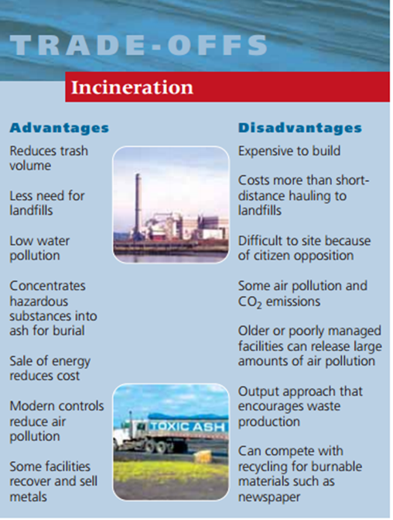
4. What is a sanitary landfill?
Solid wastes are spread out in thin layers, compacted, and covered daily with a fresh layer of clay or plastic foam, which helps keep the materials dry and reduces leakage of contaminated water (leachate) from the landfill. This covering also reduces accessibility to vermin.

Solid Waste
1. What is the difference between waste management and waste reduction?
-waste management (burying or burning waste).
-waste reduction (less waste and pollution are produced and the wastes that are produced are potential resources for reuse, recycling or composting).
2. Explain the 3 R’s.
❖ Reduce: consume less and live a simpler lifestyle.
❖ Reuse: rely more on items that can be used repeatedly instead of throwaway items. Buy necessary items secondhand or borrow/rent them. Use refillable cups instead of throwaway cups.
❖ Recycle: recycle paper, glass, cans, plastics, metal, and other items and buy products made from recycled materials.
3. What is primary (closed loop) recycling?
Materials are recycled into new products of the same type
o Ex. Turning old aluminum cans into new aluminum cans
4. What is secondary recycling?
Waste materials are converted into different products
o Ex. Used tires are shredded and turned into rubberized road surfacing
o Newspapers can be reprocessed into cellulose insulation
5. What are the 2 types of waste that can be recycled?
1. Pre-consumer or internal waste- generated in the manufacturing process; constitutes more than 75% of the total waste generated
2. Postconsumer or external waste- generated by consumer use of products
6. Explain Composting.
❖ Composting is a form of recycling that involves allowing decomposer bacteria and/or worms to recycle yard waste, food scraps, and other biodegradable organic wastes.
❖ The resulting organic material can be added to soil to supply plant nutrients, slow soil erosion, retain water, and improve crop yields.

Mining and Minerals
1. What are the 2 mineral types?
❖ Ore minerals: contains one or more elements of economic value
❖ Gangue minerals: minerals with no commercial value
2. What is subsurface mining?
✓ Subsurface mining is a mining method in which soil and rocks are removed to reach underlying coal or minerals.
• It is used to mine ore deposits that are 50 m or more beneath Earth’s surface.
- Digs tunnels and shafts

Soil
1. What is fertile soil?
Soil that can support the growth of healthy plants
2. What factors influence soil formation and how?
(1) It can be created because of the shape of the landscape. That shape is called the topography. When you have mountains, the sides of the mountains are said to have a slope. When you have a slope and it rains, there will be drainage. The runoff carries away small rocks and minerals. This runoff winds up in valleys or in the ocean. It slowly builds up and the small pieces make soil.

(2) There are climatic effects that create soil. Moisture and rain combine with the temperature to do amazing things to rocks. We just explained that when it rains you have runoff and erosion. Those physical activities break down the rocks and hard surfaces. Temperature plays a role when you move below and above the freezing point. When water freezes, it expands. Rocks and soil that hold water can be cracked when the water freezes and expands. They pop open with a cracking sound!

(3) What's in the soil is dependent on geologic factors. The type of soil under your feet is dependent on the bedrock deep below the surface. As the bedrock breaks down, smaller pieces move to the surface and mix with the existing soil.

(4) In the same way that there are large geologic factors, chronological factors play an important part in the process. Chronological means time. You need time to make soil. That's it. Sediment can move around quickly but it takes a long time to break down bedrock. We can't just sit and watch this process happen. We have to study it over many years. Also, if we pollute our soil we can't renew it in our lifetime. It takes hundreds to thousands of years.

(5) Soil is also created by biological factors. You'll find that soil is half minerals/rocks and half air/water. All sorts of biological things are happening in the air/water space. The organic material is most important. There are tiny living organisms (like bacteria) that break down organic stuff. The "stuff" could be dead leaves or dead animals. The organic stuff is called humus. There are also roots and tunneling creatures that work like the microbes. They turn the soil around and move it, which allows air to flow through.
3. What is erosion?
A process in which the materials of the Earth’s surface are loosened, dissolved, or worn away and transported from one place to another by a natural agent, such as wind, water, ice, or gravity.
4. What are ways to reduce soil erosion and protect topsoil?
There are many ways of protecting and managing topsoil and reducing erosion.
• Prevent downhill erosion by contour plowing, which consists of plowing across the slope of a hill instead of up and down the slope.
• No-till farming allows for a crop to be harvested without turning the soil over and then the next crop is planted. The remains of the first crop help to hold the new crop in place and reduce erosion.
• Reduce impervious surfaces. Impervious surfaces like driveways and patios allow precipitation to flow freely over them. Water flow gains momentum when moving over such surfaces and can then erode stream banks and lakeshores. A good compromise is to use paving stones rather than a concrete slab for your patio to allow the water to percolate down into the soil.
• Plant windbreaks. Windbreaks prevent soil erosion by slowing the force of the wind over open ground. You can plant trees or shrubs in your windbreak.
• Re-establish forest cover. The re-establishment of forest cover provides an extensive, tree-root network that offers a long-term solution to soil erosion. It can function both as a windbreak and a means to anchor soils in place.
• Compost can be used to enrich the topsoil instead of using chemical fertilizers. Compost is a mixture of decomposing organic matter, such as manure and rotting plants that is used as fertilizer and soil conditioner.

Water
1. Be able to label and explain the water cycle and its processes.
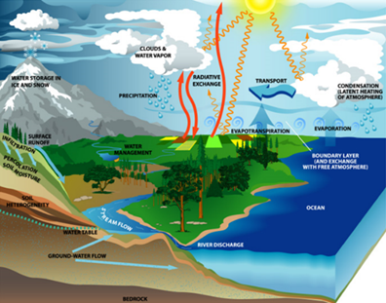
The water cycle is powered by the sun.
Major processes:
➢ Evaporation: changes liquid water into water vapor (gas form) in the atmosphere
➢ Precipitation: gravity draws the water back to the earth’s surface as precipitation (rain, snow, sleet, or dew)
➢ Transpiration: water that evaporated from the surfaces of plants
➢ Condensation: where water changes from the gas phase back to the liquid phase in the clouds
➢ Infiltration: the process by which water on the ground surface enters the soil
2. What is a watershed?
The land from which water drains into a particular river, lake, wetland or other body of water
3. The majority of water is used for _______________.
Agriculture
4. What are the types and causes of water pollution?
• Point sources
• Located at specific places
• Easy to identify, monitor, and regulate
• Examples:
• Ditches, sewer lines, drain pipes, oil tankers, underground mines
• Nonpoint sources
• Broad, diffuse areas from which pollutants enter bodies of surface water or air
• Difficult to identify and control
• Expensive to clean up
• Examples
• Runoff (chemical or biological) from feedlots, cropland, lawns, golf courses, logged forests, urban streets & parking lots (THINK BIG AREA)

Air
1. Label the layers of the atmosphere.
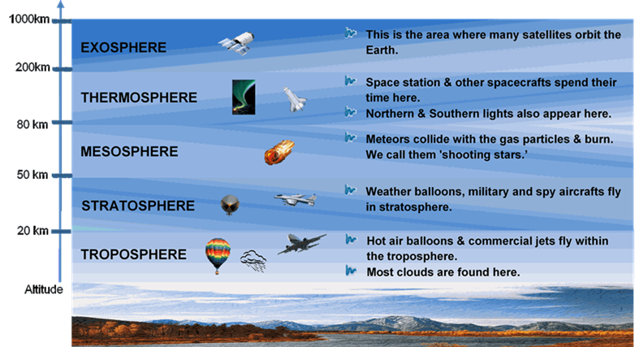
2. What causes acid rain?
Acid rain is caused by a chemical reaction that begins when compounds like sulfur dioxide and nitrogen oxides are released into the air (from coal-burning power plants, industrial plants, and vehicle emissions).
3. What is the Clean Air Act and what are some of its accomplishments since it began?
Federal Law implemented to protect public health and welfare from different types of air pollution caused by a diverse array of pollution sources known to be hazardous to human health.
Since 1970,
The six commonly found air pollutants have decreased by more than 50%
Air toxins from large industrial sources, such as chemical plants, petroleum refineries, and paper mills have been reduced by nearly 70%
New cars are more than 90% cleaner and will be even cleaner in the future
Production of most ozone-depleting chemicals has ceased.
4. What causes global warming? What can we do to reduce it?
▪ CO2, CH4, and N2O emissions are higher
▪ Main sources: agriculture, deforestation, and burning of fossil fuels
▪ There is a correlation of rising CO2 and CH4 levels with rising global temperatures
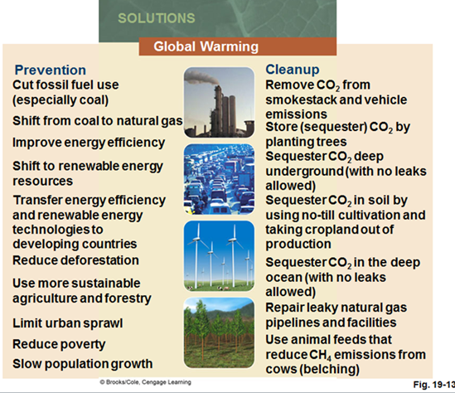
5. What causes ozone depletion? Why is depleting ozone bad?
Chlorofluorocarbons: CFCs (Freon’s)
Increases UV Radiation
6. List some solutions for indoor and outdoor air pollution.
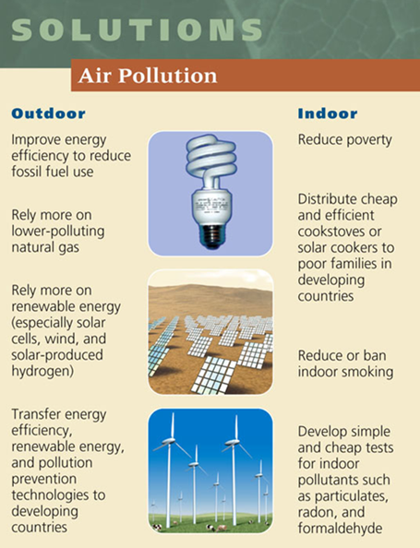

7. Which layer of the atmosphere contains most of the Earth’s Weather?
Troposphere
8. What is the chemical formula for ozone?
O₃
9. What does the ozone layer absorb?
UV Rays
10. What is the most abundant gas in the atmosphere?
Nitrogen

Energy
1. Where does most of the world’s energy come from?
Nonrenewable Resources
2. Who is OPEC? List the contributing countries.
Organization of Petroleum Exporting Countries: Algeria, Angola, Indonesia, Iran, Iraq, Kuwait, Libya, Nigeria, Qatar, Saudi Arabia, the United Arab Emirates, and Venezuela.
3. What are the top 3 places in the US to drill oil?
Texas, Alaska, Gulf of Mexico
4. Natural Gas is the vapor form of petroleum.

5. What are solar panels made of?
Photovoltaic Cells
6. Biofuels are mostly grown from corn.

7. Two major nuclear disasters (list place, year and what happened)
1. Three Mile Island
▪ Worst Commercial Nuclear Power Plant Accident in the U.S.
▪ March 29, 1979 near Harrisburg, PA, U.S.
▪ Nuclear reactor lost its coolant water b/c of mechanical failures and human error
▪ Led to a partial uncovering and melting of the radioactive core
▪ Unknown amounts of radioactivity escaped
▪ People fled the area but no human casualties
▪ Increased public concerns for safety
• Led to improved safety regulations and evacuation plans in the U.S.

2. Chernobyl
▪ Worst Nuclear Power Plant Accident in the World
▪ April 26, 1986 in Chernobyl, Ukraine
▪ Series of explosions caused the roof of a reactor building to blow off
▪ Partial meltdown and fire for 10 days
▪ Huge radioactive cloud spread over many countries and eventually the world
▪ 350,000 people left their homes
▪ Effects on human health, water supply, and agriculture
• Increased frequency of birth defects and mental retardation in newborns
• Higher incidences of leukemia, thyroid cancer and immune system abnormalities in children exposed to the radioactive fallout

8. Most of the world’s oil is located beneath countries in the middle east.

9. How does a solar cell work?
Convert light energy into electrical energy

10. What is natural gas? Which gases make it up?
Natural gas is the vapor form of petroleum. It is a mixture of gases, 50-90% of which is CH4 (methane). It also contains heavier hydrocarbons like ethane (C2H6), propane (C3H8), and butane (C4H10).

11. List the steps of the nuclear fuel cycle:
1. Mine the uranium
2. Process the uranium to make the fuel
3. Use it in the reactor
4. Safely store the radioactive waste
5. Decommission the reactor (an old nuclear power plant must be safely retired; it cannot be simply boarded up and abandoned)
Each step in the nuclear fuel cycle adds to the cost of nuclear power and reduces its net energy yield. The current nuclear fuel cycle is extremely inefficient, using or wasting 92% of the energy content of its nuclear fuel.
12. How much energy could we potentially save if we improved our energy efficiency?
43%

