**Soil Notes**

Brodnax

“The soil is the great connector of our lives, the source and destination of all.” ***--- Wendell Berry 1977***

**Fertile Soil**

**Fertile soil**- Soil that can support the growth of healthy plants

* **Topsoil** is the surface layer of the soil, which is usually richer in organic matter than the subsoil is.
* Fertile topsoil is composed of living organisms, rock particles, water, air, and organic matter, such as dead or decomposing organisms.
* Several layers of soil lie under the topsoil. The bottom layer is bedrock, which is the solid rock from which most soil originally forms.

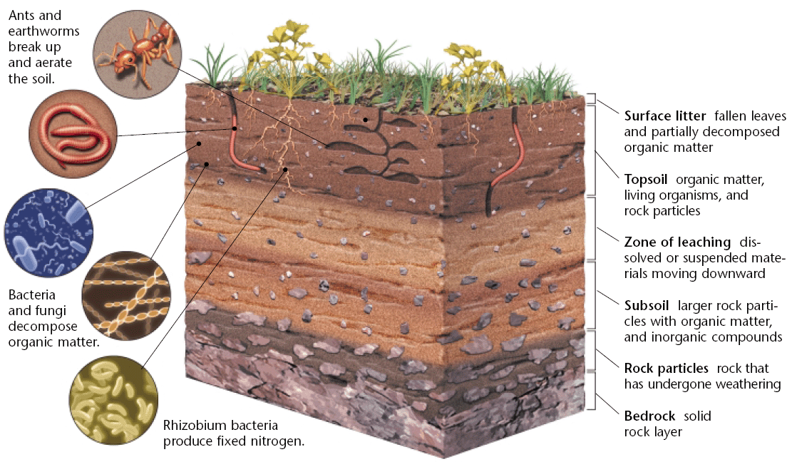

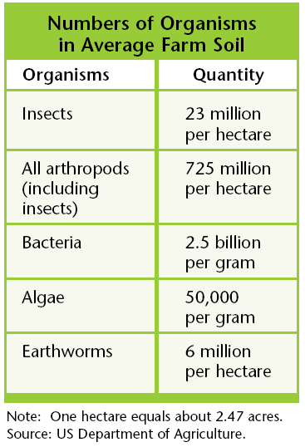

**Soil Formation**

There are five major factors that influence **soil formation**:

1. Topography
2. Climate
3. Geology
4. Time
5. Biological organisms

The combined influence of these **soil**-**forming** factors determines the properties of a **soil.**

[Soil Formation Video](https://www.youtube.com/watch?v=7iyxocIhfu0)

**Soil Formation and Horizons**

**(1)**It can be created because of the **shape of the landscape**. That shape is called the **topography**. When you have mountains, the sides of the mountains are said to have a slope. When you have a slope and it rains, there will be drainage. The runoff carries away small rocks and minerals. This runoff winds up in valleys or in the ocean. It slowly builds up and the small pieces make soil.   
  
**(2)**There are **climatic effects** that create soil. Moisture and rain combine with the temperature to do amazing things to rocks. We just explained that when it rains you have runoff and erosion. Those physical activities break down the rocks and hard surfaces. Temperature plays a role when you move below and above the freezing point. When water freezes, it expands. Rocks and soil that hold water can be cracked when the water freezes and expands. They pop open with a cracking sound!   
  
**(3)**What's in the soil is dependent on **geologic factors**. The type of soil under your feet is dependent on the bedrock deep below the surface. As the bedrock breaks down, smaller pieces move to the surface and mix with the existing soil.   
  
**(4)**In the same way that there are large geologic factors, **chronological factors** play an important part in the process. Chronological means time. You need time to make soil. That's it. Sediment can move around quickly but it takes a long time to break down bedrock. We can't just sit and watch this process happen. We have to study it over many years. Also, if we pollute our soil we can't renew it in our lifetime. It takes hundreds to thousands of years.   
  
**(5)**Soil is also created by **biological factors**. You'll find that soil is half minerals/rocks and half air/water. All sorts of biological things are happening in the air/water space. The organic material is most important. There are tiny living organisms (like bacteria) that break down organic stuff. The "stuff" could be dead leaves or dead animals. The organic stuff is called humus. There are also roots and tunneling creatures that work like the microbes. They turn the soil around and move it, which allows air to flow through.

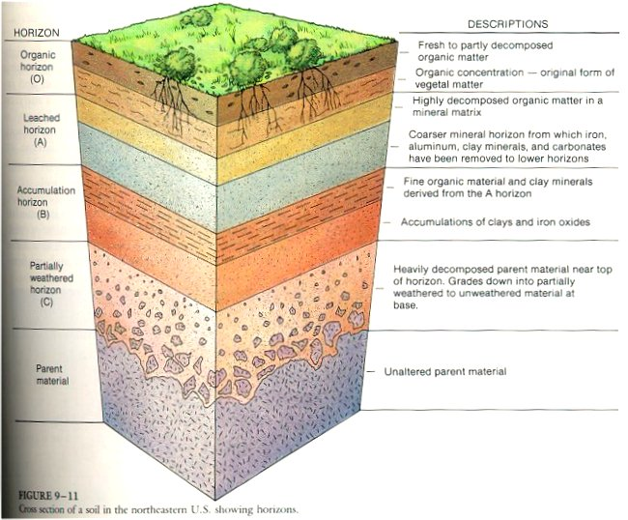

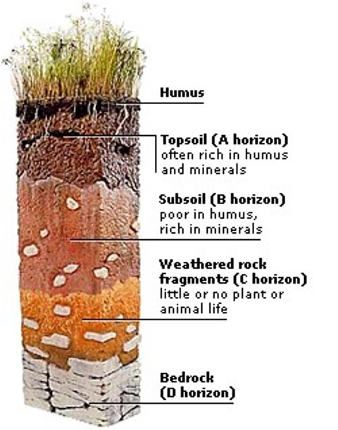

C Horizon = regolith

**Soil Erosion**

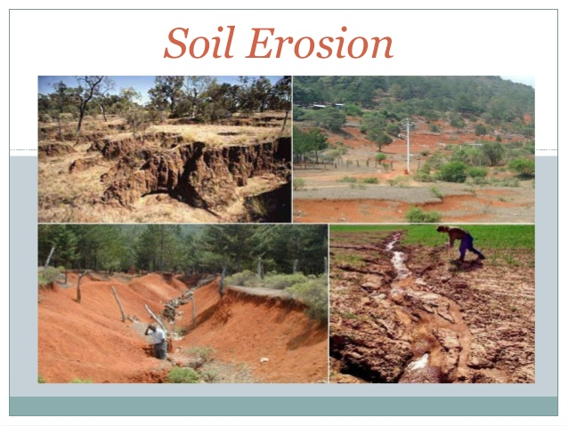

**Erosion** is a process in which the materials of the Earth’s surface are loosened, dissolved, or worn away and transported from one place to another by a natural agent, such as wind, water, ice, or gravity.

* In the U.S., about half of the original topsoil has been lost to erosion in the past 200 years.
* Without topsoil, crops cannot be grown. Yet, almost all farming methods increase the rate of soil erosion.

**Desertification** is the process by which human activities or climatic changes make arid or semiarid areas more desert-like.

* This process is causing some of our arable land to disappear.
* Overgrazing means fewer plants to hold the topsoil in place

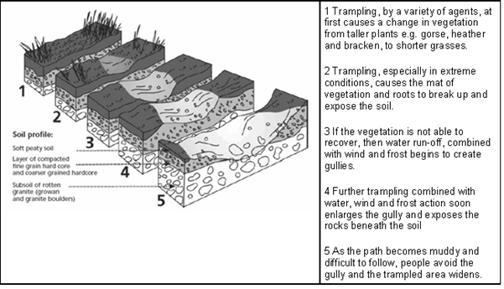

[Soil Erosion Video](https://www.youtube.com/watch?v=Hy_PqKsv9mY)

Causes of soil contamination in European countries

**Soil Contamination**

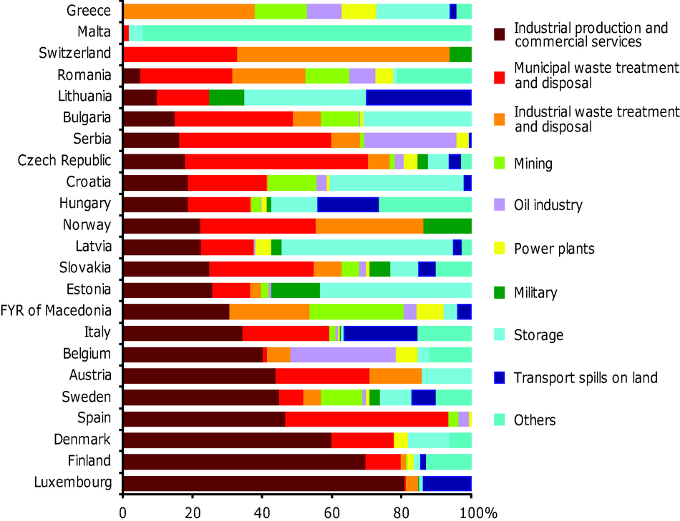

**Soil contamination** is either solid or liquid hazardous substances mixed with the naturally occurring soil. Usually, contaminants in the soil are physically or chemically attached to soil particles, or, if they are not attached, are trapped in the small spaces between soil particles.

How did it get there?

* Soil contamination results when hazardous substances (pesticides, fertilizers, biological wastes, oil spills, etc.) are either spilled or buried directly in the soil or migrate to the soil from a spill that has occurred elsewhere.
* Wind can carry in contaminated particles
* Water can flow in contaminated particles and/or chemicals

What are biological effects?

* Can hurt or kill plants, soil organisms and organisms that eat or handle these organisms



Waste storage

**Soil Conservation**

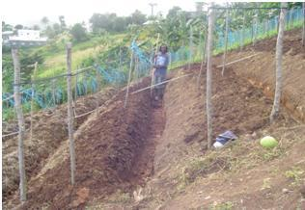

**Contour Plowing**

There are many ways of protecting and managing topsoil and reducing erosion.

* Prevent downhill erosion by **contour plowing**, which consists of plowing across the slope of a hill instead of up and down the slope.
* **No-till farming** allows for a crop to be harvested without turning the soil over and then the next crop is planted. The remains of the first crop help to hold the new crop in place and reduce erosion.
* Reduce **impervious surfaces**. Impervious surfaces like driveways and patios allow precipitation to flow freely over them. Water flow gains momentum when moving over such surfaces and can then erode stream banks and lakeshores. A good compromise is to use paving stones rather than a concrete slab for your patio to allow the water to percolate down into the soil.
* Plant **windbreaks**. Windbreaks prevent soil erosion by slowing the force of the wind over open ground. You can plant trees or shrubs in your windbreak.
* Re-establish **forest cover**. The re-establishment of forest cover provides an extensive, tree-root network that offers a long-term solution to soil erosion. It can function both as a windbreak and a means to anchor soils in place.
* Compost can be used to enrich the topsoil instead of using chemical fertilizers. **Compost** is a mixture of decomposing organic matter, such as manure and rotting plants that is used as fertilizer and soil conditioner.

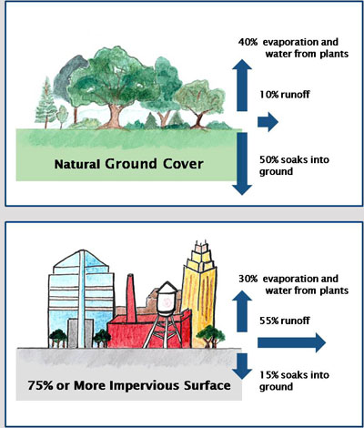

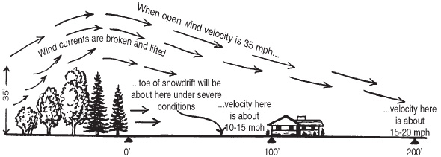

**Windbreaks**

[Soil Conservation Video](https://www.youtube.com/watch?v=_UeVvUzgJAY)

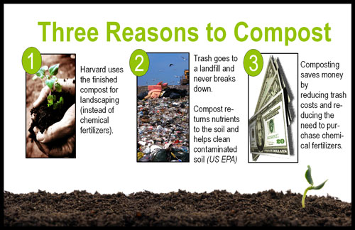

[Soil Lecture Video](https://www.youtube.com/watch?v=T1-RGmqtFOI)