Brodnax

**Energy Efficiency and Renewables Notes**

*Concept 16-1*: We could save as much as 43% of all the energy we use by improving energy efficiency.

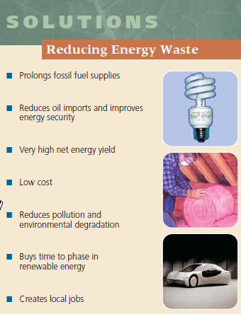

**Global improvements in energy efficiency could save the world an average of $1.9 million per minute!**

**Energy conservation**: a decrease in energy use based primarily on reducing unnecessary waste of energy

The best way to conserve energy is to improve **energy efficiency**- the measure of how much work we can get from each unit of energy we use.

* In the U.S., about 84% of all commercial energy is wasted.
* 41% of that is unavoidable because of energy degradation imposed by the second law of thermodynamics (When energy is changed from one form to another, we always end up with lower-quality or less usable energy than we started with.)
* The other 43% is wasted unnecessarily due to the inefficiency of…
  + Incandescent lights
  + Furnaces
  + Industrial motors
  + Coal and nuclear power plants
  + Vehicles with internal combustion engines
  + Poorly insulated buildings

**Solutions**:

* Replace incandescent bulbs with fluorescent or LED bulbs
* Use fuel cells to power vehicles and to provide heat and electricity to buildings
* Use wind and solar cell farms for electricity
* Improving insulation
* Plugging air leaks
* Use energy-efficient windows and appliances
* Improve fuel efficiency of vehicles; improving miles per gallon

Some companies and industries are using **cogeneration systems, or combined heat and power systems (CHP)**: 2 useful forms of electricity (like steam and electricity) are produced from the same fuel source.

* For example, the steam produced from generating electricity can be used to heat the plant or nearby buildings, rather than wasted to the environment as heat loss.
* The efficiency of these systems are as high as 80%, compared to 35% for coal and nuclear plants

**Green Architecture**

The 13-story GA Power building in Atlanta uses 60% less energy than conventional buildings of its size.

* The largest surface of the building faces south to capture solar energy
* Each floor extends out over the one below it, which blocks out the high summer sun to reduce A/C costs and also allows the low winter sun to warm the rooms, decreasing heating costs
* Energy-efficient fluorescent bulbs light up work areas instead of whole floors

Green (living) roofs are also used in many urban buildings. Benefits include:

* Saving energy through insulating; keeping building cool in summer
* Improving air quality
* Reducing storm water runoff and water pollution
* Providing a habitat for birds

Other Green Architectural Designs include:

* Recycling wastewater, collecting rainwater, using waterless urinals and composting toilets
* Natural lighting, passive solar heating, motion-sensors for lights
* Cogeneration, efficient insulation, recycled building materials

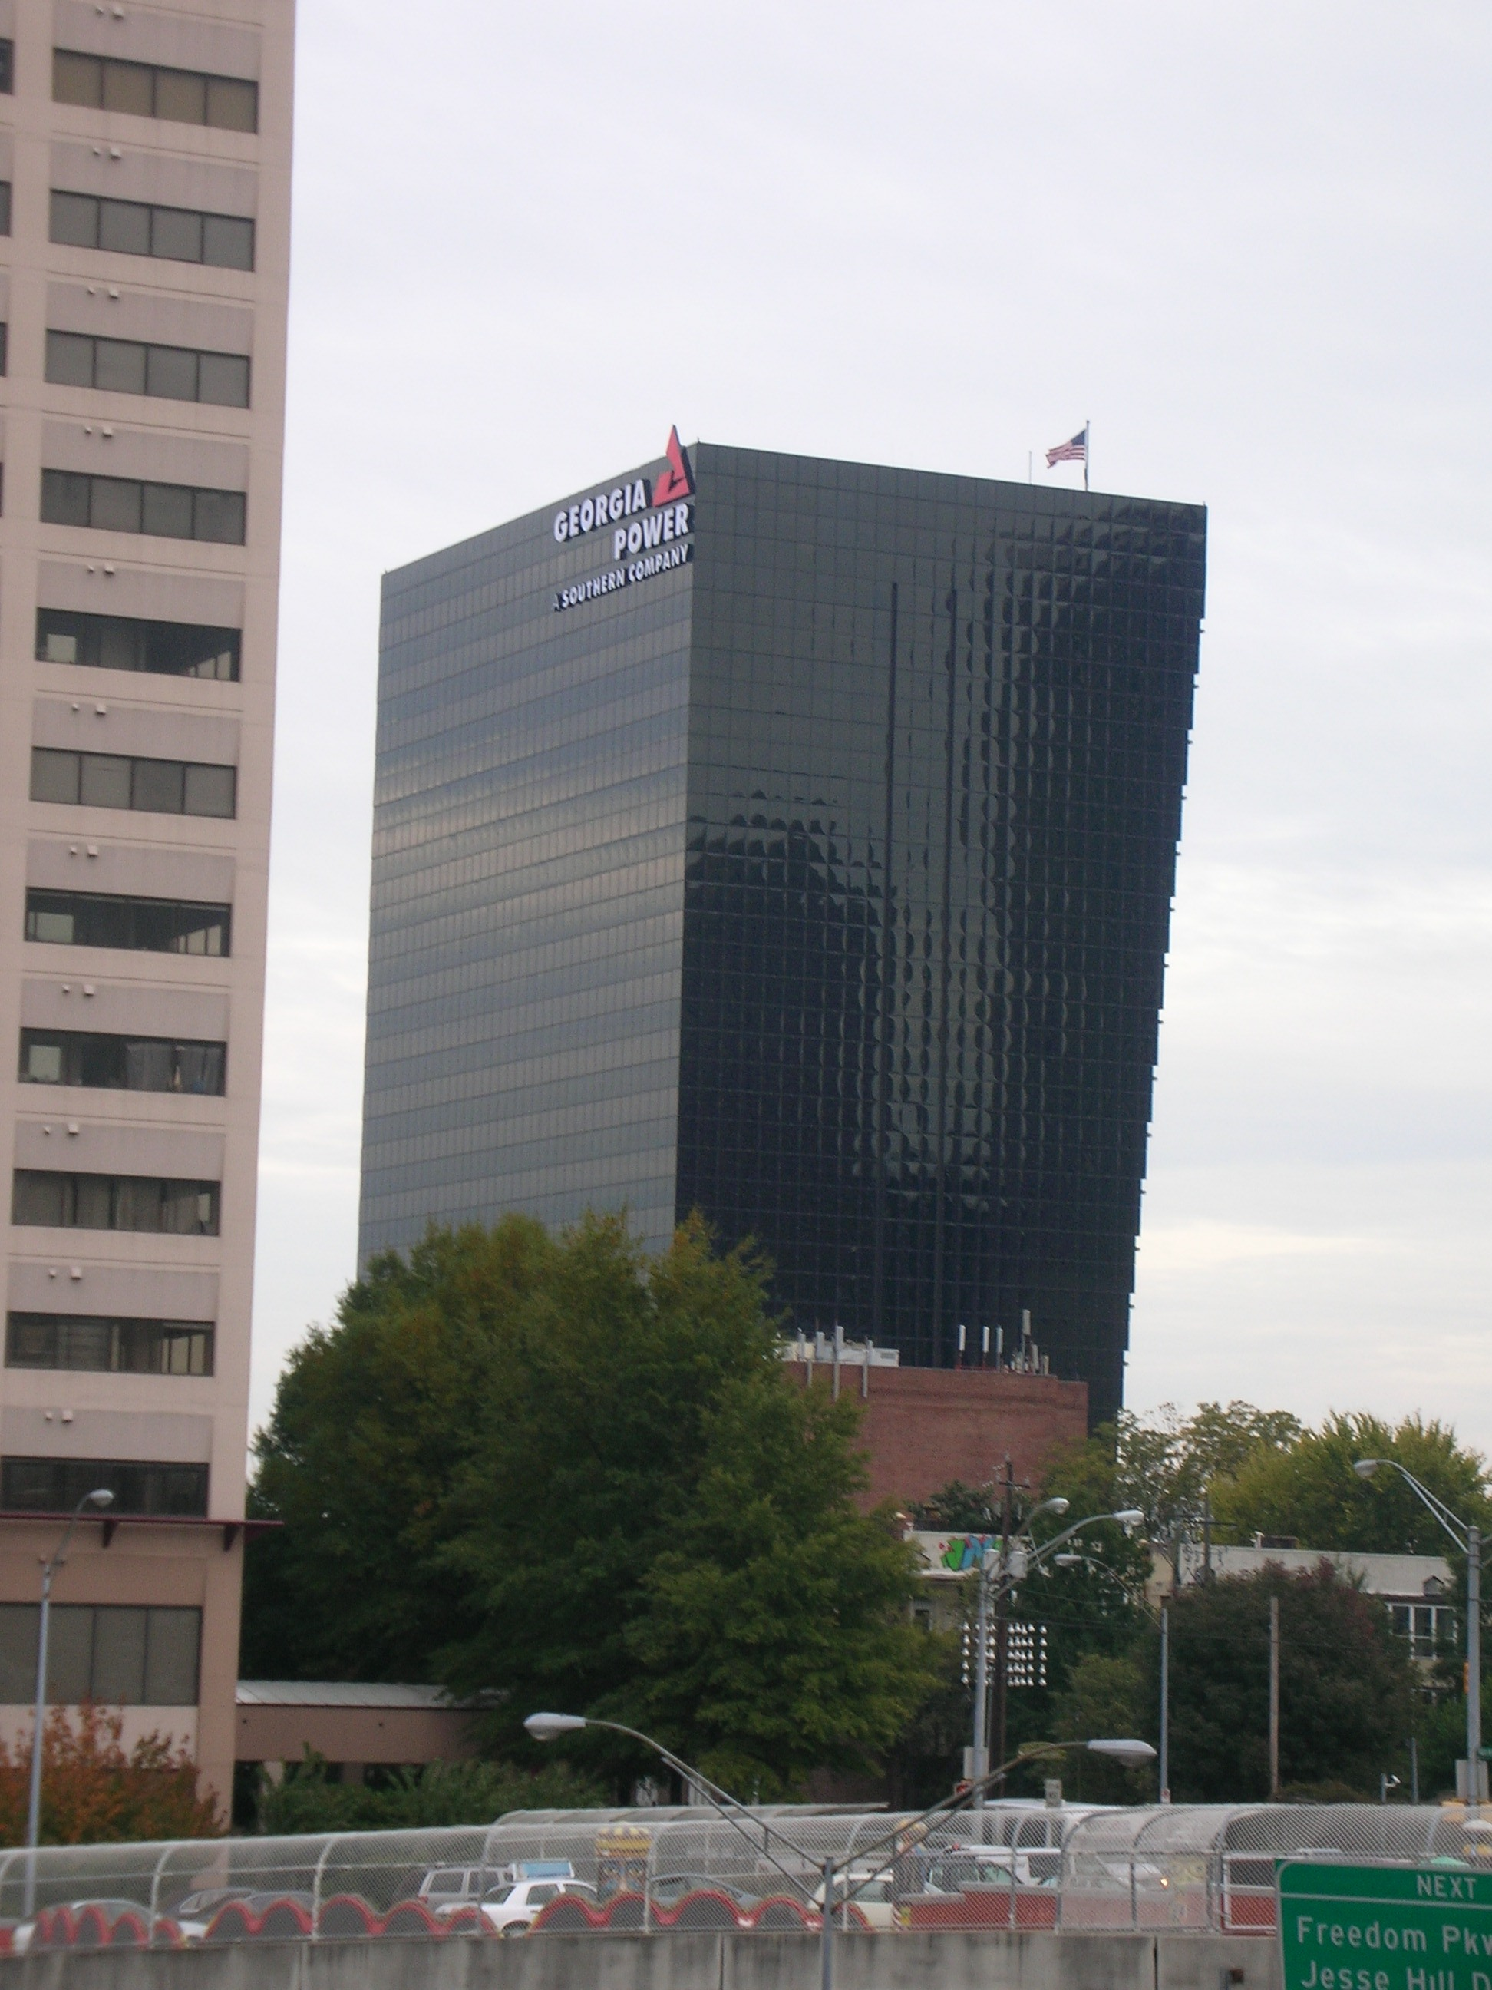

**Green Roof**

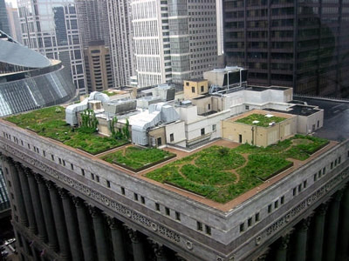

Improving Energy Efficiency

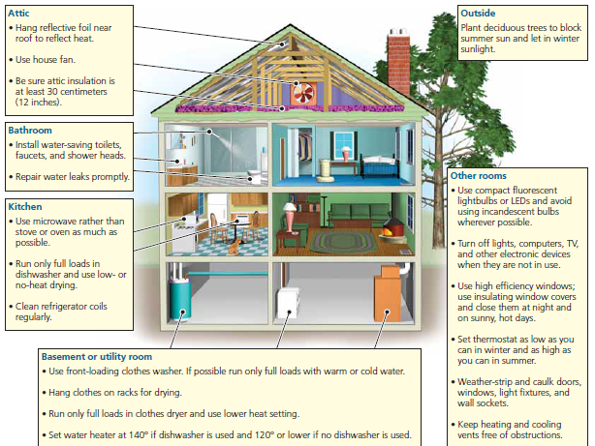

**Solar Energy**

*Concept 16-3:* Passive and active solar heating systems can heat water and buildings effectively, and the costs of using direct sunlight to produce high temperature heat and electricity are coming down.

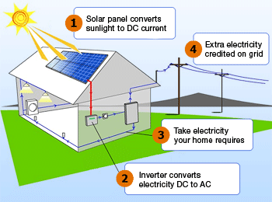

**The Sun is the Key**

* Almost all (99%) of the energy that heats the earth comes from the sun. Without this solar energy, the earth’s average temperature would be -240˚C and life as we know it would not exist.
* Solar energy also produces several forms of indirect solar energy:
  + **Wind**- moving air masses heated by the sun
  + **Hydropower**- flowing water kept fluid by heat from the sun
  + **Biomass**- solar energy converted to chemical energy and stored in trees and other plants

Buildings and water can be heated by passive and active solar power.

**Active Solar**: absorbs energy from the sun by pumping a heat-absorbing fluid (water or antifreeze) through special collectors usually mounted on the roof. Some of the heat can be used directly. The rest can be stored in a large, insulated container filled with gravel, water, clay for release as needed.

**Passive Solar**: absorbs and stores heat from the sun directly within a well-insulated structure without the need for pumps or fans to distribute the heat

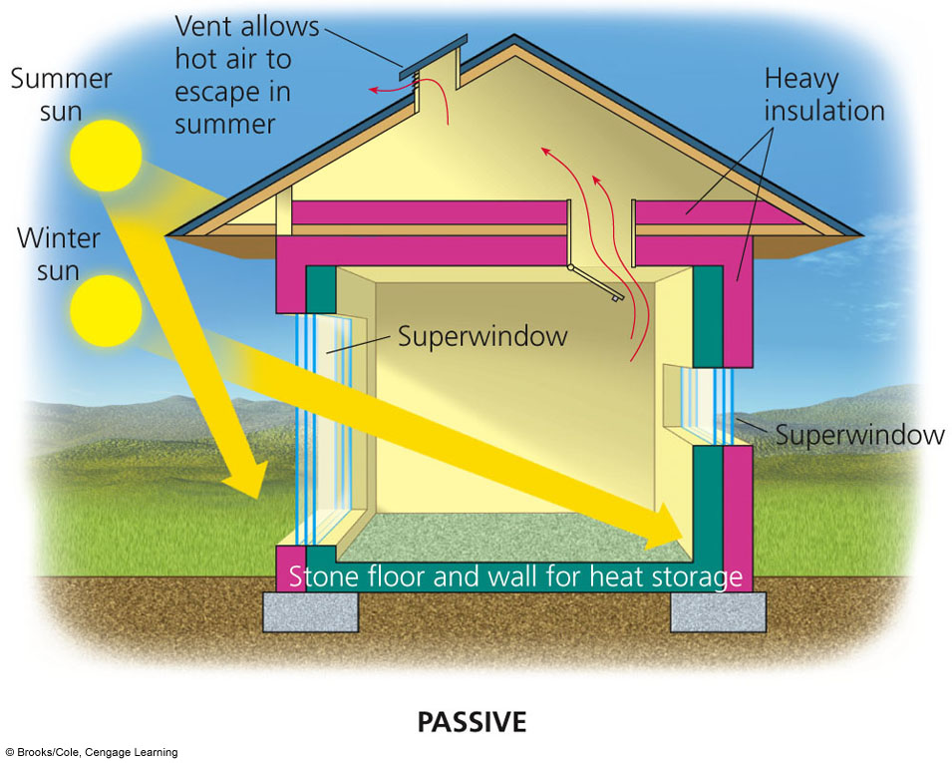

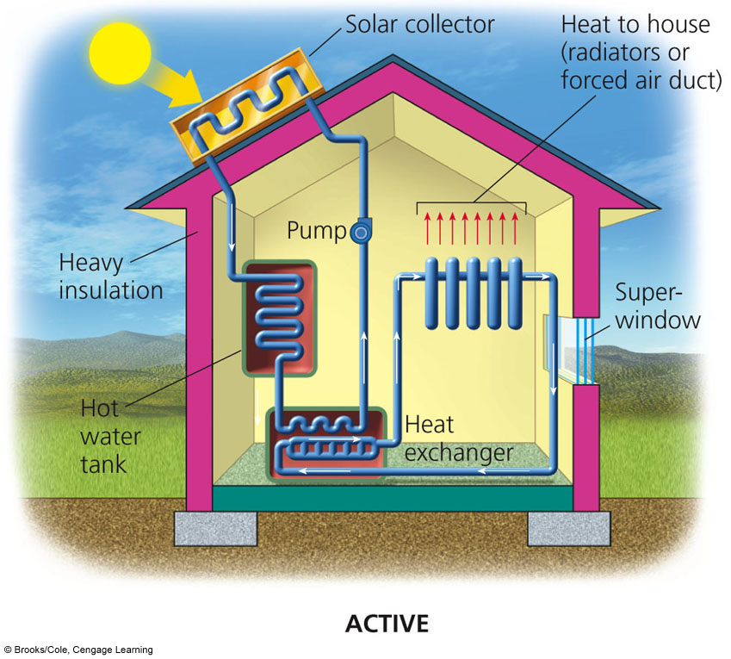

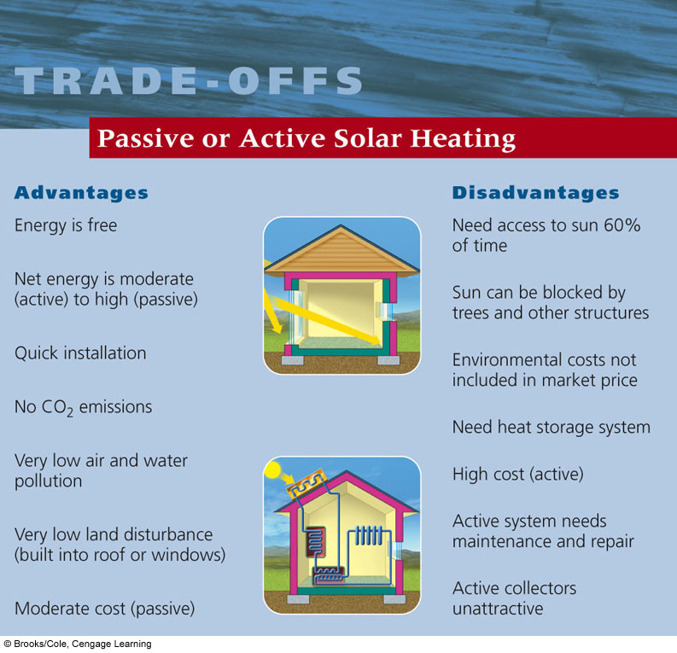

Disadvantages (cont.)

Advantages (cont.)



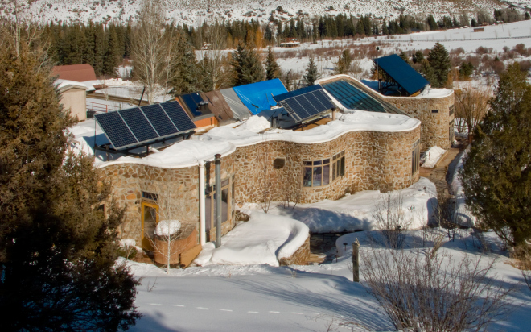

**The Lovins office-home**

A Solar-Powered Office-Home

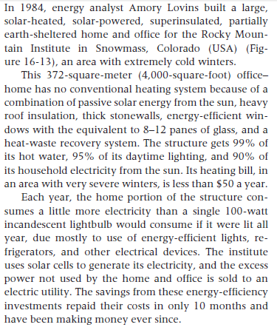

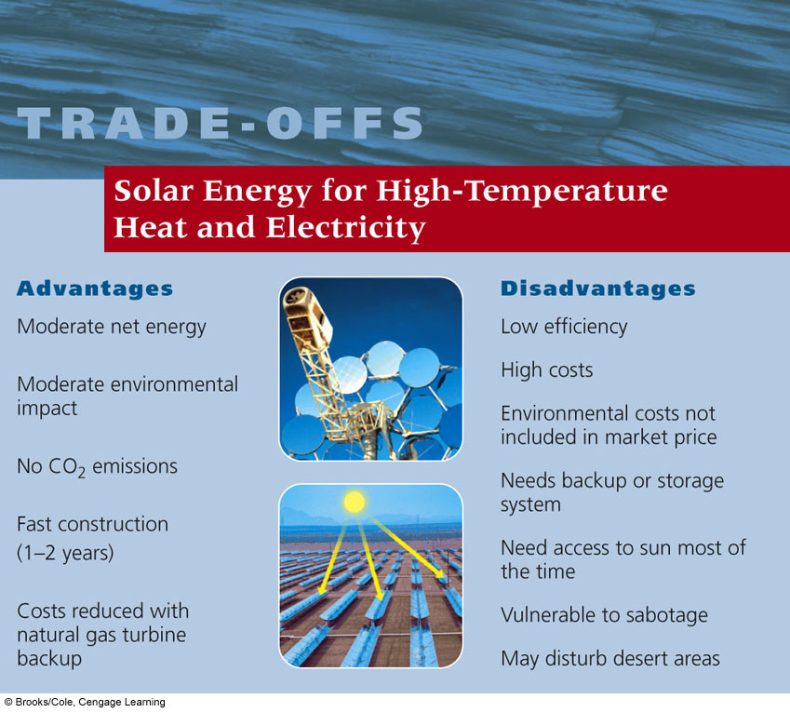

**Solar Energy for Heat and Electricity**

* What is it:
  + Concentrating heat from the sun into high-temperature thermal energy
* Best used for:
  + Generating electricity
  + Can use directly for high temperature heating (like cooking)
* Best Locations:
  + Mostly desert areas
  + Spain, California

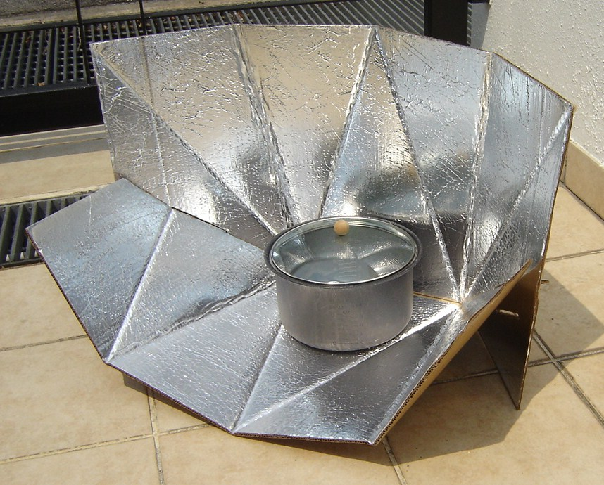

Solar cookers are an inexpensive alternative to using wood as fuel to cook or boil water. A solar cooker can be built for about $2-10 by lining an insulated box with aluminum foil to concentrate the sun’s rays on your pot. The also reduce indoor air pollution.

**Using Solar Cells to Produce Electricity**

Solar energy can be converted into electrical energy by **photovoltaic** (PV) cells, commonly called solar cells.

Most are thin wafers made of **silicon** with trace amounts of metals that act as semiconductors to produce electricity.

When sunlight strikes these cells, they emit electrons and many cells wired together in a panel can create electrical power.

The cells can be connected to the grid system or to batteries for storage until needed.

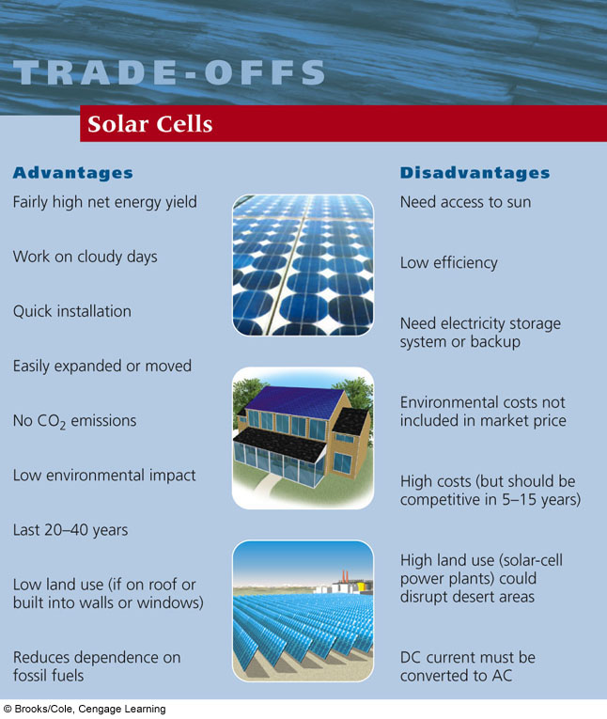

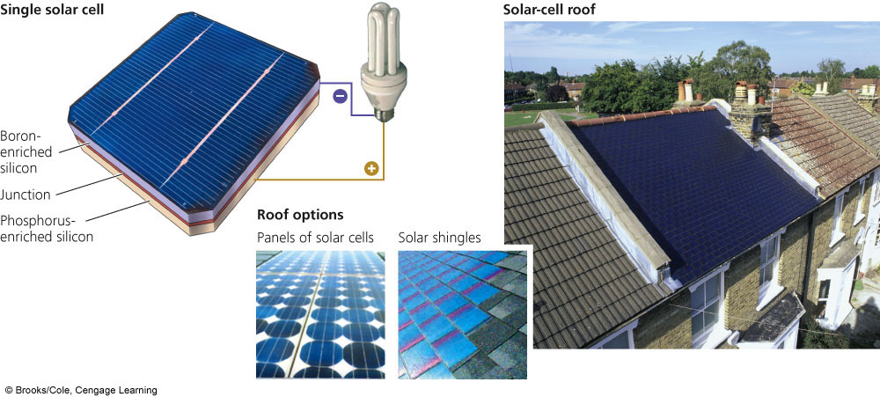

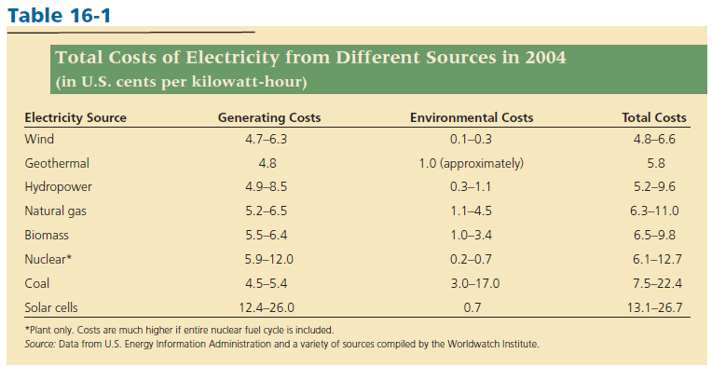

With the nanotechnology increasing, the cost of solar cells will continue to decrease.

**Hydropower**

*Concept 16-4*: Water flowing over dams, tidal flows, and ocean waves can be used to generate electricity, but environmental concerns and limited availability of suitable sites may limit the use of these energy sources.

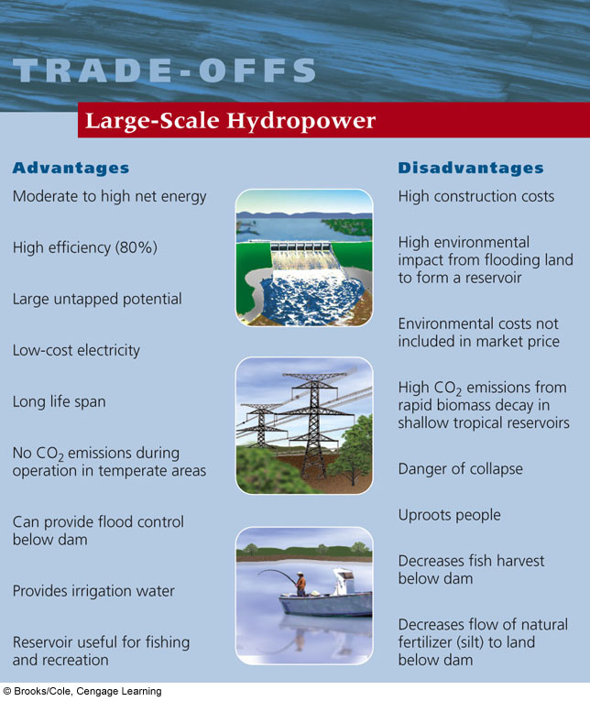

* What is it?
  + Using the kinetic energy of moving water to produce electricity
  + Indirect form of solar energy because it is based on the evaporation of water
* Best use:
  + Build a high dam across a large river to create a reservoir; some stored water from the reservoir can flow through huge pipes at controlled rates which spin turbines to generate electricity
* Best locations:
  + Anywhere with falling water or the ability to build a large dam
    - We have used up most of the world’s sites
  + Top Producers of hydropower: Canada, China, Brazil, U.S., and Russia
  + In 2006, hydropower supplied 99% of Norway’s electricity, but only 7% in the U.S.



**Tidal Power**

* What is it?
  + Produce electricity from flowing water in the ocean tides and waves
* Best use:
  + Electricity
* Locations limited:
  + Current: France, Nova Scotia
  + Working on installing in New York City
* Disadvantages
  + Few suitable sites
  + High costs
  + Equipment damaged by storms and corrosion

**Wind Power**

*Concept 16-5*: When environmental costs of energy sources are included in market prices, wind power is the least expensive and least polluting way to produce electricity.

Wind is put in motion by the uneven heating of the earth’s surface by the sun

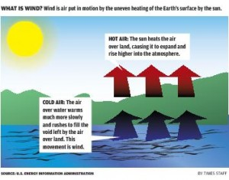

* What is it?
  + an indirect form of solar energy, the kinetic/mechanical energy is captured by turbines and converted into electrical energy
* Best use:
  + Produce electricity
* Locations:
  + Dominated by Europe right now
  + The Great Plains are our “Saudi Arabia of wind power”
    - North Dakota, South Dakota, Kansas, Texas

**Hot Air**: The sun heats the air over land, causing it to expand and rise higher into the atmosphere.

**Cold Air**: The air over water warms more slowly and rushes to fill the void left by the air over land. This movement is **wind**.

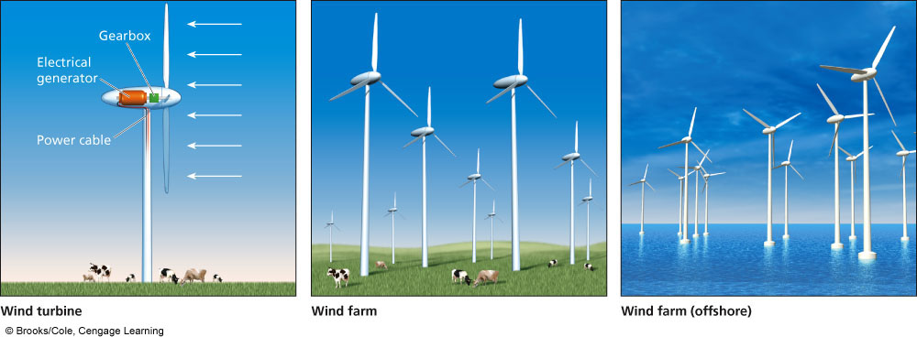

On land wind farms, the land underneath can still be used to raise livestock or grow crops.

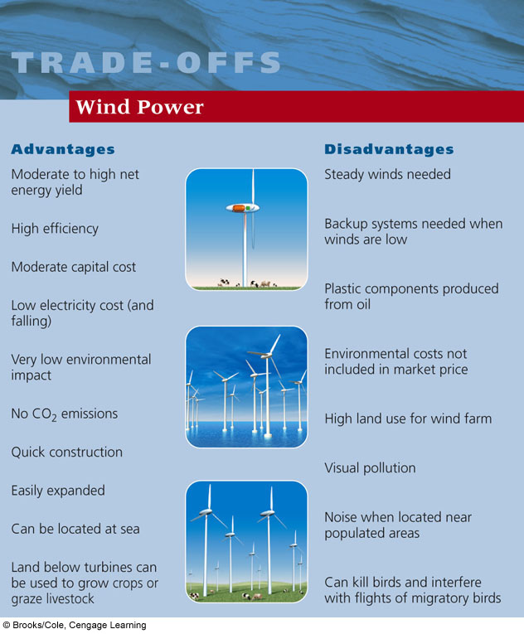

**Wind Power is a rapidly growing global industry**

* Countries with the highest total installed wind power capacity
  + Germany
  + United States
  + Spain
  + India
  + Denmark
* A single wind turbine on 0.1 hectare (0.25 acre) of land can produce about $300,000 worth of electricity per year.
* Farmers typically receive $3,000 – 10,000 a year for each turbine erected on their land. Farmers can still use the land for crops or livestock.

**Biofuels**

*Concept 16-6A*: Solid biomass is a renewable resource, but burning it faster than it is replenished produces a net gain in atmospheric greenhouse gases, and creating biomass plantations can degrade soil and biodiversity.

*Concept 16-6B*: Liquid biofuels derived from biomass can be used in place of gasoline and diesel fuels, but creating biofuel plantations could degrade soil and biodiversity and increase food prices and greenhouse gas emissions.

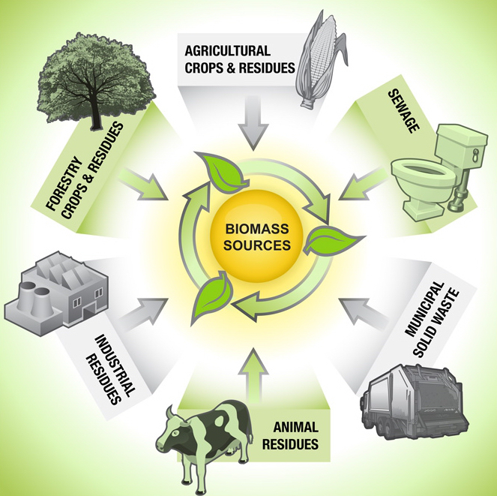

* What is it?
  + Biofuels are liquid fuels produced from plants and plant wastes
  + Biomass is an indirect form of solar energy because it consists of organic compounds produced through photosynthesis
* Best use:
  + Solid biomass is used mostly for cooking and heating, but also for industrial processes and generating electricity
  + Liquid biofuels (biodiesel & ethanol) can replace gasoline in transportation
* Biggest producers of liquid biofuels- Brazil (45% of its cars run on ethanol), United States, European Union and China
  + Biofuel crops can be grown almost anywhere, meaning countries can improve their energy and economic security by reducing their dependence on imported oil

Wood is only renewable as long as it is not harvested faster than it is replenished.

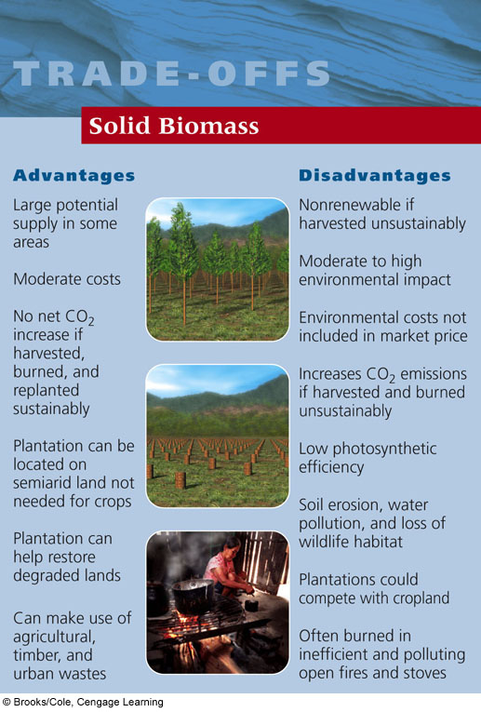

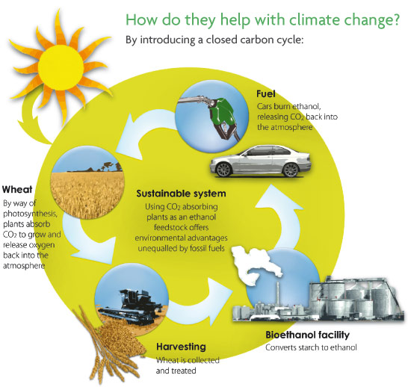

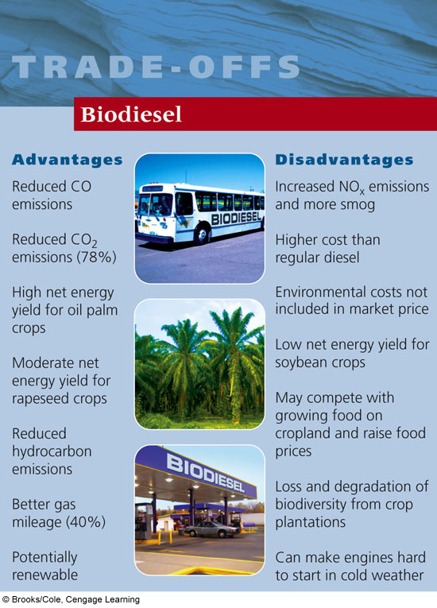

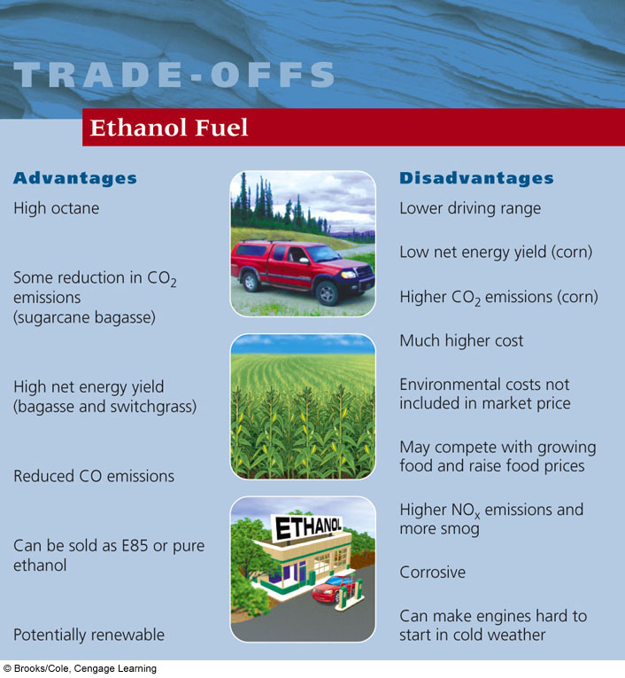

**Geothermal Energy**

*Concept 16-7*: Geothermal energy has great potential for supplying many areas with heat and electricity and generally has a low environmental impact, but locations where it can be exploited economically are limited.

* **What is it?**
  + **Geothermal energy** taps theheat stored in the earth’s soil, underground rocks and fluids in the earth’s mantle
* Best used for:
  + Electricity generation
  + Space heating
* Locations
  + Iceland, and any place that has “hot” crust
    - Particularly out west for U.S.
* How it works…
  + A geothermal heat pump system can heat and cool a house by exploiting the temperature differences between the earth’s surface and underground, almost anywhere in the world at a depth of about 10-20 feet
  + In winter, a closed loop of buried pipes circulates a fluid (water or antifreeze) which extracts heat from the ground and carries it to a heat pump, which transfers the heat to a home’s heat distribution system (a blower and air ducts).
  + In summer, the system works in reverse, removing heat from a home’s interior and storing it underground
  + It creates NO air pollution and NO CO2 emissions

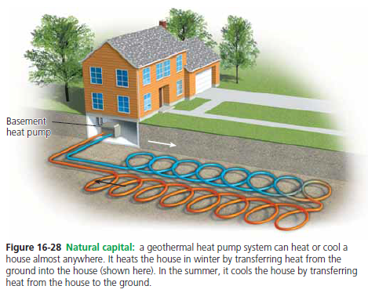

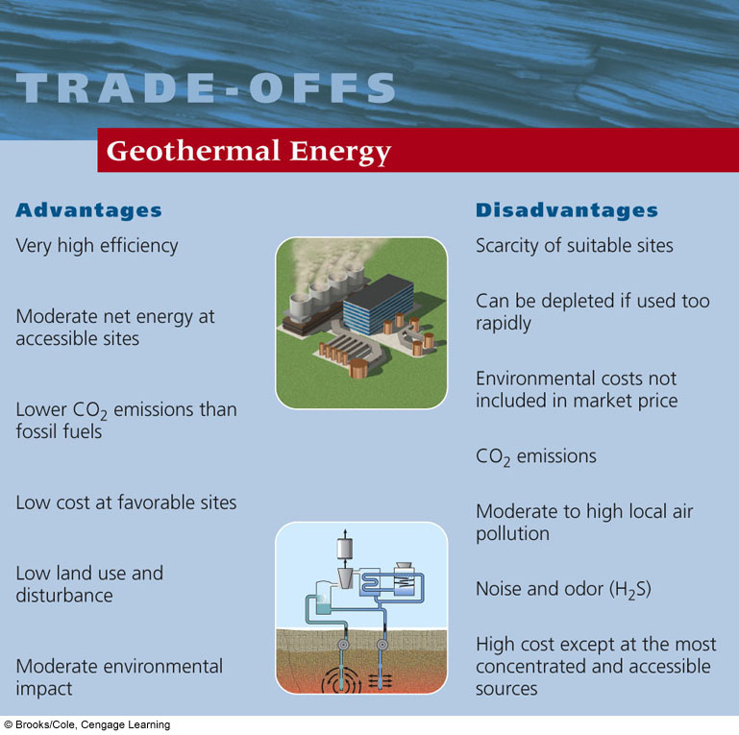

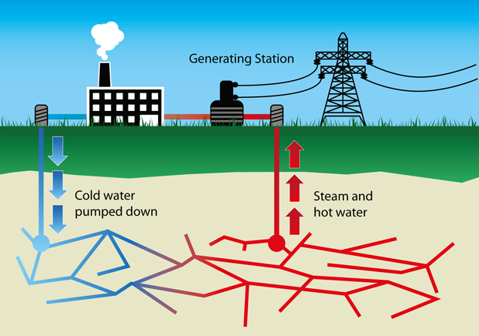

**Hydrogen Fuels**

*Concept 16-8*: Hydrogen fuel holds great promise for powering cars and generating electricity, but to be environmentally beneficial, it would have to be produced without the use of fossil fuels.

* What is it:
  + Combines hydrogen and oxygen to produce electricity (by-product is water vapor)
* Best used for:
  + Replacement for oil
  + In homes to replace electricity
* The “catch”
  + Hydrogen is locked up in water and organic compounds like methane, so it takes energy and money to separate it out for use in fuel cells
  + In order to receive low air pollution and low CO2 emissions, the energy used to make H2 must come from low-polluting renewable resources that emit little or no CO2 such as solar-cell plants and geothermal energy

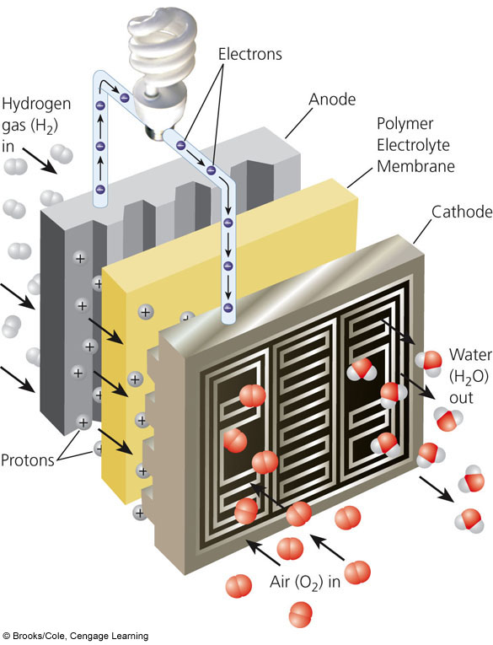

**A fuel cell separates the hydrogen atoms’ electrons from their protons**

