Brodnax

**Nonrenewable Energy Notes**

***Concept 15-1A:*** *About three-quarters of the world’s commercial energy comes from nonrenewable fossil fuels and the rest comes from nonrenewable nuclear fuel and renewable sources.*

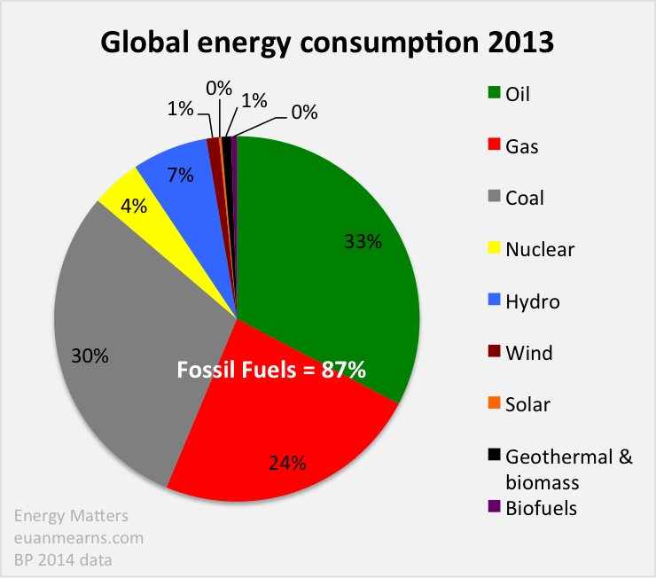

**Energy Usage Today**

About 91% of the commercial energy consumed in the world comes from nonrenewable energy resources…

* + 87% from fossil fuels (oil, natural gas and coal)
  + 4% from nuclear power
  + 18% from renewable energy resources (biomass, hydropower, geothermal, wind, and solar energy)
    - We will discuss these in the next set of notes

**ANALYZE:** How does the US differ in energy usage from the world? Do they use more or less nonrenewable energy sources?

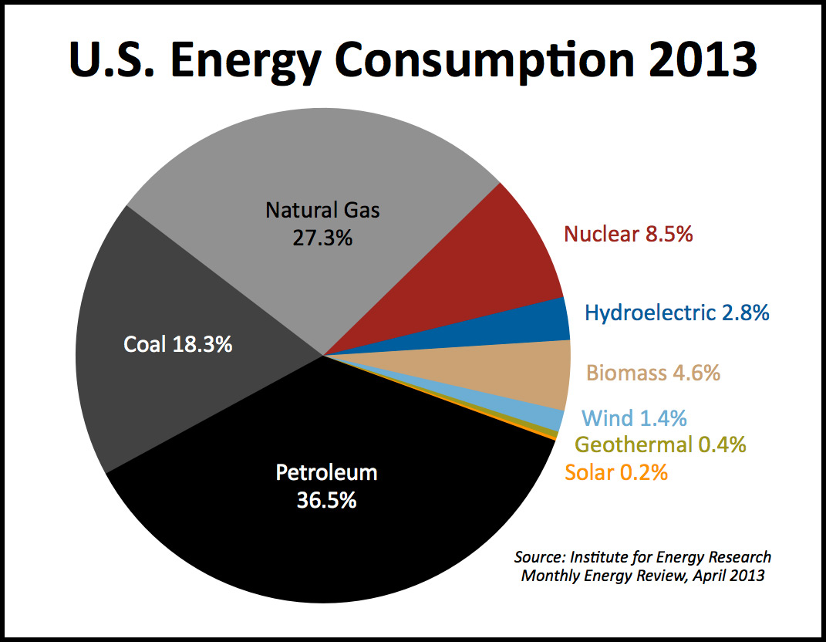

***Concept 15-1B:*** *Net energy is the amount of high-quality usable energy available from a resource after the amount of energy needed to make it available is subtracted.*

Net energy available for use is calculated by estimating the total energy available from the resource over its lifetime and then subtracting the amount of energy used (the first law of thermodynamics), automatically wasted (the second law of thermodynamics), and unnecessarily wasted in finding, processing, concentrating, and transporting the useful energy to users.

It takes energy to get energy. For example, before oil is useful to us, it must be found, pumped from below ground or ocean floor, transferred to a refinery and converted to useful fuels, transported to users, and burned in furnaces and cars. Each of these steps uses high-quality energy. The second law of thermodynamics tells us that some of the high-quality energy used in each step is automatically wasted and degraded to lower-quality energy. The usable amount of high-quality energy available from a given quantity of an energy resource is its **net energy**.

[Net energy Video](https://www.youtube.com/watch?v=v0_9xD9QQUY)

**Net Energy Ratios**

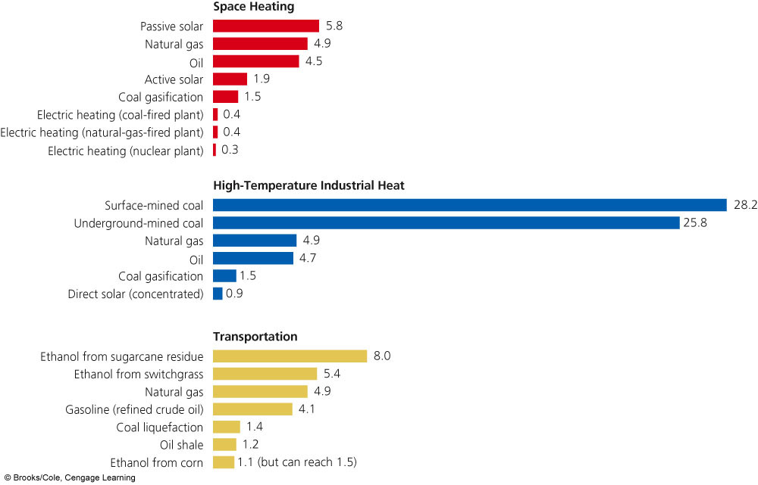

The higher the ratio, the greater the net energy. When the ratio is less than 1, there is a net energy loss.

Energy resources with a low net energy will need government (taxpayer) subsidies.

**Advantages and Disadvantages of Oil**

**What is Petroleum?**

Petroleum, crude oil (oil as it comes out of the ground), is a thick liquid containing hydrocarbons that we extract from underground deposits in sedimentary bedrock and separate into products such as gasoline, heating oil, and asphalt.

**Where does it come from?**

Crude oil was formed from the decaying remains (fossils) of organisms that lived 100-500 million years ago.

**How is it extracted?**

Wells are drilled deep into the earth or seafloor (as far as 7 miles down) to reach the pores and cracks where the crude oil and natural gas (vapor form of petroleum) are accumulated. The oil gets pumped to the surface and transported to a refinery by pipeline, truck or ship.

**How is crude oil refined?**

In a process called **refining**, the crude oil is heated and distilled to separate it into components with different boiling points. Refining oil decreases its net energy yield. **Petrochemicals** are products of oil distillation and are used as raw materials in industrial organic chemicals, cleaning fluids, pesticides, plastics, synthetic fibers, paints, medicines, etc.

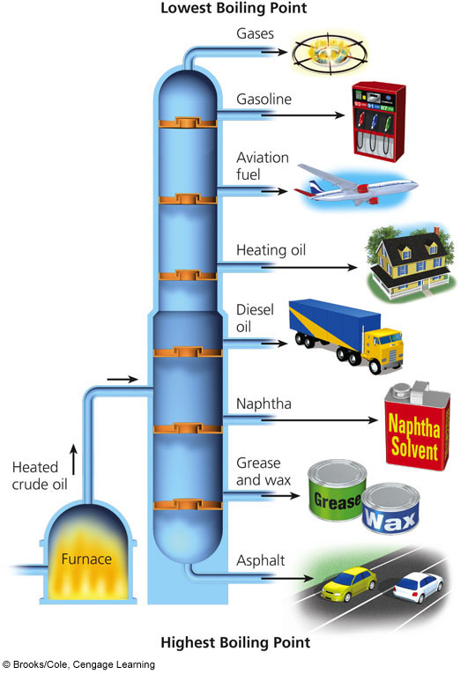

[Oil Fractions Video](https://www.youtube.com/watch?v=JZdvsQzOKuk)

[Oil Drilling Video](https://www.youtube.com/watch?v=SfazJ6P_g7w)

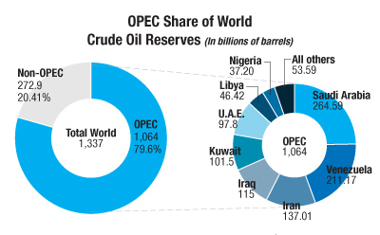

**OPEC Controls Most of the World’s Oil Supplies**

**Oil reserves** are identified deposits from which conventional oil can be extracted profitably at current prices with current technology.

* Since the world is heavily dependent on oil, the oil industry is the world’s largest business.
* There are 13 countries which make up the OPEC (Organization of Petroleum Exporting Countries): Algeria, Angola, Indonesia, Iran, Iraq, Kuwait, Libya, Nigeria, Qatar, Saudi Arabia, the United Arab Emirates, and Venezuela.
* In 2007, OPEC oil revenue averaged $1.3 million per minute.
* The top 2 countries for crude oil reserves are Saudi Arabia (25%) and Canada (15%).
  + Because of secrecy, no one knows for sure the sizes of each country’s oil reserves.

**Possible effects of steeply rising oil prices**

* Shift to non-carbon energy sources
* Higher prices for products made with petrochemicals
* Higher food prices; buy locally-produced food
* Higher airfares
* Demand for smaller, more fuel-efficient vehicles
* Upgrade of public transportation

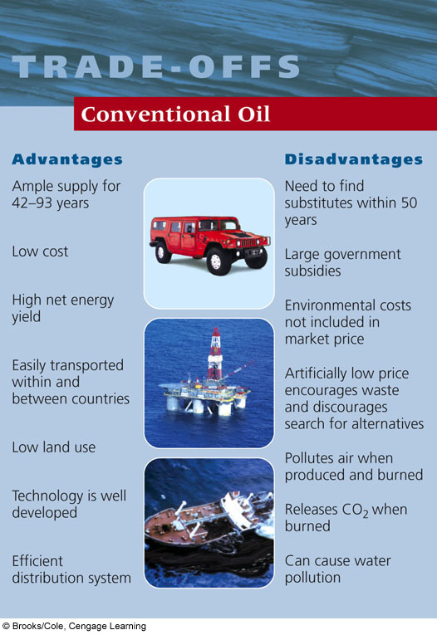

**The United States Uses Much More Oil Than It Produces**

* The US produces 9% of the world’s oil
* The US imports 60% of its oil
* The US has about 2.4% of the world’s oil reserves
* Most of the oil drilling in the US occurs in the Gulf of Mexico near Louisiana and Texas and in Alaska’s North Slope region
* Scientists are attempting to genetically engineer bacteria to increase the flow of oil so that more can be pumped to the surface or converted to natural gas.
  + The trick is to develop organisms that can do this in 10 years instead of the 10 million years it would take to naturally form.

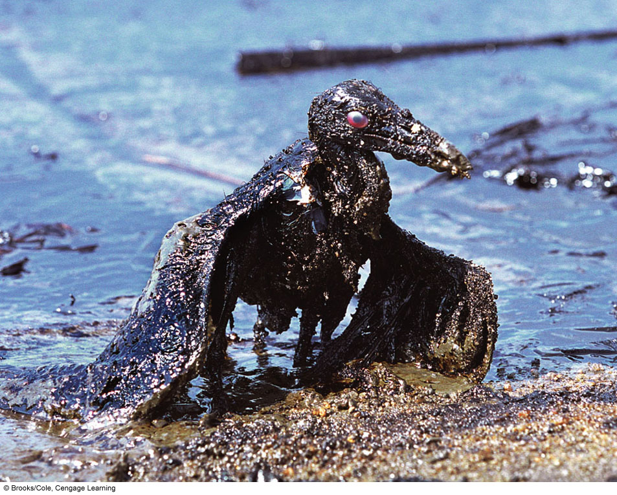

Conventional oil is a versatile fuel that can last for at least 50 years, but burning it produces air pollution and releases the greenhouse gas carbon dioxide into the atmosphere.

**Nonconventional Petroleum Sources**

Oil sands, or tar sands, are deposits of rock or sediment that contain a heavy oil- or tar-like fossil fuel substance called **bitumen**. In the summer, tar sands look like a fine-grain asphalt road mix.

Bitumen is used as asphalt for road surfaces and some fuels, like diesel jet fuels.

**How is bitumen extracted?**

Because tar sands are so thick, surface mining is most common (since deep drilling will not work because the tar is too thick to be pumped up).

The Alberta tar sands may contain about one trillion barrels of petroleum. The Canadian tar sands are a mixture of 84-88% sand and clay, 8-12% bitumen and 4% water. The overburden is removed on site and the tar sand is scooped up and loaded onto trucks that will haul it to the extraction plant. At the plant, the tar sands are mixed with chemically treated water at 180°F in huge, rotating drums. It goes to separation cylinders where the sand and clay settle to the bottom and the bitumen floats to the surface. The bitumen is piped to a refinery.

With bitumen extraction, there is a serious environmental impact and a low net energy yield. Is it worth it?

**Oil Shale**

Another nonconventional petroleum source is **oil shale**. Oil shale is sedimentary rock that contains an organic solid called **kerogen**. When retorted (heated), the kerogen breaks down into synthetic crude oil and hydrocarbon gas.

The world’s largest reserves of shale oil (about 4 trillion barrels of potential oil) are found in the Rocky Mountains. Currently, very little is being done to develop shale oil because the world price of oil is too low there is a low net energy yield.

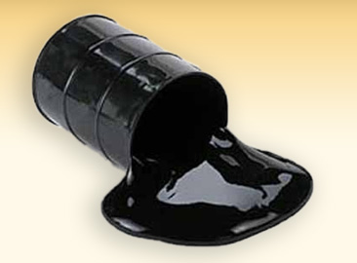

**Bitumen**

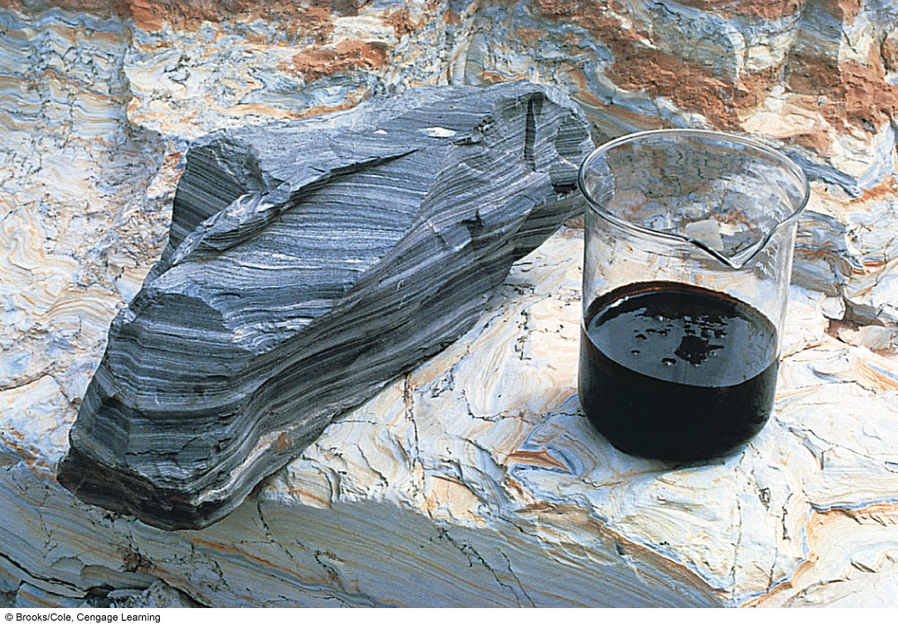

**Shale oil**

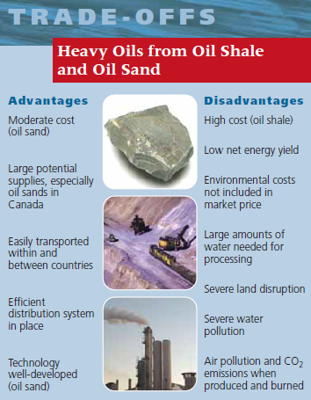

Concept 15-3: Conventional natural gas is more plentiful than oil, has a high net energy yield and a fairly low cost, and has the lowest environmental impact of all fossil fuels.

Environmentally friendly?

All fossil fuels release CO2 into the atmosphere, but natural gas releases much less CO2 per unit of energy gained than burning coal or producing petroleum products.

Natural gas is the vapor form of petroleum. It is a mixture of gases, 50-90% of which is CH4 (methane). It also contains heavier hydrocarbons like ethane (C2H6), propane (C3H8), and butane (C4H10).

Natural gas is used to heat homes and water, in raw material processing, food preparation, petrochemical feedstocks, refinery fuel, to fuel cars with minor engine modifications, and power generation.

[Natural Gas Video](https://www.youtube.com/watch?v=Em1crnEt45Q)

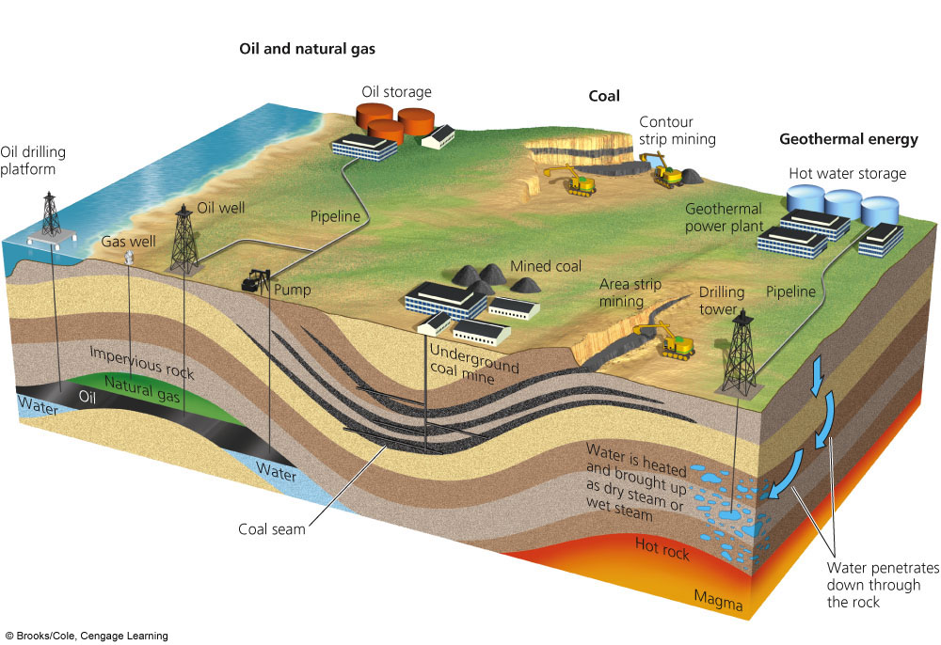

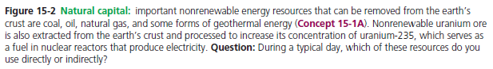

When a natural gas field is tapped, propane and butane gases are liquefied and removed as **liquefied petroleum gas** **(LPG).** LPG is stored in pressurized tanks for use mostly in rural areas that are not served by natural gas pipelines. The tanks can be buried underground if preferred.

The rest of the gas (mostly methane) is dried to remove water vapor, cleansed of poisonous hydrogen sulfide, and pumped into pressurized pipelines for distribution across land areas.

Most natural gas pipelines are buried underground which is why is it very important to call 811 before you dig so you don’t bust the line!

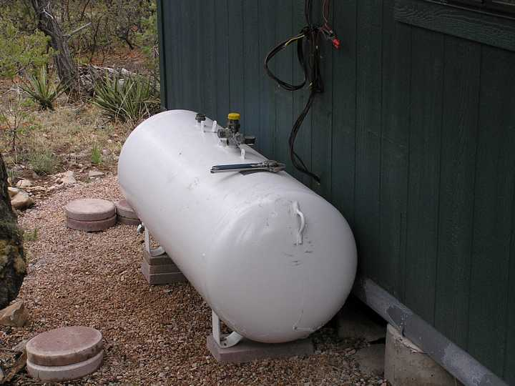

* Russia has the most natural gas reserves in the world.
* The US has only about 3% but uses about 27% of the world’s production.

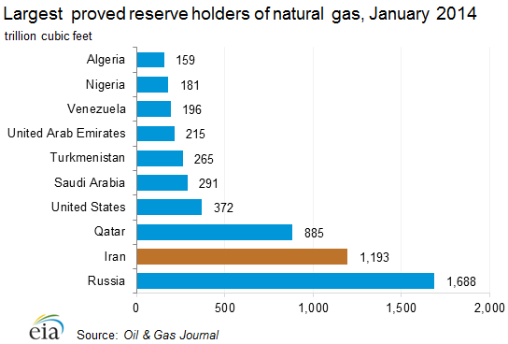

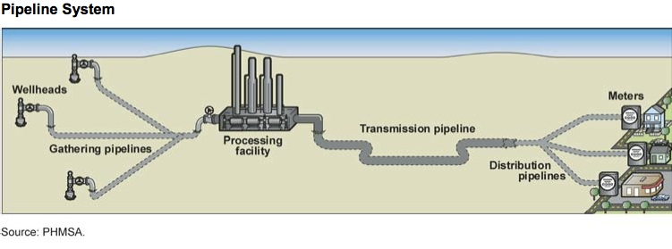

**How can it be transported across oceans?**

Natural gas can be converted to **liquefied natural gas (LNG)** at a very low temperature and high pressure in order to be transported across oceans. This highly flammable liquid is boarded on refrigerated tanker ships. After arriving at its destination, it is heated and converted back to gas before entering the pipeline system.

**Nonconventional forms of Natural Gas**

* **Coal bed methane gas**- found in coal beds near the earth’s surface in US and Canada.
  + Bad environmental impacts: causing scarring of land and pollution of air and water.
* **Methane hydrate-** methane found in icy, cage-like structures of water molecules. They are buried in areas of tundra under arctic permafrost in Alaska and Siberia.
  + Cost is too high to be profitable-low net energy yield
  + High environmental impact- releases the greenhouse gas methane into the atmosphere, which could speed up global warming

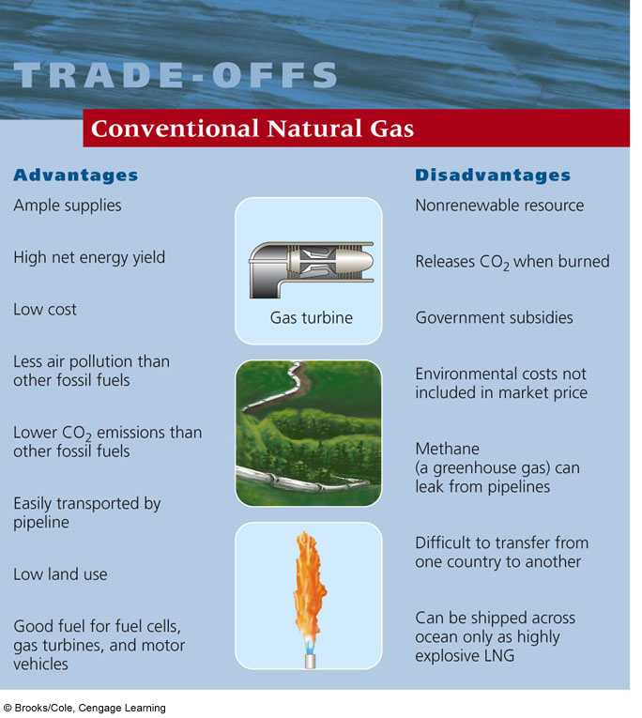

*Concept 15-4A*: Conventional coal is very plentiful and has a high net energy yield and low cost, but it has a very high environmental impact.

*Concept 15-4B*: Gaseous and liquid fuels produced from coal could be plentiful, but they have lower net energy yields and higher environmental impacts than conventional coal has.

[Fossil Fuel formation Video](https://www.youtube.com/watch?v=_8VqWKZIPrM)

**Coal comes in many forms and is burned mostly to produce electricity**

**Coal** is a solid fossil fuel that was formed in stages out of the remains of land plants that were buried 300-400 million years ago and subjected to intense heat and pressure over many millions of years.

**Peat** is a soil material made from moist, partially decomposed organic matter and is not classified as coal, although it too is used as fuel.

The different types of coal vary in the amounts of heat, CO2, and SO2 released per unit of mass when they are burned

* Coal is burned in about 2,100 power plants to generate about 40% of the world’s electricity
* Using a coal-burning power plant is essentially a complex and inefficient way to boil water and produce steam, which is used to spin turbines and produce electricity
* Largest coal-burning countries: China, US, and India

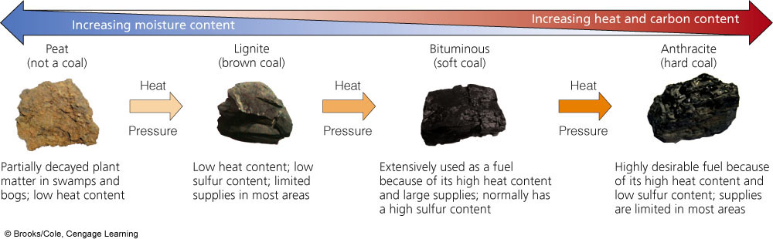

Heat produced by burning pulverized coal in a furnace boils water to produce steam that spins a turbine to produce electricity. The steam is cooled, condensed, and returned to the boiler for reuse. Waste heat can be transferred to the atmosphere or to a nearby source of water. Water is pumped through a condenser and back to the water source to remove the waste heat.

The largest coal-burning power plant in the U.S. is in Indiana. It burns 25 tons of coal per minute, or three 100-car trainloads of coal per day.

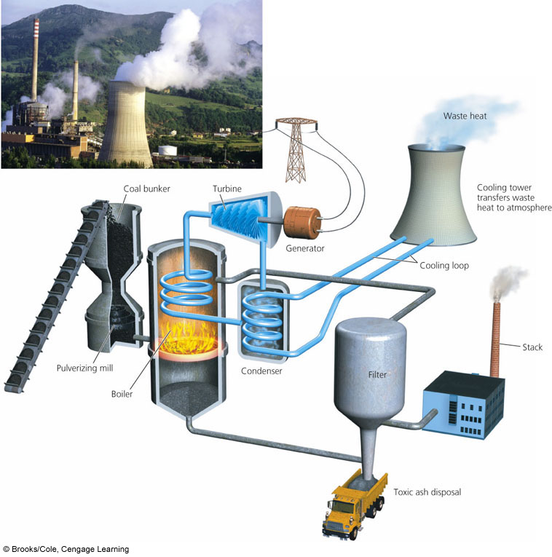

[Coal Plant Video](https://www.youtube.com/watch?v=SeXG8K5_UvU)

**Coal is a plentiful but dirty fuel**

* Coal is the world’s most abundant fossil fuel
  + U.S. has 25%, Russia has 15%, India and China have 13% each
* Environmental costs of burning coal = Severe air pollution
  + Sulfur released as SO2
  + Large amount of soot particulates
  + CO2 (25% of world’s CO2 emissions and 40% of U.S. CO2 emissions comes from burning coal)
  + Trace amounts of Hg (mercury) and radioactive materials
* Environmentalists call for:
  + Taxation on CO2 production by power plants
  + Cleaner coal-burning plants
  + Increased use of renewable energy sources

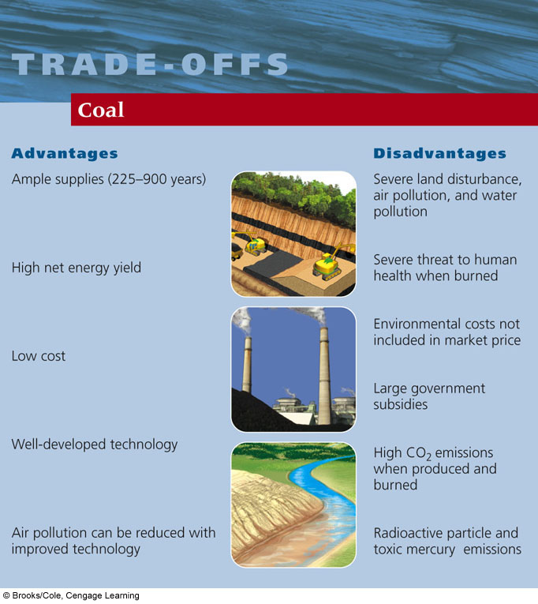

**Nuclear Energy**

***Concept 15-5:***Nuclear power has a low environmental impact and a very low accident risk, but high costs, a low net energy yield, long-lived radioactive wastes, vulnerability to sabotage, and the potential for spreading nuclear weapons technology have limited its use.

Nuclear power plants are similar to coal-burning plants in that they both heat water into pressurized steam which drives a turbine generator to produce electricity. The difference is in how they heat the water.

Nuclear plants depend on the heat that occurs during **nuclear fission**, when one atom splits into two and releases energy. Nuclear fission happens naturally every day. **Uranium**, for example, constantly undergoes spontaneous fission at a very slow rate. This is why the element emits radiation, and why it's a natural choice for the **induced fission** that nuclear power plants require.

Uranium is a common element on Earth and has existed since the planet formed. While there are several varieties of uranium, **uranium-235** (U-235) is the one most important to the production of both nuclear power and nuclear bombs.

U-235 decays naturally by alpha radiation: It throws off an alpha particle, or two neutrons and two protons bound together. It's also one of the few elements that can undergo induced fission. Fire a free neutron into a U-235 nucleus and the nucleus will absorb the neutron, become unstable and split immediately.

The splitting of an atom releases an incredible amount of heat and **gamma radiation**, or radiation made of high-energy photons.

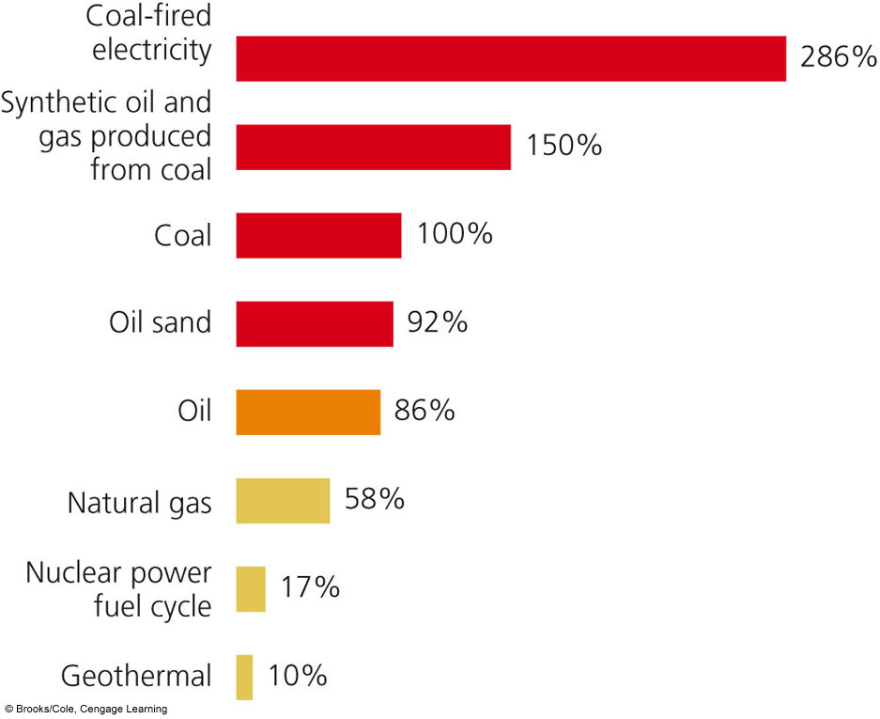

**CO2 Emissions per Unit of Electrical Energy Produced for Energy Sources**

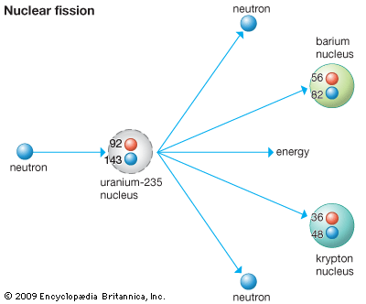

**How does a Nuclear Fission Reactor work?**

**Light-water reactors** are the most common nuclear reactors and produce about 85% of the world’s nuclear-generated electricity (100% in the U.S.). They are highly inefficient, losing about 83% of the energy available as waste heat to the environment.

[Nuclear Plant Video](https://www.youtube.com/watch?v=_UwexvaCMWA)

Mined uranium must be enriched to increase the concentration of its fissionable U-235 form the normal 0.7% to about 3%. Enriched U-235 is processed into small pellets of uranium dioxide. Each pellet, about the size of a pencil eraser, contains the energy equivalent of about a ton of coal. Large numbers of the pellets are packed into closed pipes called **fuel rods**, which are then grouped together in **fuel assemblies**, to be placed in the core of a reactor.

To control the reaction, devices called **control rods** are moved in and out of the reactor core to absorb neutrons, thereby regulating the rate of fission and the amount of power produced. A **coolant**, usually water, circulates through the reactor’s core to remove heat, which keeps fuel rods and other materials from melting and releasing massive amounts of radioactivity into the environment. A **containment shell** with thick, steel-reinforced, concrete walls surrounds the reactor core for protection.

Light-water–moderated and –cooled nuclear power plant with a pressurized water reactor

Some nuclear plants withdraw water for cooling from a nearby source of water and return the heated water to such a source, as shown here.

Other nuclear plants that do not have access to a source of cooling water transfer the waste heat to the atmosphere by using one or more gigantic cooling towers, as shown in the insert photo of the Three Mile Island nuclear power plant near Harrisburg, Pennsylvania.

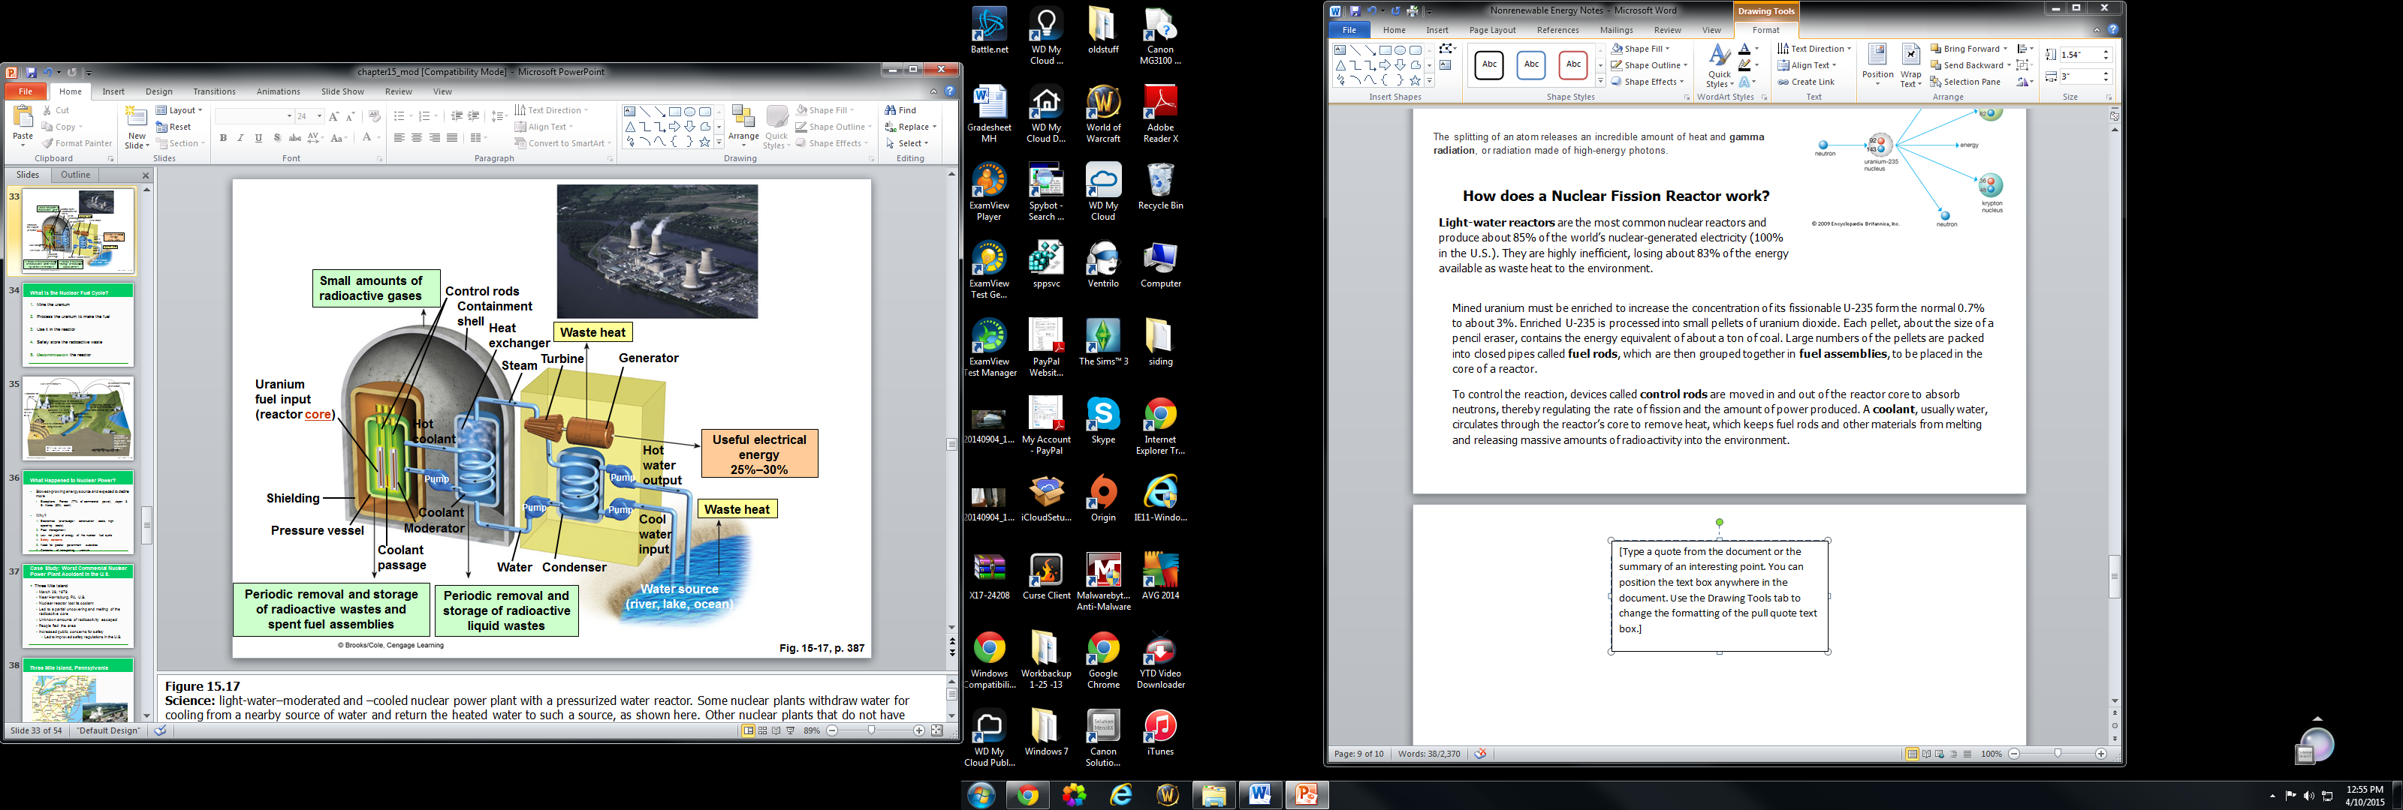

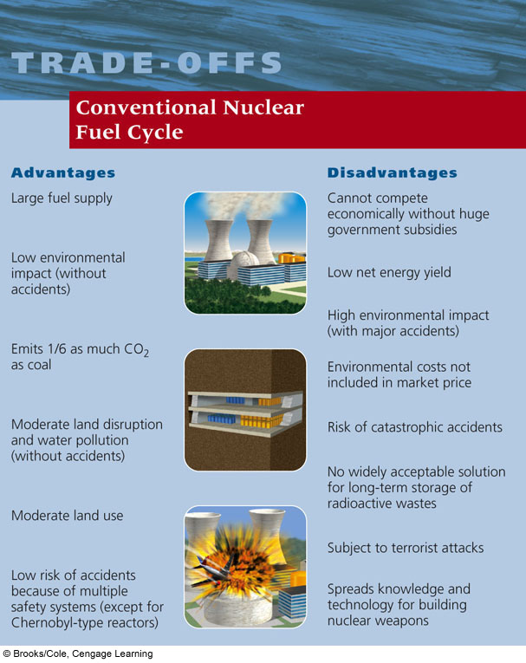

**The Nuclear Fuel Cycle**

The Nuclear Fuel Cycle includes several steps:

1. Mine the uranium
2. Process the uranium to make the fuel
3. Use it in the reactor
4. Safely store the radioactive waste
5. **Decommission** the reactor (an old nuclear power plant must be safely retired; it cannot be simply boarded up and abandoned)

Each step in the nuclear fuel cycle adds to the cost of nuclear power and reduces its net energy yield. The current nuclear fuel cycle is extremely inefficient, using or wasting 92% of the energy content of its nuclear fuel.

[Nuclear Fuel Cycle Video](https://www.youtube.com/watch?v=jS89td3gc8o)

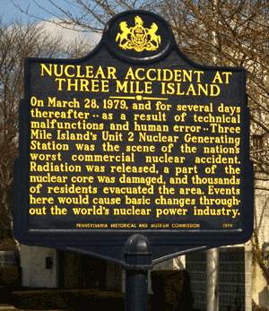

Three Mile Island

* Worst Commercial Nuclear Power Plant Accident in the U.S.
* March 29, 1979 near Harrisburg, PA, U.S.
* Nuclear reactor lost its coolant water b/c of mechanical failures and human error
* Led to a partial uncovering and melting of the radioactive core
* Unknown amounts of radioactivity escaped
* People fled the area but no human casualties
* Increased public concerns for safety
  + Led to improved safety regulations and evacuation plans in the U.S.

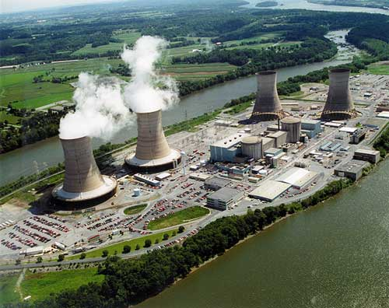

[Three Mile Island Accident Video](https://www.youtube.com/watch?v=eGI7VymjSho)

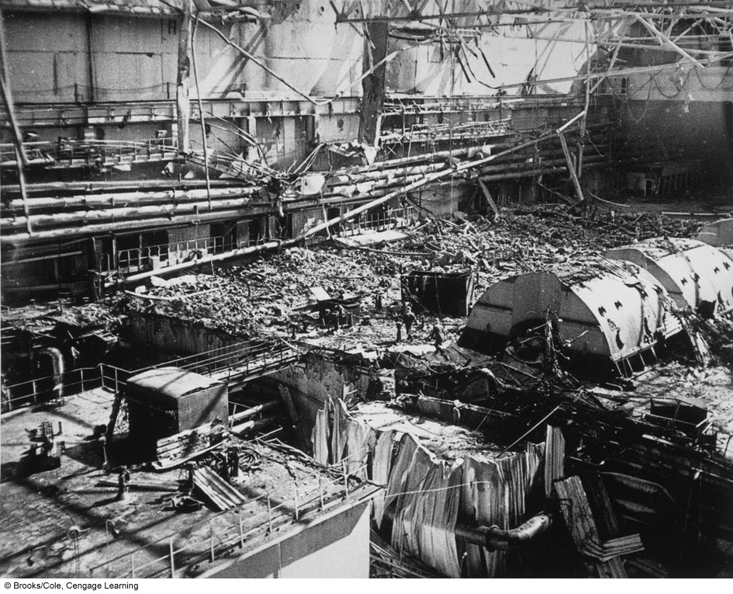

Chernobyl

* Worst Nuclear Power Plant Accident in the World
* April 26, 1986 in Chernobyl, Ukraine
* Series of explosions caused the roof of a reactor building to blow off
* Partial meltdown and fire for 10 days
* Huge radioactive cloud spread over many countries and eventually the world
* 350,000 people left their homes
* Effects on human health, water supply, and agriculture
  + Increased frequency of birth defects and mental retardation in newborns
  + Higher incidences of leukemia, thyroid cancer and immune system abnormalities in children exposed to the radioactive fallout



Thyroid cancers are so common that the resulting surgical scars at the base of the neck are known as the “Chernobyl necklace.”

[Chernobyl Disaster Video](https://www.youtube.com/watch?v=RXZ9MhSJfVU)