Brodnax

**Impacts of Human Population Notes**

*The problems to be faced are vast and complex, but come down to this: 6.7 billion people are breeding exponentially. The process of fulfilling their wants and needs is stripping earth of its biotic capacity to support life; a climatic burst of consumption by a single species is overwhelming the skies, earth, waters, and fauna.* –Paul Hawken

Fill in the following notes while viewing the [Video](https://www.youtube.com/watch?v=sc4HxPxNrZ0).

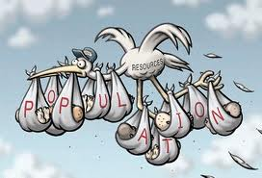

* Last year the Earth’s population hit ____ billion.
* In 1800, the earth’s population was ____ billion.
* About every second, _____ people are born and _____ people die.
* A megacity is a city with more than __________________ people.
* How many megacities are there now? _____
* _____% of humans don’t have clean drinking water.
* _____% of humans don’t have proper sanitation.

[Video #2](https://www.youtube.com/watch?v=4B2xOvKFFz4)

* What does the Earth’s most typical person look like? ________________________________________________________________________
* 1/3 of the human population lives in which 2 countries? ____________ and ______________

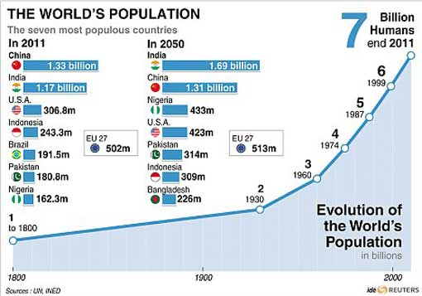

**What caused rapid increases in population in the past?**

* **Agricultural Revolution**: long, transitional period from hunting/gathering to farming, which saw several periods of rapid increase in agricultural productivity and vast improvements in farm technology.
  + Plows, seed drills, machines that harvest crops, etc.
* **Industrial Revolution**: a period from the 18th to the 19th century where major changes in agriculture, manufacturing, mining, transport, and technology had a profound effect on the [socioeconomic](http://www.wikipedia.org/wiki/Socioeconomics) and [cultural](http://www.wikipedia.org/wiki/Culture) conditions starting in the [United Kingdom](http://www.wikipedia.org/wiki/United_Kingdom), then subsequently spreading throughout Europe, North America, and eventually the world.
  + Incomes and population growth increased rapidly; standards of living improved drastically

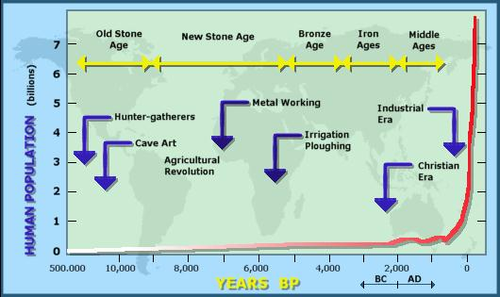

Age Structure Pyramids show the distribution of males and females in different age groups of a specific population

* Useful in determining **future** population growth
  + A crucial factor for determining future population growth is the # of females in reproductive and pre-reproductive age groups

A broad base indicates a population is high in young people = FUTURE GROWTH

* Could indicate population with poor health care, large families, developing country, etc.

A narrow base will indicate a population low in young people = FUTURE DECLINE

**Age Structure Pyramids**

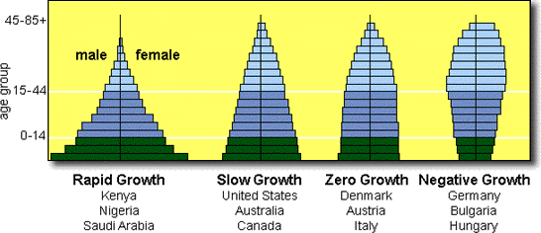

**Survivorship Curves**

* **Survivorship** is the percentage of newborn individuals in a population that can be expected to survive to a given age.
* It is used as another way to predict population trends.
* To predict survivorship, demographers study a group of people born at the same time and notes when each member of the group dies.
  + Wealthy developed countries such as Japan and Germany currently have a **Type I** survivorship curve because most people live to be very old.
  + **Type II** populations have a similar death rate at all ages.
  + **Type III** survivorship is the pattern in very poor human populations in which many children die.

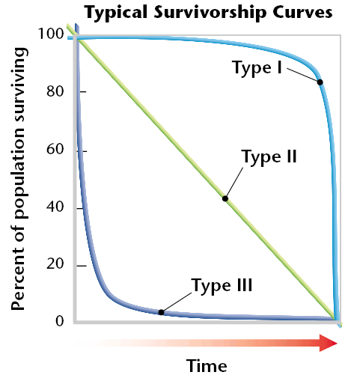

**Classifying Countries**

Demographers classify countries as either developed or developing.

* **Developed countries** have higher average incomes, slower population growth, diverse industrial economies, and stronger social support systems.
* **Developing countries** have lower average incomes, simple and agriculture-based economics, and rapid population growth.

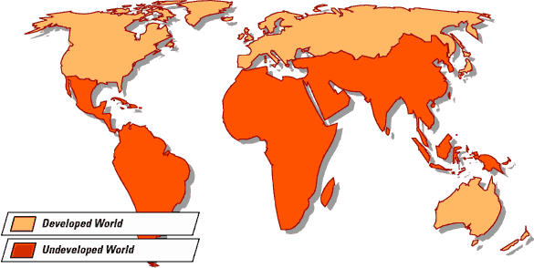

**Emerging Diseases Affect Population Growth**

Emerging infectious diseases are caused by new or previously unrecognized microorganisms. Many factors contribute to the emergence of new infectious diseases. They include the increasing **growth and** **mobility** of the world’s population, overcrowding in cities with poor sanitation, massive food preparation and international distribution, and unsanitary food preparation. Diseases can easily decrease population growth. AIDS has drastically decreased growth by eliminating many reproductive-aged people (See pic at end of notes).

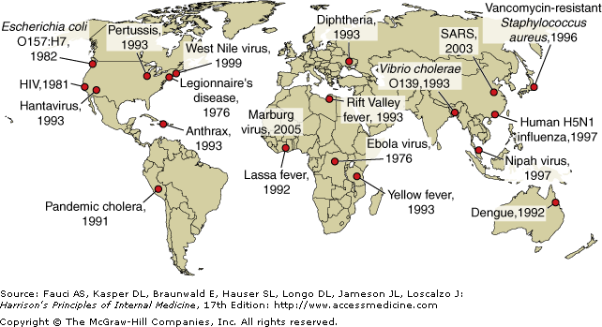

**Important Terms**

* **Total Fertility Rate**: average number of children born to a woman in her lifetime
* **Replacement-Level Fertility**: average number of children a couple must bear to replace themselves; this number is slightly more than 2 because not all children born will survive and reproduce.
* **Infant Mortality Rate**: # of babies out of every 1000 to die before reaching their first birthday
* **Crude Birth Rate**: # of births per 1000 people
* **Crude Death Rate**: # of deaths per 1000 people
* **Immigration**: moving INTO a population
* **Emigration**: moving OUT OF a population
* **Population Growth Rate**: (births + immigrants) – (deaths + emigrants) / Total Population X 100
* **Doubling time (rule of 70)**: 70 / % growth rate –or-

% growth rate = 70 / doubling time

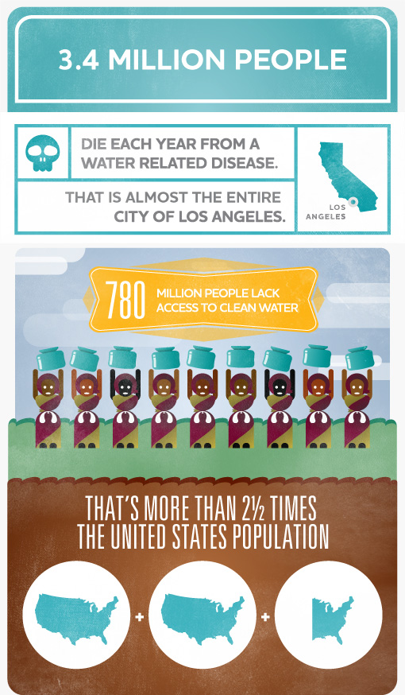

The Rule of 70 provides a quick and easy way to determine how long it will take for an amount to double at a given growth rate.

**Declining Death Rates and Increased Life Expectancies**

* The dramatic increase in Earth’s human population in the last 200 years has happened because death rates have declined more rapidly than birth rates.
* Death rates have declined mainly because more people now have access to adequate food, clean water, and safe sewage disposal.
* The discovery of vaccines in the 20th century also contributed to the declining death rates.
* Increased life expectancies can be attributed to better healthcare and preventative healthcare.

**Demographic Transitions**

* The **demographic transition** is the general pattern of demographic change from high birth and death rates to low birth and death rates, and observed in the history of more-developed countries.
* The theory behind the demographic transition is that industrial development causes economic and social progress that then affects population growth rates.
  1. In the first stage of the demographic transition, a society is in a **preindustrial condition**. The birth rate and the death rate are both at high levels and the population size is stable.
  2. In the second stage, **a population explosion occurs**. Death rates decline as hygiene, nutrition, and education improve. But, birth rates remain high, so the population grows very fast.
  3. In the third stage, **population growth slows because birth rate decreases**. As the birth rate becomes close to the death rate, the population size stabilizes. However, the population is much larger than before the demographic transition.
  4. In the fourth stage, **the birth rate drops below replacement level**, so the size of the population begins to decrease.
* It has taken from one to three generations for the demographic transition to occur.

