Brodnax
Human Population Growth Study Guide
- As of 2014, what are the 3 most populous countries (starting with the greatest)?
  - _________________________ b. _________________________ c. _________________________
- What was the agricultural revolution? ____________________________________________________________________________________________________________________________________________________________________________________________
  - How did it lead to population growth? ________________________________________________________________________________________
- What was the industrial revolution? ____________________________________________________________________________________________________________________________________________________________________________________________
  - How did it lead to population growth? ________________________________________________________________________________________
- Label this graph with the following terms: agricultural revolution, industrial revolution, bubonic plague (The Black Death)
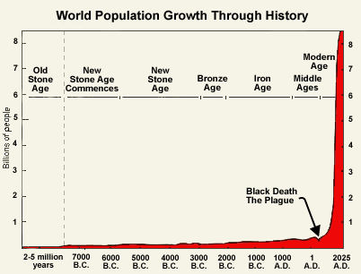

- Differentiate between developed and developing countries. ____________________________________________________________________________________________________________________________________________________________________________________________
- What is an age structure pyramid? ___________________________________________________________
  - What does it determine? ______________________________________________________________
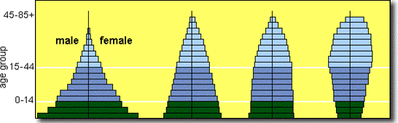

C
D
B
A

- Describe the future population growth of Population A. __________________________________________
  - List 2 countries that are currently experiencing this type of growth. _______________________________________________________________________________________
- Describe the future population growth of Population B. __________________________________________
  - List 2 countries that are currently experiencing this type of growth. _______________________________________________________________________________________
- Describe the future population growth of Population C. __________________________________________
  - List 2 countries that are currently experiencing this type of growth. _______________________________________________________________________________________
- Describe the future population growth of Population D. __________________________________________
  - List 2 countries that are currently experiencing this type of growth. _______________________________________________________________________________________
- List and describe the 3 types of Survivorship Curves:
  - Type I: ________________________________________________________________________________
  - Type II: _______________________________________________________________________________
  - Type III: ______________________________________________________________________________

MATCHING: Match the following definitions to the correct term.
- Crude birth rate
- Total Fertility Rate
- Immigration
- Doubling Time
- Infant Mortality Rate
- Crude Death Rate
- Population Growth Rate
- Emigration
- Replacement-level fertility
- ______ Moving into a population
- ______ Moving out of a population
- ______ # of babies per1000 to die before their 1st birthday
- ______ # of children a couple must have to replace themselves
- ______ 70 / % growth rate
- ______ # of births per 1000
- ______ # of deaths per 1000
- ______ (births + immigrants) – (deaths +emigrants) / Total Population X 100
- ______ # of children born to a woman in her lifetime
- In developed countries, what contributes to longer life expectancies and lower mortality rates? ____________________________________________________________________________________________________________________________________________________________________________________________
- What is the Demographic Transition Model? ______________________________________________________________________________________________
- Describe the 4 stages of the Demographic Transition Model:
  - Stage 1: _______________________________________________________________________________
  - Stage 2: _______________________________________________________________________________
  - Stage 3: _______________________________________________________________________________
  - Stage 4: _______________________________________________________________________________
- Draw and label a graph of the Demographic Transition Model:

- When will a graph of human population show a J curve? ______________________________________________________________________________________________
- When will a graph of human population show an S curve? ______________________________________________________________________________________________
- What factors contribute to families having fewer children? ______________________________________________________________________________________________
- In developing countries, why do families prefer to have many children? ______________________________________________________________________________________________
- What is a community’s infrastructure? _________________________________________________________
  - Rapidly growing populations place a lot of stress on the infrastructure. What are symptoms of overpopulation? _______________________________________________________________________
- What factors contribute to the emergence of new infectious diseases in an area? ______________________________________________________________________________________________
- Unsafe water is a major concern in developing regions. Give the cause and symptoms of each water-borne illness:
  - Dysentery: ________________________________________________________________________________________________________________________________________________________________________________
  - Typhoid fever: ________________________________________________________________________________________________________________________________________________________________________________
  - Cholera: ________________________________________________________________________________________________________________________________________________________________________________
- What is arable land? ______________________________________________________________________________________________
- What is urbanization? ______________________________________________________________________________________________
- What are some ways we can manage population growth? __________________________________________________________________________________________________________________________________________________________________________________________________________________________________________________________________________________________
- What did China do to manage their rapid population growth? ______________________________________________________________________________________________
  - How effective was this policy? ___________________________________________________________

