Brodnax
Human Population Growth Study Guide
- As of 2014, what are the 3 most populous countries (starting with the greatest)?
  - China b. India c. United States
- What was the agricultural revolution? long, transitional period from hunting/gathering to farming, which saw several periods of rapid increase in agricultural productivity and vast improvements in farm technology.
  - How did it lead to population growth?
o Plows, seed drills, machines that harvest crops, etc.
- What was the industrial revolution?
a period from the 18th to the 19th century where major changes in agriculture, manufacturing, mining, transport, and technology had a profound effect on the socioeconomic and cultural conditions starting in the United Kingdom, then subsequently spreading throughout Europe, North America, and eventually the world.
- How did it lead to population growth?
Incomes and population growth increased rapidly; standards of living improved drastically
- Label this graph with the following terms: agricultural revolution, industrial revolution, bubonic plague (The Black Death)
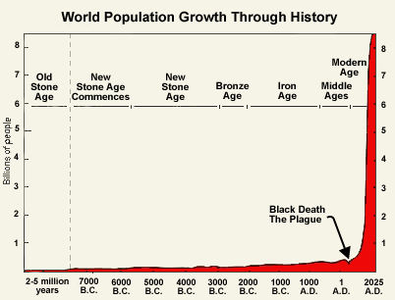

Agricultural Revolution-Human population around 3 Billion
Industrial Revolution- Human Population around 4.5-4 Billiom
Bubonic Plague- Arrow

- Differentiate between developed and developing countries.
• Developed countries have higher average incomes, slower population growth, diverse industrial economies, and stronger social support systems.
• Developing countries have lower average incomes, simple and agriculture-based economics, and rapid population growth.
- What is an age structure pyramid? Age Structure Pyramids show the distribution of males and females in different age groups of a specific population
  - What does it determine? Future Population growth
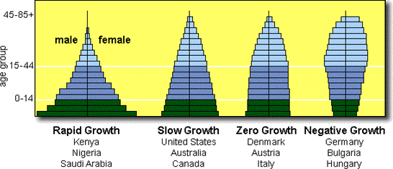

C
D
B
A

- Describe the future population growth of Population A. Rapid Growth (Future Growth)
  - List 2 countries that are currently experiencing this type of growth. Kenya, Nigeria, Saudi Arabia
- Describe the future population growth of Population B. Slow Growth
  - List 2 countries that are currently experiencing this type of growth. U.S., Australia, Canada
- Describe the future population growth of Population C. Zero Growth
  - List 2 countries that are currently experiencing this type of growth. Denmark, Austria, Italy
- Describe the future population growth of Population D. Negative Growth (Future Decline)
  - List 2 countries that are currently experiencing this type of growth. Germany, Bulgaria, Hungary
- List and describe the 3 types of Survivorship Curves:
  - Type I: Wealthy developed countries such as Japan and Germany currently have a Type I survivorship curve because most people live to be very old.
  - Type II: populations have a similar death rate at all ages.
  - Type III: survivorship is the pattern in very poor human populations in which many children die.

MATCHING: Match the following definitions to the correct term.
- Crude birth rate
- Total Fertility Rate
- Immigration
- Doubling Time
- Infant Mortality Rate
- Crude Death Rate
- Population Growth Rate
- Emigration
- Replacement-level fertility
- C Moving into a population
- H Moving out of a population
- E # of babies per1000 to die before their 1st birthday
- I # of children a couple must have to replace themselves
- D 70 / % growth rate
- A # of births per 1000
- F # of deaths per 1000
- G births + immigrants) – (deaths +emigrants) / Total Population X 100
- B # of children born to a woman in her lifetime
- In developed countries, what contributes to longer life expectancies and lower mortality rates?
Better healthcare and preventative care. Death rates have declined mainly because more people now have access to adequate food, clean water, and safe sewage disposal. The discovery of vaccines.
- What is the Demographic Transition Model?
The general pattern of demographic change from high birth and death rates to low birth and death rates, and observed in the history of more-developed countries.
- Describe the 4 stages of the Demographic Transition Model:
  - Stage 1: a society is in a preindustrial condition. The birth rate and the death rate are both at high levels and the population size is stable.
  - Stage 2: a population explosion occurs. Death rates decline as hygiene, nutrition, and education improve. But, birth rates remain high, so the population grows very fast.
  - Stage 3: population growth slows because birth rate decreases. As the birth rate becomes close to the death rate, the population size stabilizes. However, the population is much larger than before the demographic transition.
  - Stage 4: the birth rate drops below replacement level, so the size of the population begins to decrease.
- Draw and label a graph of the Demographic Transition Model:
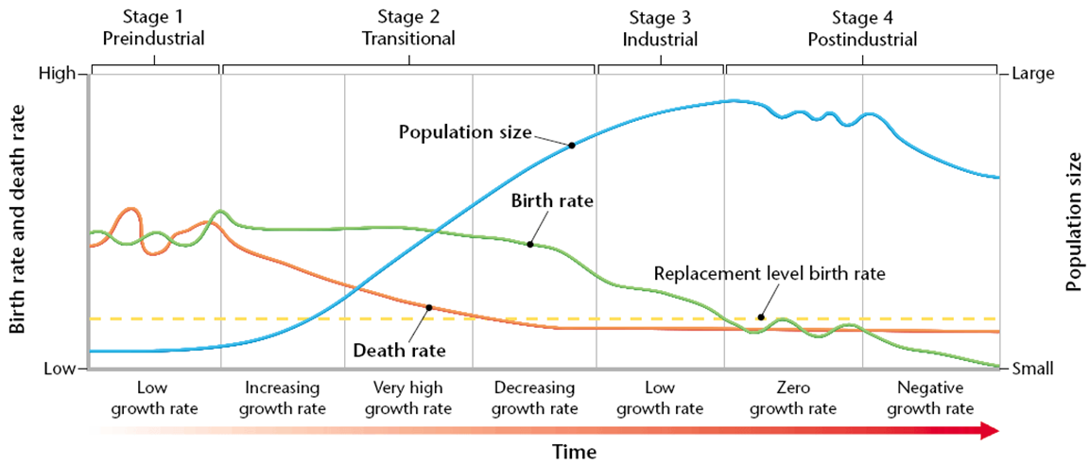

- When will a graph of human population show a J curve? When resources are abundant.
- When will a graph of human population show an S curve? When resources are limited.
- What factors contribute to families having fewer children? This often happens when a country modernizes. Health care improves and better medicine and sanitation reduce infant mortality. Known as Demographic Transition.
- In developing countries, why do families prefer to have many children? children can work and contribute to the family income from a young age
- What is a community’s infrastructure? the basic facilities of a country or region, such as roads, bridges, sewers, power plants, subways, schools, and hospitals.
  - Rapidly growing populations place a lot of stress on the infrastructure. What are symptoms of overpopulation? suburban sprawl, polluted rivers, barren land, inadequate housing, and overcrowded schools.
- What factors contribute to the emergence of new infectious diseases in an area? Lack of sanitation
- Unsafe water is a major concern in developing regions. Give the cause and symptoms of each water-borne illness:
  - Dysentery: diarrhea that contains blood; usually caused by microscopic organisms like E. coli, Salmonella enterica, and the amoeba Entamoeba histolytica
  - Typhoid fever: caused by Salmonella typhi; symptoms include fever, diarrhea or constipation, distended abdomen, weight loss, etc.
  - Cholera: an infection of the small intestine that causes a large amount of watery diarrhea; caused by the bacterium Vibrio cholerae
- What is arable land? farmland that can be used to grow crops.
- What is urbanization? an increase in the ratio or density of people living in urban areas rather than in rural areas.
- What are some ways we can manage population growth? public advertising, family planning programs, economic incentives, or legal punishment. A big part has been improvements in women’s status.
- What did China do to manage their rapid population growth? Introduced The One Child Policy
  - How effective was this policy? Prevented up to 400 million births.

