Cycles of Matter Notes

Matter, in the form of nutrients, cycles within and among ecosystems and the biosphere, and human activities are altering these chemical cycles.

6 essential elements on earth: SPONCH
The compounds that make up nutrients move continually through air, water, soil, rock, and living organisms in the biosphere in cycles are called biogeochemical cycles.
The 4 main biogeochemical cycles include the hydrologic (water), carbon, nitrogen, phosphorus, and sulfur cycles.
As nutrients move through these cycles, they may accumulate in temporary storage sites called reservoirs (lakes, oceans, underground, etc.).
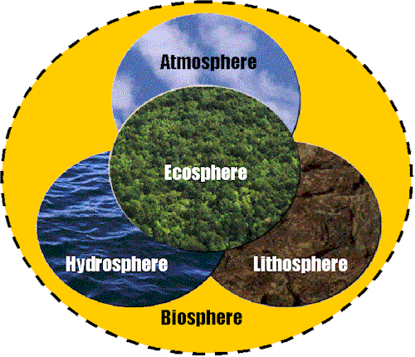

The hydrologic, or water cycle, collects, purifies, and distributes the earth’s fixed supply of water.
The water cycle is powered by the sun.
4 major processes:
- Evaporation: changes liquid water into water vapor (gas form) in the atmosphere
- Precipitation: gravity draws the water back to the earth’s surface as precipitation (rain, snow, sleet, or dew)
- Transpiration: water that evaporated from the surfaces of plants
- Condensation: where water changes from the gas phase back to the liquid phase in the clouds
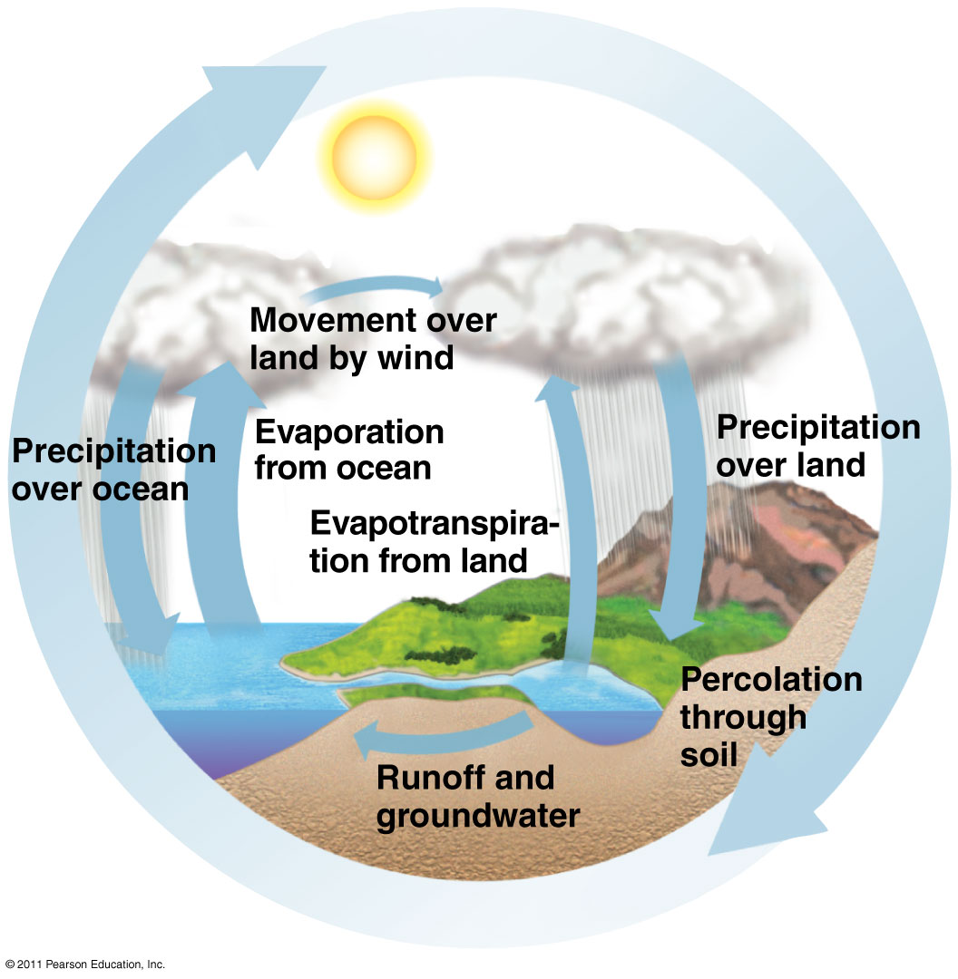
Water song

Carbon is the basic building block of carbohydrates, fats, proteins, DNA, and other organic compounds necessary for life.
The carbon cycle depends on photosynthesis and aerobic respiration by earth’s living organisms.
The carbon cycle is based on carbon dioxide (CO₂) gas, a key component of earth’s thermostat.
- Too much CO₂ and the earth warms up
- Not enough CO₂ and the earth cools down
Terrestrial producers remove CO₂ from the atmosphere and aquatic producers remove it from the water. These producers use photosynthesis to convert the CO₂ into their food source, glucose (C₆H₁₂O₂) and give off oxygen.
Consumers and decomposers carry out aerobic respiration which breaks down glucose and converts the carbon back to CO₂ for reuse by producers.
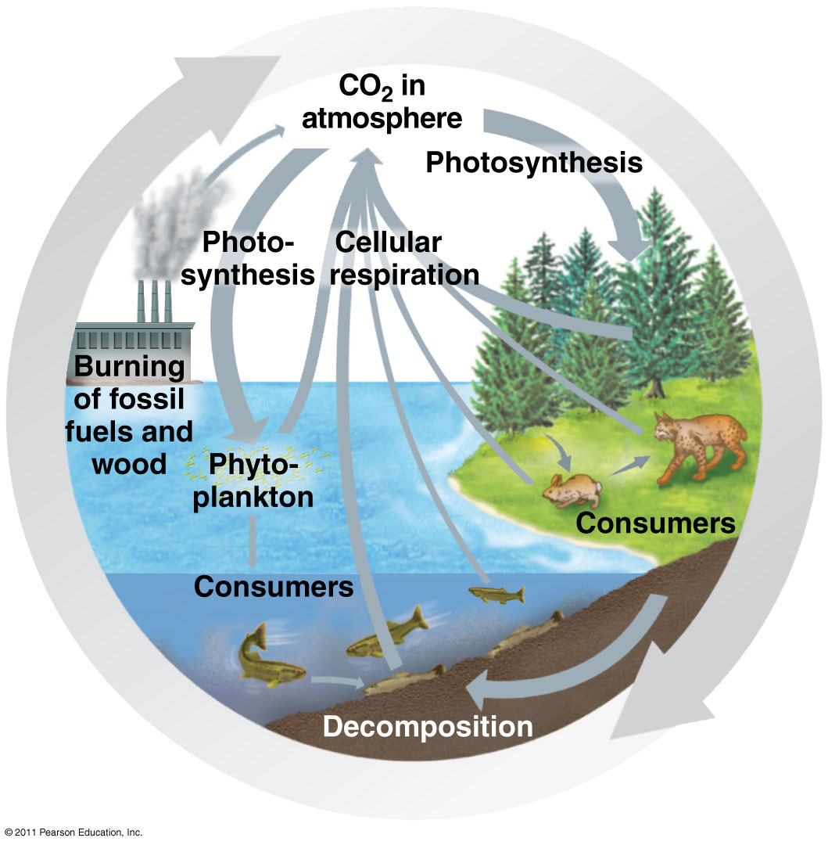

Video
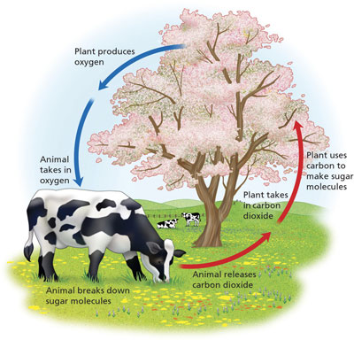



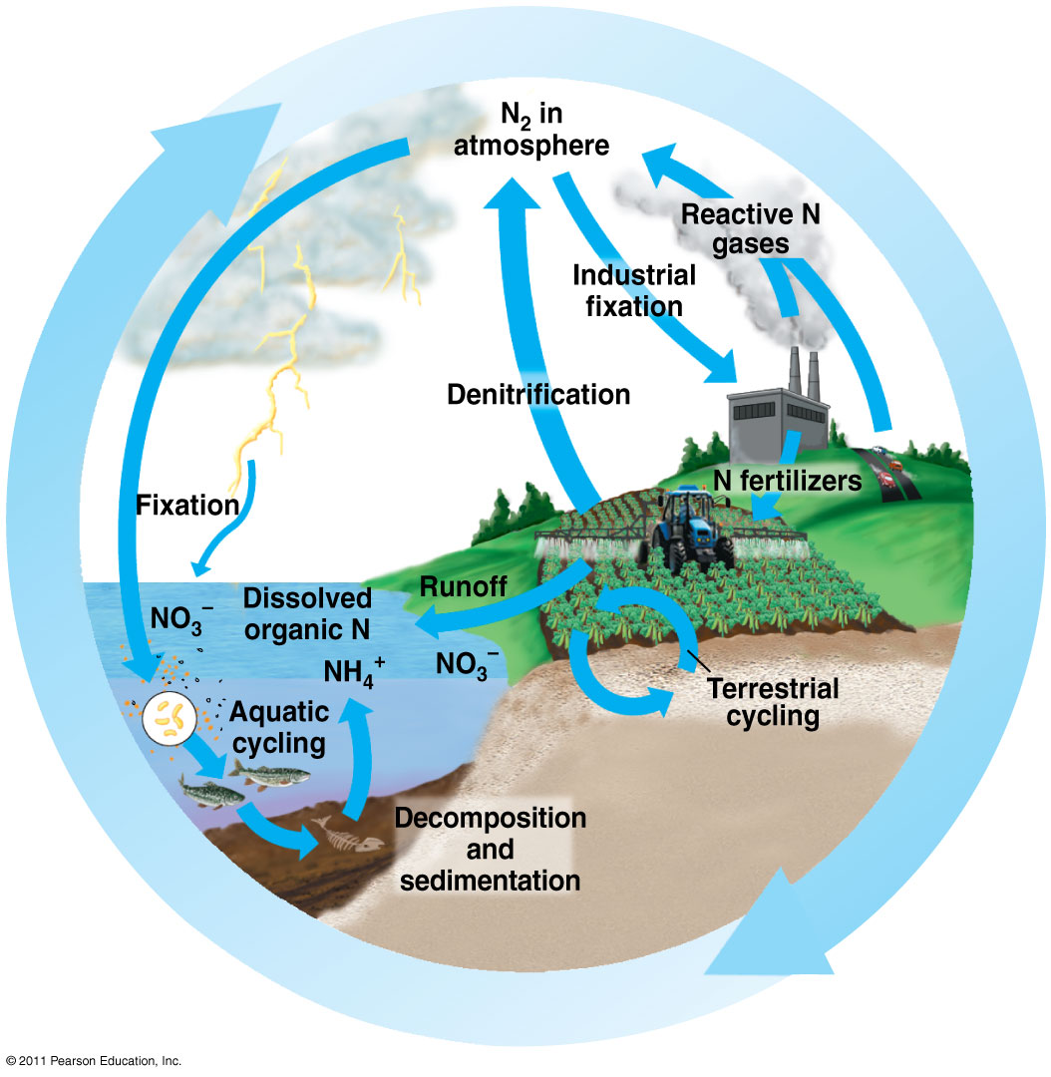
Nitrogen is a crucial component in proteins, many vitamins, and DNA.
N₂ is the chemically unreactive nitrogen gas that makes up about 78% of the atmosphere. However, plants and animals cannot use N₂ directly.
2 Processes that can convert N₂ into useable forms:
- Lightning in the atmosphere
- Nitrogen-fixation by bacteria in the soil, aquatic systems and in the roots of some plants
In nitrogen-fixation, specialized bacteria in the soil and cyanobacteria in aquatic systems combine N₂ with hydrogen to make ammonia, NH₃. The bacteria use some of the ammonia and excrete the rest to their environment where plants can take it up.
Soil bacteria can also convert the NH₃ and NH₄+ to nitrate ions, NO₃-, which are easily taken up by plants and used to produce amino acids, nucleic acids and vitamins. Animals that eat plants consume these nitrogen compounds for use in their own bodies.
Plants and animals return nitrogen-rich compounds to the earth as wastes and through their bodies when they die.
In denitrification, bacteria in waterlogged soil (in sediments of lakes, oceans, bogs and swamps) convert the NH₃ and NH₄+ back into nitrate and nitrite ions and then back into N₂ gas that are released back into the atmosphere to begin the cycle again.
Video

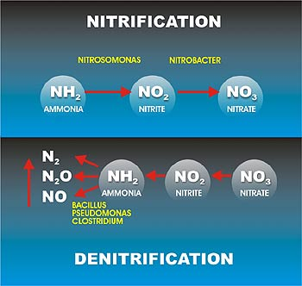

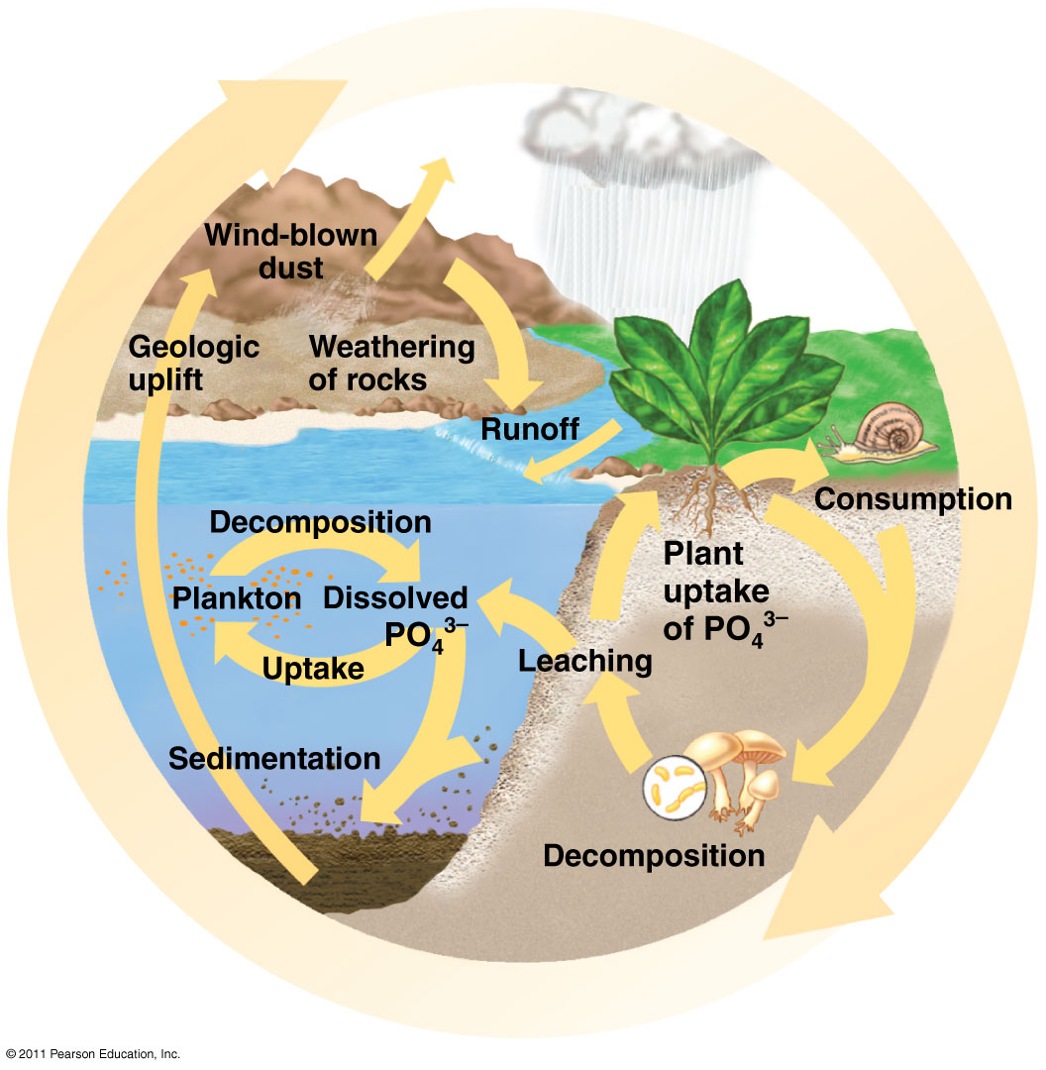
Phosphorus is a component of nucleic acids, energy transferring molecules like ADP and ATP, and in vertebrate bones and teeth.
Phosphorus cycles through water, the earth’s crust and living organisms but is NOT found in the atmosphere.
Found in the ground and then taken up by plants and animals.
Phosphorus starts its existence as phosphate ions (PO₄) in the rocks of the world.
When it rains, the phosphates and other minerals are removed from the rocks and distributed in soils and water all over the planet.

Video clip

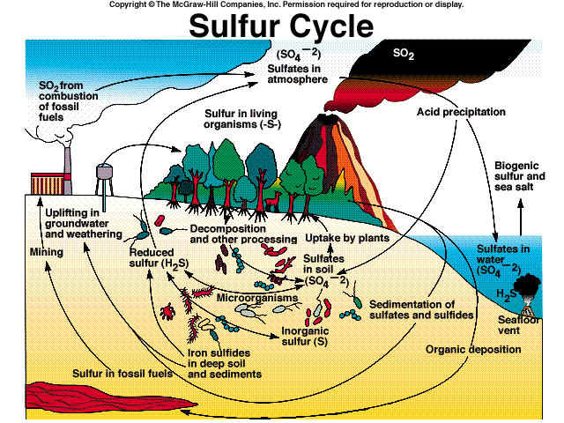

Much of the earth’s sulfur is stored underground in rocks and minerals, including sulfate (SO₄²-) salts buried deep under ocean sediments.
Volcanoes release hydrogen sulfide (H₂S) and sulfur dioxide (SO₂) gas into the atmosphere.
Plant roots absorb sulfate ions and use them to make proteins.

Video Clip
Brodnax

