Alternative Energy Sources Concept Map
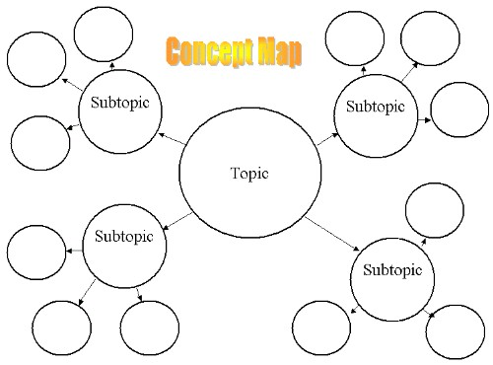
Create a concept map (like the one the picture) describing the 5 main types of alternative energy sources: solar, wind, geothermal, biofuels, and hydrogen fuel cells. Make sure to include the following information for each type:
- Description of the energy source
- How it is obtained
- What is it best used for?
- Relevant statistics or facts
- A few advantages and disadvantages
- An illustration with labels

- Please make the map neat and professional looking. Add color to make it more appealing to look at.

