Air Test Study Guide
Brodnax
Name: __________________________________ Class: _____ Date: _________________
Air Quality and Pollution

Key Terms: Define and/or illustrate each term.
acid deposition- the falling of acidic compounds (pH < 5.6) from the atmosphere to the earth’s surface
air pollution- the presence of chemicals in the atmosphere in concentrations high enough to harm organisms, ecosystems, or human-made materials
atmospheric pressure- the pressure exerted by the weight of the atmosphere
carbon oxides- produced from fossil fuels burning
density- mass per volume
grasshopper effect- Occurs when volatile air pollutants are transported by evaporation and winds from tropical and temperate areas through the atmosphere to the earth’s polar areas, where they are deposited. This happens mainly in winter.
industrial smog- consists of sulfur dioxide, droplets of sulfuric acid, and suspended solid particles. This smog is “gray smog.”
nitrogen oxides- produced from coal burning, part of acid rain
nitric acid- can cause asthma and bronchitis
ozone- O₃
ozone layer- filters UV radiation
particulates- any particle in the air
photochemical smog- Exhaust from morning vehicles release large amounts of NO and VOCs into the air of a city. NO is converted to NO2. When exposed to UV rays from the sun, the NO2 reacts in complex ways with VOCs. The resulting smog is a chemical brew called photochemical oxidants because they can oxidize certain compounds in the atmosphere and in your lungs.
primary pollutants- harmful chemicals emitted directly into the air from natural processes & human activities
secondary pollutants- new harmful chemicals that are formed once IN the atmosphere when primary pollutants react with one another and with the basic components of air
stratosphere- Is our global sunscreen, Similar composition to the troposphere, with 2 exceptions, Much less water, Contains the ozone layer, which filters UV radiation
sulfur dioxide- cause of acid rain
sulfuric acid- produced from volcanic gases
temperature inversion- Under certain atmospheric conditions, a layer of warm air can temporarily lie atop a layer of cooler air nearer the ground
troposphere- 75–80% of the earth’s air mass, Closet to the earth's surface, Chemical composition of air, Rising and falling air currents: weather and climate, Involved in chemical cycling
volatile organic compounds (VOCs)- Methane emissions from plants, wetlands and termites

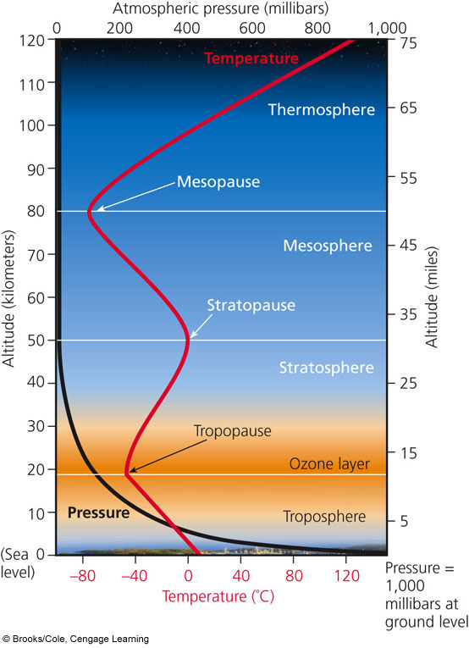
- Fill in the layers of the atmosphere to the right.
Thermosphere
- Which layer determines our weather and climate?
Troposphere
- Which layer contains our natural sunscreen?
Stratosphere
Stratosphere
- The air we breathe is 78% Nitrogen and 21% Oxygen.
Mesosphere
- Air pollution is the presence of chemicals in the atmosphere in concentrations high enough to harm organisms, ecosystems, or human-made materials.
Troposphere

- Fill in the chart below about air pollution sources:
Natural Sources | Sources of Air Pollution | Human Sources
-dust blown by wind - Pollutants from wildfires &volcanoes  -Volatile Organic Compounds (VOCs) released by plants |  | -most are generated by burning coal in industrial plants (stationary source) and cars (mobile source).

- If there are more factories and cars in urban areas, why do rural areas still have to deal with some primary and secondary pollutants? Wind blows the pollutants

- Fill in the chart below about the types of air pollutants:
Primary Pollutants | Categories of Air Pollution | Secondary Pollutants
-harmful chemicals emitted directly into the air from natural processes and human activity |  | -happens when primary pollutants react with each other and form new harmful chemicals

- Fill in the chart about the major outdoor air pollutants:
Pollutant  “Name” | Natural Sources | Human Sources | Human Health Impact | Environmental Impact
Carbon Monoxide | Burning of forests and grasslands | Auto exhaust, tobacco smoke, inefficient stoves/heaters | Reacts with hemoglobin and reduces oxygen transport; headache, nausea, drowsiness, coma, death | Contributes to smog and ground-level ozone
Carbon Dioxide | Animal respiration | Burning fossil fuels, cutting down forests | Dizziness, headaches, unconsciousness | Global warming and climate change
Nitrogen Compounds | Lightening, soil bacteria | Auto engines, coal-burning plants | Irritation to the eyes, nose and throat; cause asthma and bronchitis | Suppress plant growth and reduce visibility
Sulfur Compounds | Volcanic gases | Industrial power plants, oil refining | Respiratory and cardiovascular illness | Precursor to acid rain, which damages lakes, rivers and trees
Particulates | Dust, wildfires, sea salt | Coal-burning power, industrial plants, motor vehicles, plowed fields, road construction, tobacco smoke, etc. | Irritate nose and throat, damage lungs, aggravate asthma and bronchitis, shorten lifespan, cause mutations, reproductive problems and cancer | Reduce visibility, corrode metals, discolor clothes and paints
Ozone (O₃) | Formed from reaction of nitrogen oxides and VOCs | Good ozone is in the stratosphere. Bad ozone is the troposphere. Human activities are decreasing the good and increasing the bad ozone. | Aggravate lungs and heart, irritate eyes, nose and throat, coughing, breathing problems | Smog precursor, reduce crop production and forest growth, damage plants
VOCs  (Volatile Organic Chemicals) | Methane emissions from plants, wetlands and termites | Methane: Landfills, rice paddies, cow belching, Other VOCs: industrial solvents, dry cleaning liquids, gas, plastics, rubber, etc. | Eye and skin irritation, nausea, headaches, cancer, blood disorders, immune damage | Smog precursor

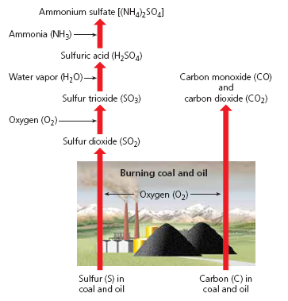
- Burning coal produces sulfur dioxide
- This is industrial smog -colored smog.
- When coal and oil are burned:
  - Carbon is converted to carbon dioxide and carbon monoxide.
  - Sulfur reacts with O₂ to produce sulfur dioxide.
  - Some of the SO₂ reacts with O₂ to produce sulfur trioxide.
  - Some of the SO₃ reacts with water vapor to produce sulfuric acid.
  - Some of the H₂SO₄ reacts with ammonia to form solid ammonium sulfate.

- All of these chemicals and particulates give smog the gray color.

- China has the highest levels of industrial smog.
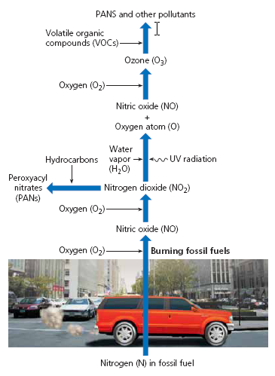
- Sunlight plus NO and VOCs equals Photochemical Smog.

- This is brown-colored smog.
- Hotter days lead to higher levels of O_{3.}

- Chemical composition: VOCs + NO₂ + Heat + Sunlight
  - Which yields:
    - Ground level O₃ and other photochemical oxidants
    - Aldehydes
    - Other secondary pollutants

- Fill in the chart about outdoor air pollution.
DECREASE Air Pollution | Natural Factors That Influence Outdoor Air Pollution | INCREASE Air Pollution
1. Particles more dense than air settle due to gravity  2. Rain and snow cleansethe air of pollutants  3. Salty sea spray from oceans wash out pollutants from air that flows over the ocean  4.Winds sweep pollutants away, diluting it with cleaner air  5. Some pollutants are removed by  Chemical reactions |  | 1. Urban buildings can slow wind speed and reduce dilution of pollutants  2. Hills and mountains reduce flow of air in valleys so pollutants build up at ground level  3. High temperatures promote photochemical smog  4. Emissions of VOCs from certain trees and plants helps form photochemical smog  5. Grasshopper Effect- air pollutants are transported by evaporation and winds to the cooler regions  6. Temperature Inversion

- Explain and illustrate a temperature inversion.

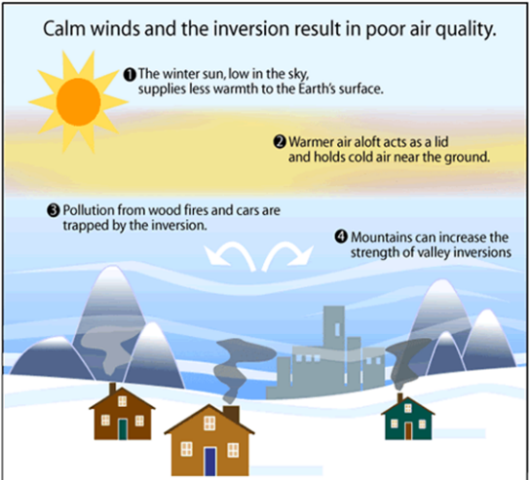
Temperature inversions can cause pollutants to accumulate in high levels.
During the day, the sun warms the air near the earth’s surface. Normally, this warm air and most of the pollutants it contains rise to mix and disperse with the cooler air above it. Under certain atmospheric conditions, a layer of warm air can temporarily lie atop a layer of cooler air nearer the ground. This is called a temperature inversion.
Because the cooler air is denser than the warmer air above it, the air near the surface does not rise and mix with the air above. This allows pollutants to build up in the stagnant layer of cool air near the ground.

- Explain and illustrate the grasshopper effect.
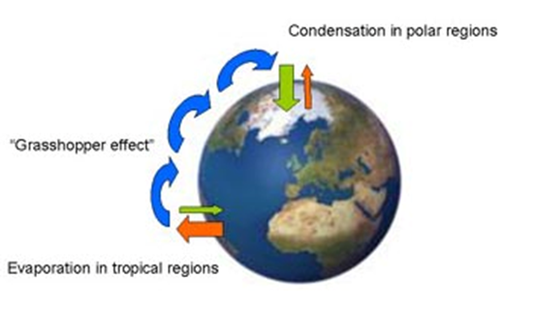

Occurs when volatile air pollutants are transported by evaporation and winds from tropical and temperate areas through the atmosphere to the earth’s polar areas, where they are deposited. This happens mainly in winter.

- Explain why arctic polar bears, sharks and other top carnivores in the Polar Regions have high levels of toxic pollutants in their bodies.
Occurs when volatile air pollutants are transported by evaporation and winds from tropical and temperate areas through the atmosphere to the earth’s polar areas, where they are deposited. This happens mainly in winter.

- What is acid deposition?
the falling of acidic compounds (pH < 5.6) from the atmosphere to the earth’s surface
- Differentiate between wet acid deposition and dry acid deposition.
➢ Acid rain refers to the wet deposition consisting of acid rain, snow, fog and cloud vapor
Occurs within 4-14 days in distant, downwind areas from the emission source
➢ Dry deposition consists of dry acidic particles
Occurs within 2-3 days near the emission sources
- How does acid rain form?
Acid rain is caused by a chemical reaction that begins when compounds like sulfur dioxide and nitrogen oxides are released into the air (from coal-burning power plants, industrial plants, and vehicle emissions).
- The primary pollutants (sulfur dioxide and nitrogen oxides) emitted high into the troposphere may be transported as far as 1,000 kilometers (600 miles) by prevailing winds.

- List the harmful effects of acid deposition:
Harmful Effects of Acid Deposition
- respiratory disease
- damages statues, monuments, buildings, metals, car finishes
- makes some aquatic ecosystems too acidic- most fish can’t live below a pH of 4.5
- harm trees and crops if soil pH is below 5.1
- affects forests by leaching essential plant nutrients (calcium and magnesium) from soils and releasing aluminum, lead, and mercury which are toxic to trees- weakens the trees; mountain top trees are the hardest hit

- Give solutions to acid deposition:
SOLUTIONS TO ACID DEPOSITION
Prevention | Clean Up
- Reduce coal use  - Increase use of renewable energy sources  - Remove SO₂ and NO from smokestack gases  - Remove NO from vehicular exhaust  - Tax emissions of SO₂ | - Add lime to neutralize acidified lakes  - Add phosphate fertilizer to neutralize acidified lakes

- Indoor air pollution is most threatening to people of developing countries that practice indoor burning of wood dung, charcoal, crop residues and coal in poorly ventilated areas.

- Why is indoor air pollution greater than outdoor air pollution in developed countries?
1. 11 of the common air pollutants are higher inside than outside
2. Greater in vehicles than outside
3. Health risks magnified: people spend 70–98% of their time indoors

- Fill in the chart about indoor air pollutants:
Indoor Pollutant | Sources | Human Health Risks
Tobacco Smoke | Smoking | Lung cancer, respiratory ailments, heart disease
Formaldehyde | Furniture stuffing, paneling, particleboard, foam insulation | Irritation of eyes, throat, skin & lungs; nausea; dizziness
Radioactive Radon-222 gas | Underground rock deposits (seeps in through cracks in foundation or walls) | Lung Cancer
Very Small Particles | Pollen, pet dander, dust mites, cooking particles, fungal spores | Irritated lungs, asthma, itchy eyes, runny nose, lung disease

- How can your body protect you from air pollutants?
✓ Nose hairs filter out large particles
✓ Sticky mucus lining your upper respiratory tract captures small particles; coughing and sneezing expels the particles
✓ Cilia also lines your upper respiratory tract and traps particles; sends trapped particles to your throat where they are swallowed or expelled

- The World Health Organization (WHO) estimates that 3 million people die each year due to the effects of air pollution. 73% of those deaths are due to indoor air pollution.

- EPA has established the 6 outdoor criteria air pollutants:
CO, NOX, SO2, SPM, O3, Pb

- Fill in the chart about air pollution solutions:
Outdoor | Air Pollution Solutions | Indoor
- Emissions Trading (aka:  Cap-and-trade) allows major “polluters” to sell emissions allotments to help reduce SO₂ emissions  - Burn low sulfur coal  - Disperse emissions above thermal inversion layer with tall smokestacks.  - Use mass transit  - Give large tax breaks for those who buy low polluting vehicles  - Inspect car exhaust systems throughout the year  - Rely more on low polluting energy sources  - Improve energy efficiency |  | - Ban smoking indoors  - Stricter formaldehyde emissions from carpet and furniture companies  - Use office machines in well ventilated areas  - Less polluting cleaning supplies  - Circulate buildings air through rooftop greenhouses  - Use exhaust hoods for stoves  - Distribute cheap, efficient stoves or solar cooker to developing countries  - Develop cheap test for indoor air pollutants  - CO detectors

Climate Change and Ozone Depletion
Key Terms: Define and/or illustrate each term.
Greenhouse gas –the ones that get hot. Water vapor, carbon dioxide, ozone, methane, nitrous oxide, CFCs
Greenhouse effect- natural heating of the earth. Good.
Kyoto Protocol-(1997 International Treaty)
▪ Goal- to reduce emissions of CO2, CH4, and N2O by 2012 to levels of 1990
▪ Trading greenhouse gas emissions among countries
▪ Not signed by the U.S.
• President G.W. Bush’s reasons
• It would hurt the economy
• Did not require reductions in China, India, Brazil or Indonesia
• However, a majority of Americans feel we should have signed
▪ In 2005, countries began negotiating the second phase that is supposed to go into effect after 2012.
▪ Australia signed up for the second phase of the Kyoto Protocol that would require reducing greenhouse gas emissions to 5% below year 2000 levels by 2020.
Renewable energy- energy generated from natural resources
Carbon capture and storage (CCS)- process of trapping carbon dioxide or other chemicals produced by burning fossil fuels and storing it in such a way it is unable to affect the atmosphere.
Global warming- unnatural heating of the earth. Bad.
Ozone depletion- Measurements reveal thinning of the ozone everywhere except for the tropics with the most loss over Antarctica and the Arctic. The depletion varies with altitude, location and season.
CFC’s- Chemically unreactive, odorless, nonflammable, nontoxic, noncorrosive compounds that were used in refrigerants (AC/fridge) and as propellants in aerosol cans

- Explain and illustrate the natural greenhouse effect.

Natural warming of the Earth due to the greenhouse gases.

- Since the Industrial Revolution, CO2, CH4, and N2O emissions are higher.
  - Main sources include: agriculture, deforestation, and burning of fossil fuels

- How do scientists estimate past atmospheric conditions like temperature and levels of CO₂?
Use of ice core samples

- Fill in the chart about climate change:
Evidence that Supports Climate Change: | Evidence For and Against Climate Change | Arguments Against Climate Change (look it up):
- Between 1906-2000, average global surface temp has increased by 0.74˚C.
- Greenhouse gas emissions has risen 70% since 1970
- Arctic temps have risen twice as fast in the past 50 years
- Glaciers and floating sea ice are melting
- Rainfall patterns are changing
- Sea level has risen by 4-8 inches

- Fill in the table about possible effects of global warming:
Event | Effect
Ice and snow melting | Increase in Ice and Snow Melting
Sea levels rising | Increase in Sea level
Ocean currents changing | Temperature causes air pressure and currents to change
Extreme weather | Increased extreme weather due to air pressure change
Threats to biodiversity | Decrease in Biodiversity
Agriculture | Decrease in agriculture due to increased drought
Health | Increased Health Risk

- Of the 15 Climate Stabilization Wedges, list 2 from each category:
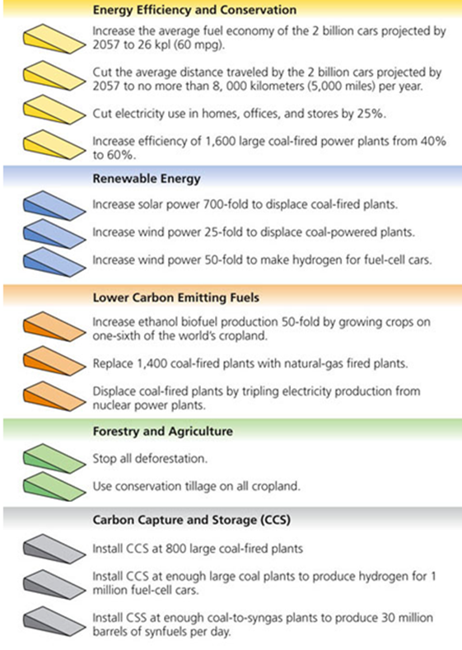
- What can the government do to slow climate change?
Enter into international climate negotiations
- What was the goal of the Kyoto Protocol?
To reduce emissions of CO2, CH4, and N2O by 2012 to levels of 1990
- How have we depleted ozone in the stratosphere?
Widespread use of certain chemicals has reduced ozone levels in the stratosphere, which allows for more harmful ultraviolet radiation to reach the earth’s surface.
- List 3 ozone-depleting chemicals.
▪ Chlorofluorocarbons: CFCs (Freon’s)
• Chemically unreactive, odorless, nonflammable, nontoxic, noncorrosive compounds that were used in refrigerants (AC/fridge) and as propellants in aerosol cans
▪ Halons & Hydrobromoflurocarbons (HBFCs) – fire extinguishers
▪ Methyl Bromide (fumigant)
▪ Hydrogen Chloride (space shuttle)
▪ Cleaning solvents: carbon tetrachloride, etc…
- What are possible harmful effects of lower ozone levels?
Increasing damaging UV levels

- How do UV rays cause skin cancer?
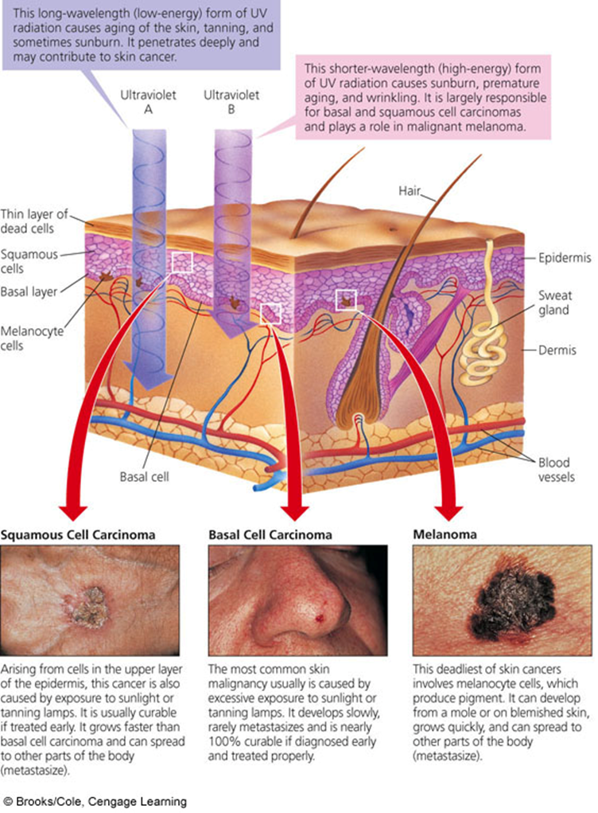

- How can we reverse ozone depletion?
▪ Stop producing all ozone-depleting chemicals
▪ 60–100 years of recovery of the O3 layer

- What can YOU do to reduce your UV exposure?
