Brodnax

**Agriculture Notes**

Give a person a fish, and you feed him for a day. Teach that person to fish, and you can feed him for a lifetime. –Ancient Chinese Proverb

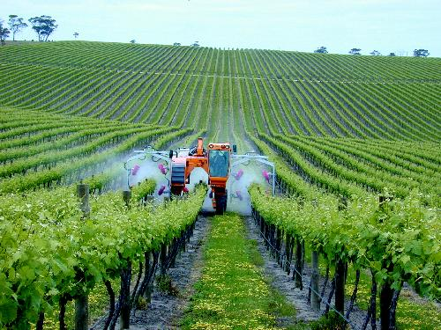

**The challenge of agriculture is to feed the world and preserve our biosphere.**

Currently, 3 systems supply most of our food:

1. **Croplands**- produce mostly grains; provides 77% of the world’s food using 11% of its land area
2. **Rangelands, pastures, and feedlots**- produce meat; provides 16% of the world’s food using about 29% of the world’s land area
3. **Ocean fisheries and aquaculture**- provides 7% of the world’s food
   1. **Aquaculture**: breeding, rearing and harvesting plants and animals in all types of water environments such as ponds, rivers, lakes, ocean or manmade tanks.

Of the 50,000 plant species that are edible by humans, only 14 of them supply about 90% of the world’s food calories.

2/3 of all humans survive primarily on three grains: wheat, rice and corn.

This food specialization puts humans in a vulnerable position. At any time, these species could succumb to disease or climate change.

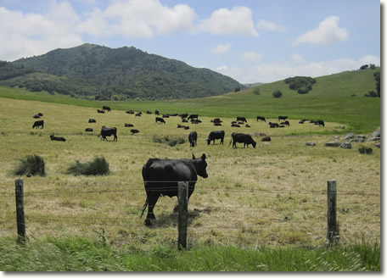

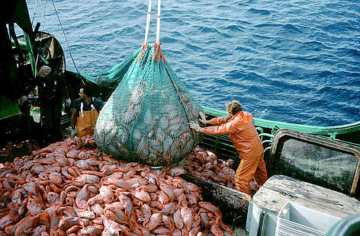

Since 1960, there has been a staggering increase in global food production because of technological advances such as…

* Tractors and farming machinery
* High-tech fishing equipment
* Chemical fertilizers
* Irrigation systems
* Pesticides
* High-yield grain varieties
* Factory farming of livestock

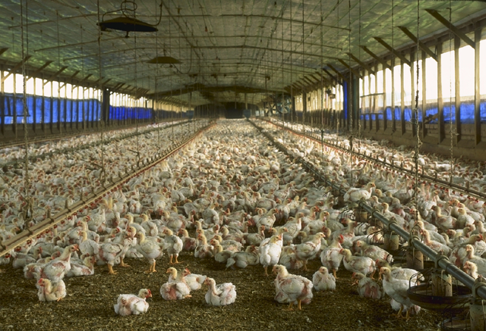

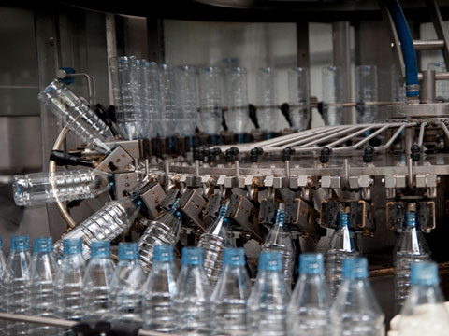

[**Video clip**](http://www.youtube.com/watch?v=kipdLxzTw4g)

Agriculture used to grow crops can be divided into two main types: industrialized agriculture and subsistence agriculture.

* **Industrialized agriculture:** used heavy equipment, large amounts of financial capital, fossil fuel, water, commercial fertilizers, and pesticides to produce **monocultures** (single crops).
  + Goal is to steadily increase crop yield (amount of food produced per unit of land)
  + Produces about 80% of the world’s food
  + Since monocultures have less biodiversity, they are more susceptible to disease and pest infestations
  + **Plantation agriculture**: form of industrialized agriculture used in tropical developing countries to grow cash crops such as bananas, soybeans (mostly to feed livestock), sugarcane, coffee, palm oil (used for cooking and to produce biodiesel fuel), and vegetables
* **Subsistence agriculture**: uses mostly human labor to produce enough crops for a farm family’s survival with little leftover for storage or to sell.
  + Many farmers choose to grow several crops on the same land simultaneously (polyculture).
  + These polyculture plots are less susceptible to pests and disease.
  + **Slash-and-burn** **agriculture**: involves burning and clearing small plots in tropical forests, growing a variety of crops for a few years until the soil is depleted of nutrients and then shifting to other plots.
    - It takes between 10-30 years for the soil to become fertile enough for crops again

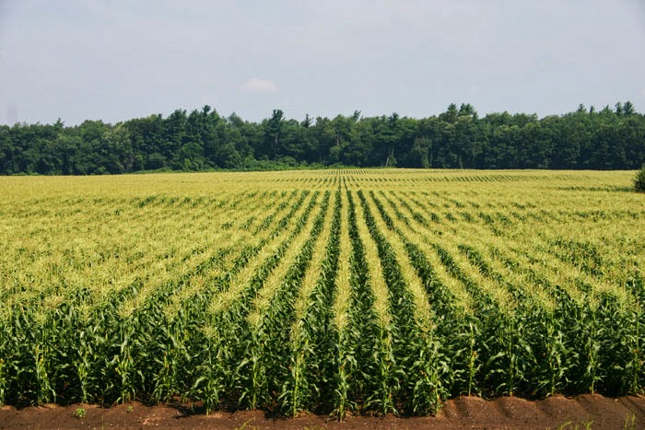

**Monoculture of corn**

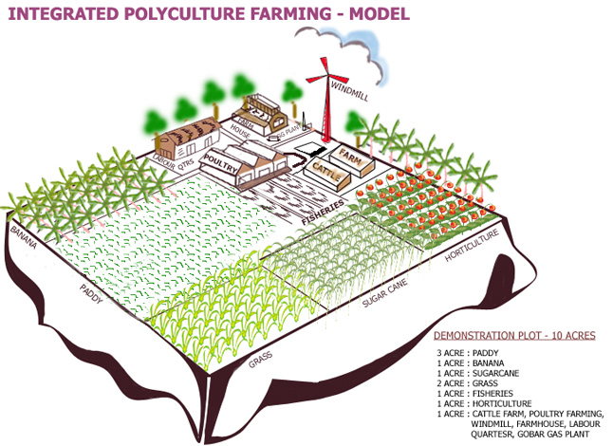

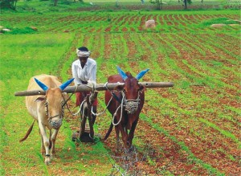

**Subsistence Agriculture**

[Subsistence Living Clip](http://channel.nationalgeographic.com/channel/life-below-zero/videos/life-below-zero-subsistence-living/)

**No-till Farming**: growing crops   
from year to year without disturbing the soil through tillage. No-till leaves the residues from the prior crop on the soil surface, rather than burying them with tillage.

* Increases amount of water infiltrating the soil
* Reduces water run-off
* Decreases soil erosion
* Reduces fuel usage of machinery

**Strip-cropping**: alternating crop rows between heavy-rooted plants and loosely-rooted plants

* Reduces erosion
* Reduces fuel usage of machinery
* Increases in crop yield
* Allows for crop rotation

Between 1950 and 1970, the first green revolution dramatically increased crop yields in most developed countries, especially the US.

The **second green revolution** has been occurring since 1967. Fast-growing dwarf varieties of rice and wheat, specially bred for tropical and subtropical climates, have been introduced into China and India. Producing more food on less land protects biodiversity by saving large areas of forests, grasslands, wetlands, and mountain terrain from being used to grow crops.

**World grain production tripled between 1950 and 1996 mostly because of the two green revolutions.**

**The Green Revolutions**

**First Green Revolution**: using high-input industrialized agriculture to increase yields in 3 steps:

1. Develop and plant monocultures of selectively-bred or genetically engineered high-yield varieties of key crops such as rice, wheat and corn.
2. Produce high yields by using large inputs of fertilizers, pesticides and water.
3. Increase the number of crops grown per year on a plot of land through multi-cropping (a form of polyculture where 2 or more crops are grown in the same space during a single growing season—usually one is harvested and then the second is planted)

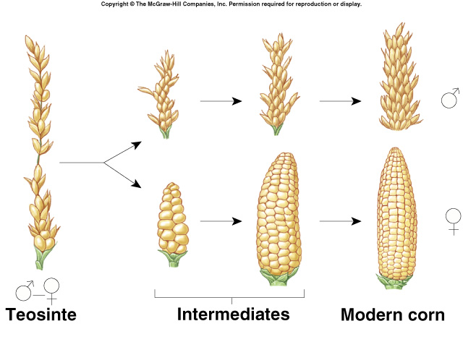

Maize was bred from an unfamiliar tall grass-like plant called Teosinte. Larger and fuller kernels were selected for in order for the crop to be a more effective food source.

**The Gene Revolutions**

**The First Gene Revolution**

For centuries, farmers and scientists have used cross-breeding through artificial selection to produce genetically improved varieties of crops and livestock.

* Slow process- usually takes 10-15 years to produce a commercially valuable new variety
* Traits can only be combined from genetically similar species
* The new varieties are useful for 5-10 years until pests and diseases reduce their effectiveness

**Dairy farmers selectively breed their cattle to produce more milk.**

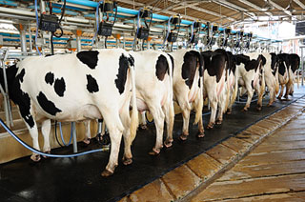

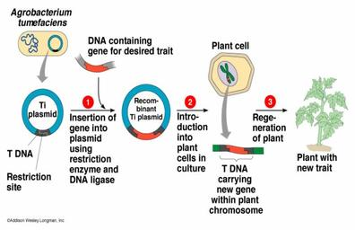

**The Second Gene Revolution**

In the 21st century, scientists started using genetic engineering to develop genetically improved strains of crops and livestock. It involves altering an organism’s genetic material through adding, deleting, or changing segments of its DNA to produce desirable traits or eliminate undesirable ones.

* Scientists can transfer genes between species that never would have interbred in nature
* The organisms are called genetically modified organisms (GMO’s) or transgenic organisms)
* Crops can be developed that are resistant to cold, heat, pests, parasites, diseases, drought, and salty or acidic soil.

Future goals are to produce crops that need very little irrigation, grow faster, and need little to no fertilizers or pesticides.

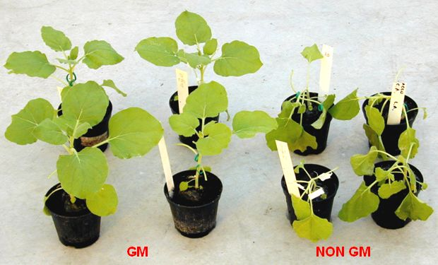

**GMO** [**Video**](http://www.foxnews.com/health/2013/07/14/gmos-researchers-debate-healthy-safety-genetically-modified-foods/)

Food production in the future may be limited by serious environmental impacts including soil erosion and degradation, desertification, water and air pollution, greenhouse gas emissions, and biodiversity reduction.

**Harmful effects of food production**

According to the US Environmental Protection Agency (EPA), agriculture is responsible for ¾ of the water quality problems in US rivers and streams.

30% of the world’s cropland has been degraded by soil erosion, salt buildup and chemical pollution.

