Environmental Science Agriculture Test Study Guide

Agriculture
1. What are the 3 main systems that provide most of our food? Explain each.
1. Croplands- produce mostly grains; provides 77% of the world’s food using 11% of its land area
2. Rangelands, pastures, and feedlots- produce meat; provides 16% of the world’s food using about 29% of the world’s land area
3. Ocean fisheries and aquaculture- provides 7% of the world’s food
a. Aquaculture: breeding, rearing and harvesting plants and animals in all types of water environments such as ponds, rivers, lakes, ocean or manmade tanks.
2. What is factory farming and what are characteristics of factory farming?
A large, industrial operation that raises large numbers of animals for food.
- Cattle fed with corn
- Increased cases of disease
- Cattle almost constantly in manure
- Confined spaces
3. What is industrialized agriculture?
Uses heavy equipment, large amounts of financial capital, fossil fuel, water, commercial fertilizers, and pesticides to produce monocultures (single crops).
4. What is plantation agriculture?
form of industrialized agriculture used in tropical developing countries to grow cash crops such as bananas, soybeans (mostly to feed livestock), sugarcane, coffee, palm oil (used for cooking and to produce biodiesel fuel), and vegetables
5. What is subsistence agriculture?
uses mostly human labor to produce enough crops for a farm family’s survival with little leftover for storage or to sell.
o Many farmers choose to grow several crops on the same land simultaneously (polyculture).
o These polyculture plots are less susceptible to pests and disease.
6. What are alternatives to using pesticides?
Use of natural predators
7. How do pests become resistant to chemical pesticides?
Evolution, overtime the pest evolve and adapt to the pesticides and become resistant.
8. Explain slash and burn agriculture.
o Slash-and-burn agriculture: involves burning and clearing small plots in tropical forests, growing a variety of crops for a few years until the soil is depleted of nutrients and then shifting to other plots.
▪ It takes between 10-30 years for the soil to become fertile enough for crops again
9. Explain no-till farming and strip cropping.
No-till farming- growing crops from year to year without disturbing the soil through tillage. No-till leaves the residues from the prior crop on the soil surface, rather than burying them with tillage.
✓ Increases amount of water infiltrating the soil
✓ Reduces water run-off
✓ Decreases soil erosion
✓ Reduces fuel usage of machinery
Strip cropping- alternating crop rows between heavy-rooted plants and loosely-rooted plants
✓ Reduces erosion
✓ Reduces fuel usage of machinery
✓ Increases in crop yield
✓ Allows for crop rotation
10. Describe what occurred during the First Green Revolution.
using high-input industrialized agriculture to increase yields in 3 steps:
1. Develop and plant monocultures of selectively-bred or genetically engineered high-yield varieties of key crops such as rice, wheat and corn.
2. Produce high yields by using large inputs of fertilizers, pesticides and water.
3. Increase the number of crops grown per year on a plot of land through multi-cropping (a form of polyculture where 2 or more crops are grown in the same space during a single growing season—usually one is harvested and then the second is planted)
11. What occurred in the First Gene Revolution? What occurred in the Second Gene Revolution?
1st- For centuries, farmers and scientists have used cross-breeding through artificial selection to produce genetically improved varieties of crops and livestock.
• Slow process- usually takes 10-15 years to produce a commercially valuable new variety
• Traits can only be combined from genetically similar species
• The new varieties are useful for 5-10 years until pests and diseases reduce their effectiveness
2nd- In the 21st century, scientists started using genetic engineering to develop genetically improved strains of crops and livestock. It involves altering an organism’s genetic material through adding, deleting, or changing segments of its DNA to produce desirable traits or eliminate undesirable ones.
• Scientists can transfer genes between species that never would have interbred in nature
• The organisms are called genetically modified organisms (GMO’s) or transgenic organisms)
• Crops can be developed that are resistant to cold, heat, pests, parasites, diseases, drought, and salty or acidic soil.
Future goals are to produce crops that need very little irrigation, grow faster, and need little to no fertilizers or pesticides.
12. Explain soil conservation.
Uses a varieties of ways to reduce erosion and restore soil fertility
13. Why does agriculture use the greatest amount of water globally?
Used for plants and irrigation.
14. Why is agriculture considered the primary source of most water pollution?
Pesticide use, runoff, fertilizers
15. Define arable land.
Land used to grow crops

Organic Farming
1. What are the general organic principles?
• protect the environment, minimize soil degradation and erosion, decrease pollution, and optimize biological productivity
• maintain long-term soil fertility by optimizing conditions for biological activity within the soil
• maintain biological diversity within the system
• recycle materials and resources to the greatest extent possible within the enterprise
• provide attentive care that promotes the health and meets the behavioral needs of livestock
• prepare organic products, emphasizing careful processing, and handling methods in order to maintain the organic integrity of the products at all stages of production
• rely on renewable resources in locally organized agricultural systems

2. Explain crop rotation.
growing a series of dissimilar/different types of crops in the same area in sequential seasons
3. What are cover crops? What is green manure?
CC- a type of plant grown to suppress weeds, help build and improve soil, and control diseases and pests
GM- type of organic fertilizer consists of freshly cut or growing green vegetation that is plowed into topsoil to increase organic matter and humus
4. List the causes for increased costs and explain each.
➢ Higher production costs to account for management, labor, and infrastructure
o No chemicals = more labor to hand-pull weeds
o Transporting compost and animal manure is more expensive than chemical fertilizers
o Employees must be hired to maintain strict daily record-keeping that must be available for inspection at any time.
o Organic farms must pay an annual inspection/certification fee, which starts at $400 to $2,000 a year, depending on the agency and the size of the operation.
➢ Lower farm yields and shorter shelf lives
o In crop-rotation, organic farmers grow cover crops to add nitrogen back to the soil for future crops, which takes away the amount of profitable crops they grow
o Organic foods have a shorter storage time and shelf life because of lack of chemical preservatives
➢ Higher standards of living for livestock
o All livestock must be fed organic grains/feed which costs more than conventional feed
o All livestock must have outdoor access and sanitary living conditions, which costs more than conventional farms
➢ Higher marketing costs

5. What is the Environmental Quality Incentives Organic Initiative?
provides financial and technical assistance to certified or transitioning organic producers who voluntarily implement conservation practices.
6. What is the Agricultural Management Assistance Program?
provides financial and technical assistance to agricultural producers who voluntarily address issues such as water management, water quality, and erosion control on their lands.
7. What is the Organic Certification Cost-Share Program?
reimburses eligible operations for as much as 75 percent of their certification costs-up to a maximum of $750 a year.
8. What is the Farmers Market Promotion Program?
provides funding to institutions to improve and expand domestic farmers' markets, roadside stands, community-supported agriculture programs, and other direct producer-to-consumer market opportunities.
9. List the benefits of eating organic?
✓ Organic farming practices are designed to benefit the environment by reducing pollution and conserving water and soil quality
✓ Food contains no preservatives, artificial sweeteners, colorings and flavorings, or monosodium glutamate
✓ Organic foods have less pesticide residues
✓ Organically raised animals are NOT given antibiotics, growth hormones, or fed animal byproducts (which leads to higher incidence of Mad Cow disease)
10. What problems can pesticides cause?
• Children and fetuses are most vulnerable to pesticide exposure because their immune systems, bodies, and brains are still developing. Exposure at an early age can cause developmental delays, behavioral disorders, and motor dysfunction.
• Pregnant women are more vulnerable due to the added stress pesticides put on their already taxed organs. Plus pesticides can be passed from mother to child in the womb, as well as through breast milk. Some exposures can cause delayed effects on the nervous system, even years after the initial exposure.
• Most of us have an accumulated build-up of pesticide exposure in our bodies due to numerous years of exposure. This chemical "body burden" as it is medically known could lead to health issues such as headaches, birth defects, and added strain on weakened immune systems.
11. What are farm subsidies?
When the government pays the farmers
12. In genetically modified plants, the DNA is integrated into what part of the bacteria to form a transgenic cell? Plasmid

Nutrition
1. Define malnutrition.
diet is deficient in proteins and other key nutrients
2. Define undernutrition.
cannot grow or buy enough food to meet basic needs
3. Define overnutrition.
when food energy intake exceeds energy use and causes excess body fat
4. What does iron do? How does it affect the body?
Iron is a component of the hemoglobin that transports oxygen in your blood
✓ Iron deficiency causes fatigue, increases likelihood of infections, and can lead to anemia (low RBC count), and increase a woman’s chances of dying from hemorrhage in childbirth
✓ According to WHO, 1 in 5 people (mostly children and women) are iron deficient
5. What does iodine do? How does it affect the body?
Iodine is essential for proper functioning of the thyroid gland, which produces hormones that control the body’s rate of metabolism.
✓ Chronic lack of iodine can cause stunted growth, mental retardation, and goiter (a swollen thyroid gland that can lead to deafness)
✓ According to the United Nations, 600 million people (mostly in rural areas of south Asia) suffer from goiter
6. Why are proteins essential for the body?
Proteins are essential for growth and repair, good functioning and structure of all living cells. Proteins have many functions: hormones control body functions (insulin controls blood sugar levels), enzymes help break down food, antibodies fight infections, and muscle proteins allow you to move.
7. What is Kwashiorkor?
a diet that is severely deficient in protein; seen in small children with bloated bellies and puffy skin
8. What is Marasmus?
a diet low in proteins and calories; seen in young children with stunted growth and emaciated bodies
9. Why is vitamin A important for the body?
Vitamin A is important for good vision, a healthy immune system and cell growth.
✓ Vitamin A deficiency results in susceptibility to disease and blindness
10. What has undernutrition caused?
Today we produce more than enough food to meet the basic nutritional needs of every person on earth. The problem is access. Developing countries have to overcome obstacles like poverty, war, corruption, and political upheaval before being able to provide enough food for everyone.
❖ Hunger kills more people every year than AIDS, malaria and tuberculosis combined.
❖ ~805 million people do not have enough food to lead a healthy active life. That’s about 1 in 9 people on earth.
❖ The vast majority of the world’s hungry people live in developing countries, where 13.5% of the population is undernourished.
❖ Asia is the continent with the most hungry people- 2/3 of the total population.
❖ Sub-Saharan Africa has the highest prevalence (percentage of population) of hunger. 25% of their population is undernourished.
❖ Poor nutrition causes 45% of deaths in children under 5 (3.1 million children each year).
11. What is famine? What causes it?
A famine occurs when there is a shortage of food in an area accompanied by mass starvation, many deaths, economic chaos, and social disruption. Famines are usually caused by crop failures from drought, flooding, war or other catastrophic events.
Faced with starvation, desperate people eat the seed grain they have stored for future years and slaughter their breeding livestock. Famines often result in mass migrations where people search for food, water and medical help.
12. What is overnutrition and what can it cause? Where is it most common?
- Occurs when food energy intake exceeds energy use and causes excess body fat
- Caused by too many calories, too little exercise or both
- Can lead to lower life expectancy, greater susceptibility to disease, lower productivity and lower life quality
- According to the Obesity Task Force in 2004, 25% of people in the world were overweight and 1 in 20 were obese
- The US has the highest overnutrition rate in the world, with 66% being overweight and 33% obese
- Most common in developed countries of Europe and North America
13. What is a macronutrient? Example.
A substance required in relatively large amounts by living organisms.
Ex. Carbohydrates, fats, proteins
14. What is a micronutrient? Example.
A chemical element or substance required in trace amounts for the normal growth and development of living organisms.
Ex. Folic acid, vitamins, minerals
15. What 3 major crops make up most of the total calories consumed worldwide?
Rice, wheat, corn
16. What is a cause of blindness from ones diet?
Lack of Vitamin A

Waste
1. What is solid waste?
Any unwanted or discarded material we produce that is not a liquid or a gas.
2. What is the difference between industrial waste and municipal solid waste?
IW- produced by mines, agriculture, and industries that supply people with goods and services
MSW- often called garbage or trash, consists of solid waste produced by homes and workplaces.
o Ex: paper, cardboard, food wastes, cans, bottles, yard wastes, furniture, plastics, metals, glass, wood and e-waste (computers, monitors, phones, TV’s, etc.)
3. Compare biodegradable materials vs non-biodegradable materials.
Bio- materials that can be broken down by biological processes.
• Ex.: Plant and animal matter, products made from natural materials like newspapers, cotton fibers and leather
Nonbio- materials cannot be broken down by biological processes.
• Ex.: Synthetic compounds like polyester, nylon and plastic
4. What is hazardous waste and what are the largest classes?
also called toxic waste; poisonous, chemically reactive, corrosive, or flammable materials which threaten human health and the environment
✓ Ex: industrial solvents, hospital medical waste, car batteries, household pesticides, incinerator ash, cleaners, motor oil, antifreeze, paints, etc.
The largest classes of hazardous wastes are…
➢ Organic compounds: certain solvents and pesticides
➢ Nondegradable toxic heavy metals: lead, mercury, and arsenic
➢ Highly radioactive waste: produced by nuclear power plants and nuclear weapons facilities
5. What are some advantages of burning waste? Disadvantages?
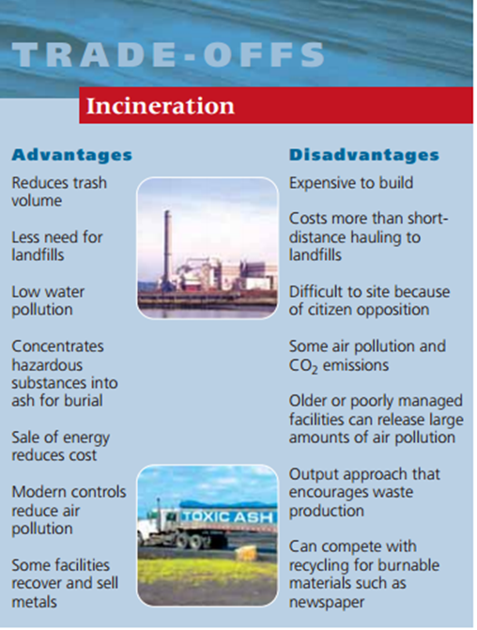
6. What are some advantages of burying waste? Disadvantages?
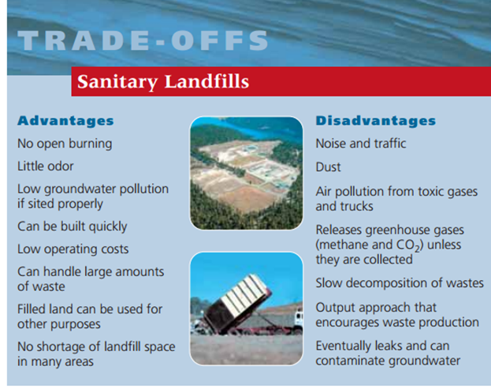

7. What is a sanitary landfill?
solid wastes are spread out in thin layers, compacted, and covered daily with a fresh layer of clay or plastic foam, which helps keep the materials dry and reduces leakage of contaminated water (leachate) from the landfill. This covering also reduces accessibility to vermin.
8. What is leachate?
a liquid that has passed through solid waste and has extracted dissolved or suspended materials from waste, such as pesticides in the soil.
Solid Waste
1. What is the difference between waste management and waste reduction?
-waste management (burying or burning waste).
-waste reduction (less waste and pollution are produced and the wastes that are produced are potential resources for reuse, recycling or composting).
2. What are the waste management integrated properties?
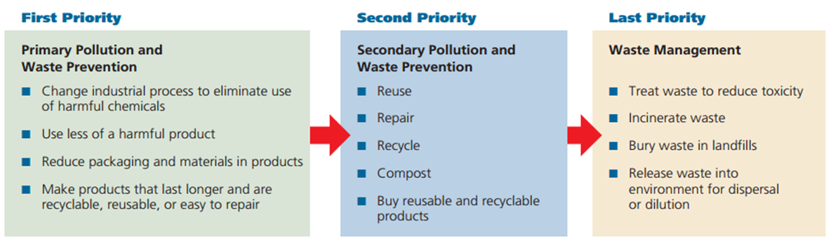
3. Explain the 3 R’s.
❖ Reduce: consume less and live a simpler lifestyle.
❖ Reuse: rely more on items that can be used repeatedly instead of throwaway items. Buy necessary items secondhand or borrow/rent them. Use refillable cups instead of throwaway cups.
❖ Recycle: recycle paper, glass, cans, plastics, metal, and other items and buy products made from recycled materials.
4. What are the 7 ways industries can reduce resource use?
1. Redesign manufacturing processes and products to use less material and energy.
2. Redesign manufacturing processes to produce less waste and pollution.
3. Develop products that are easy to repair, reuse, remanufacture, compost or recycle.
4. Eliminate or reduce unnecessary packaging.
5. Use fee-per-bag waste collection systems.
6. Establish cradle-to-grave responsibility laws
7. Restructure urban transportation systems.

5. What is primary (closed loop) recycling?
materials are recycled into new products of the same type
o Ex. Turning old aluminum cans into new aluminum cans
6. What is secondary recycling?
waste materials are converted into different products
o Ex. Used tires are shredded and turned into rubberized road surfacing
o Newspapers can be reprocessed into cellulose insulation
7. What are the 2 types of waste that can be recycled?
1. Pre-consumer or internal waste- generated in the manufacturing process; constitutes more than 75% of the total waste generated
2. Postconsumer or external waste- generated by consumer use of products
8. Explain Composting.
❖ Composting is a form of recycling that involves allowing decomposer bacteria and/or worms to recycle yard waste, food scraps, and other biodegradable organic wastes.
❖ The resulting organic material can be added to soil to supply plant nutrients, slow soil erosion, retain water, and improve crop yields.
9. What are green plastics?
made by blending the sugars in plants with a special chemical agent to make plastics.

Mining and Minerals
1. What is a mineral and what are minerals made up of?
➢ A mineral is a naturally occurring, usually inorganic solid that has a characteristic chemical composition, an orderly internal structure, and a characteristic set of physical properties.
➢ Minerals are made up of atoms of a single element, or of compounds. A compound consists of atoms of two or more elements chemically bonded together.
2. What are native elements?
These include the elements gold, silver, and copper.
3. What are the 2 mineral types?
❖ Ore minerals: contains one or more elements of economic value
❖ Gangue minerals: minerals with no commercial value
4. What is subsurface mining?
✓ Subsurface mining is a mining method in which soil and rocks are removed to reach underlying coal or minerals.
• It is used to mine ore deposits that are 50 m or more beneath Earth’s surface.
5. Explain room and pillar mining.
✓ Room-and-pillar mining is a common method of subsurface mining. This method is used to extract salt and coal.
• Networks of entries, called rooms, are cut into a seam, a horizontal layer of coal. Between the rooms, pillars of coal are left standing to support the room. When the mining of rooms is complete, the pillars are removed, beginning with the farthest point of the mine.
6. What is solution mining?
✓ Solution mining is an economical method to mine for deposits of soluble mineral ores, such as potash, salt, and sulfur.
• Solution mining dissolves the ore by injecting it with hot water.
• Compressed air is then pumped into the dissolved ore, and air bubbles lift it to the surface.
7. What is surface mining?
✓ Surface mining is a mining method in which soil and rocks are removed to reach underlying coal or minerals.
• Surface mining methods are used when ore deposits are located close to Earth’s surface.
✓ Large quantities of near-surface ores, like coal, gold, and copper are mined with open-pit mining.
• In open-pit mining, ores are mined downward, layer by layer.
• Explosives are used, if needed, to break up the ore, before it is hauled out by trucks.
8. What are quarries?
- used to mine near-surface materials such as building stone, crushed rock, sand, and gravel.
9. What are aggregates?
- sand, gravel, and crushed rock, are the principal commodities produced by quarrying.
10. What are the 6 major environmental impacts of mining? Explain each.
1. Air and noise pollution
2. Water Contamination
3. Displacement of Wildlife
4. Erosion and Sedimentation
5. Soil Degradation
6. Subsidence
11. How are mining and state regulations related?
Mining companies must obtain permits from state environmental agencies before mining a site.
❖ State agencies are also responsible for inspecting mines to ensure compliance with environmental regulations.
❖ Agencies issue violations to companies that do not comply with environmental regulations and assess fines for noncompliance.
12. What is mining reclamation?
The process of returning land to its original condition after mining is completed.
13. What did the Surface Mining Control and Reclamation Act of 1977 create?
created a program for the regulation of surface coal mining on public and private land.
• The SMCRA also established a fund that is used to reclaim land and water resources that have been adversely affected by past coal-mining activities.
Soil
1. What is fertile soil?
Soil that can support the growth of healthy plants
2. What is topsoil?
the surface layer of the soil, which is usually richer in organic matter than the subsoil is.
Fertile topsoil is composed of living organisms, rock particles, water, air, and organic matter, such as dead or decomposing organisms.
Several layers of soil lie under the topsoil. The bottom layer is bedrock, which is the solid rock from which most soil originally forms.
3. What factors influence soil formation and how?
(1) It can be created because of the shape of the landscape. That shape is called the topography. When you have mountains, the sides of the mountains are said to have a slope. When you have a slope and it rains, there will be drainage. The runoff carries away small rocks and minerals. This runoff winds up in valleys or in the ocean. It slowly builds up and the small pieces make soil.

(2) There are climatic effects that create soil. Moisture and rain combine with the temperature to do amazing things to rocks. We just explained that when it rains you have runoff and erosion. Those physical activities break down the rocks and hard surfaces. Temperature plays a role when you move below and above the freezing point. When water freezes, it expands. Rocks and soil that hold water can be cracked when the water freezes and expands. They pop open with a cracking sound!

(3) What's in the soil is dependent on geologic factors. The type of soil under your feet is dependent on the bedrock deep below the surface. As the bedrock breaks down, smaller pieces move to the surface and mix with the existing soil.

(4) In the same way that there are large geologic factors, chronological factors play an important part in the process. Chronological means time. You need time to make soil. That's it. Sediment can move around quickly but it takes a long time to break down bedrock. We can't just sit and watch this process happen. We have to study it over many years. Also, if we pollute our soil we can't renew it in our lifetime. It takes hundreds to thousands of years.

(5) Soil is also created by biological factors. You'll find that soil is half minerals/rocks and half air/water. All sorts of biological things are happening in the air/water space. The organic material is most important. There are tiny living organisms (like bacteria) that break down organic stuff. The "stuff" could be dead leaves or dead animals. The organic stuff is called humus. There are also roots and tunneling creatures that work like the microbes. They turn the soil around and move it, which allows air to flow through.

4. What is erosion?
a process in which the materials of the Earth’s surface are loosened, dissolved, or worn away and transported from one place to another by a natural agent, such as wind, water, ice, or gravity.
5. What is desertification?
The process by which human activities or climatic changes make arid or semiarid areas more desert-like.
• This process is causing some of our arable land to disappear.
• Overgrazing means fewer plants to hold the topsoil in place
6. What is soil contamination? Explain.
Either solid or liquid hazardous substances mixed with the naturally occurring soil. Usually, contaminants in the soil are physically or chemically attached to soil particles, or, if they are not attached, are trapped in the small spaces between soil particles.
How did it get there?
❖ Soil contamination results when hazardous substances (pesticides, fertilizers, biological wastes, oil spills, etc.) are either spilled or buried directly in the soil or migrate to the soil from a spill that has occurred elsewhere.
❖ Wind can carry in contaminated particles
❖ Water can flow in contaminated particles and/or chemicals
What are biological effects?
❖ Can hurt or kill plants, soil organisms and organisms that eat or handle these organisms
7. What are ways to reduce soil erosion and protect topsoil?
There are many ways of protecting and managing topsoil and reducing erosion.
• Prevent downhill erosion by contour plowing, which consists of plowing across the slope of a hill instead of up and down the slope.
• No-till farming allows for a crop to be harvested without turning the soil over and then the next crop is planted. The remains of the first crop help to hold the new crop in place and reduce erosion.
• Reduce impervious surfaces. Impervious surfaces like driveways and patios allow precipitation to flow freely over them. Water flow gains momentum when moving over such surfaces and can then erode stream banks and lakeshores. A good compromise is to use paving stones rather than a concrete slab for your patio to allow the water to percolate down into the soil.
• Plant windbreaks. Windbreaks prevent soil erosion by slowing the force of the wind over open ground. You can plant trees or shrubs in your windbreak.
• Re-establish forest cover. The re-establishment of forest cover provides an extensive, tree-root network that offers a long-term solution to soil erosion. It can function both as a windbreak and a means to anchor soils in place.
• Compost can be used to enrich the topsoil instead of using chemical fertilizers. Compost is a mixture of decomposing organic matter, such as manure and rotting plants that is used as fertilizer and soil conditioner.

7. What are ways to reduce soil erosion and protect topsoil?
Proper farming techniques (contour plowing) and reduce cutting down tree and clearing areas

Water
1. Be able to label and explain the water cycle and its processes.
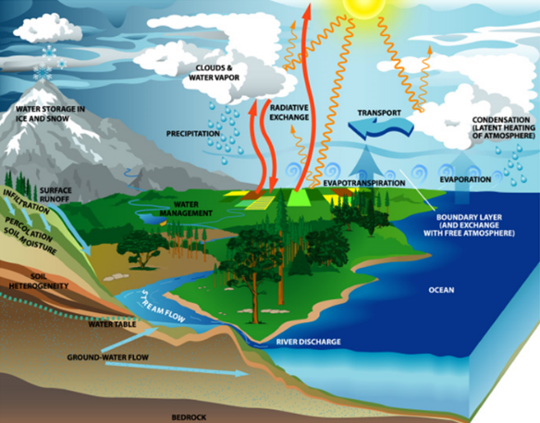
The water cycle is powered by the sun.
Major processes:
➢ Evaporation: changes liquid water into water vapor (gas form) in the atmosphere
➢ Precipitation: gravity draws the water back to the earth’s surface as precipitation (rain, snow, sleet, or dew)
➢ Transpiration: water that evaporated from the surfaces of plants
➢ Condensation: where water changes from the gas phase back to the liquid phase in the clouds
➢ Infiltration: the process by which water on the ground surface enters the soil
2. What is a watershed?
The land from which water drains into a particular river, lake, wetland or other body of water
3. What are aquifers? Why is it a bad idea to use aquifer water for agriculture?
-Underground caverns and porous layers of sand, gravel or bedrock through which groundwater flows. Groundwater normally moves from higher to lower elevation and pressure.
- It can contaminate the water.
4. The majority of water is used for agriculture.

5. What are advantages and disadvantages to building dams and reservoirs?
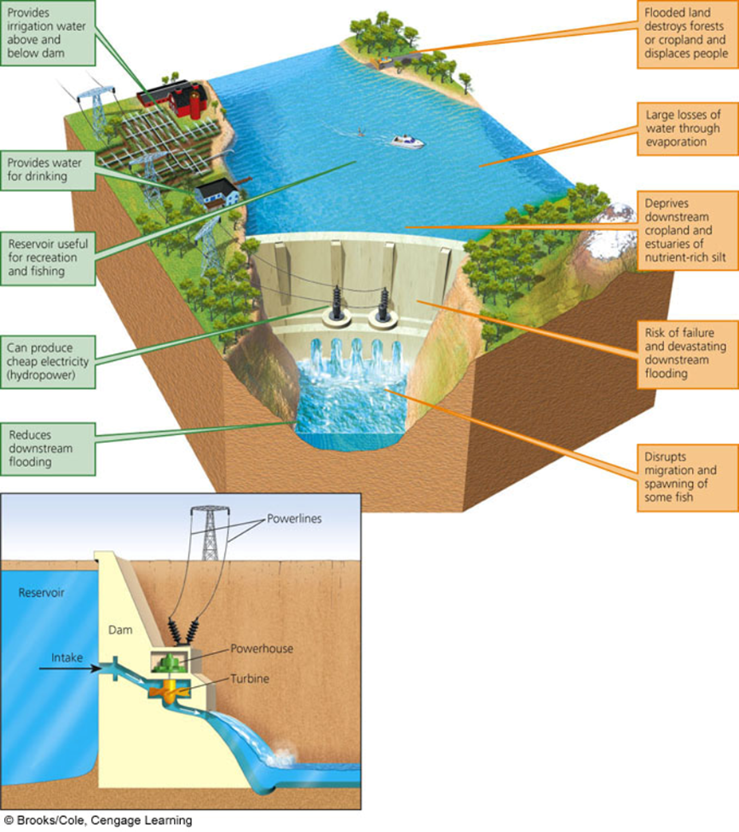
6. What are water transfer projects? Explain how they can be detrimental to nearby ecosystems.
- Transferring water from one place to another to increase water supplies in some areas, but it has also disrupted ecosystems.
- Pipelines can divide the ecosystems
- Aral Sea Disaster:
➢ Large amounts of water have been diverted from the Aral Sea and its feeder rivers to create one of the world’s largest irrigated areas, mostly for raising cotton and rice. The irrigation canal stretches more than 1,300 km (800 miles).
➢ Since 1961, the salinity level has increased sevenfold, the water level has dropped by 22 m (72 feet), and it has lost 89% of its volume and has split into 2 parts.
➢ Half of the bird and mammal species have disappeared
➢ 26 of the 32 native fish populations have gone extinct because of the increased salinity
➢ The former lake bottom is now a salt desert. Wind blows the salt up to 500 km (300 miles) away, where it pollutes water and kills wildlife, crops and other vegetation
➢ The United Nations and the World Bank have spent $600 million to purify the area’s drinking water and upgrade the irrigation and drainage systems.
7. How can we reduce water waste from irrigation practices?
✓ Center-pivot, low-pressure sprinklers- uses pumps to spray water on crops; results in a series of circular irrigated areas; 80% of water will reach crops.

✓ Low-energy precision application (LEPA) sprinklers- center-pivot irrigation where 90-95% of water reaches crops

✓ Drip or trickle irrigation- delivers small amounts of water precisely to crops through underground plastic tubing; costly but 90-95% efficiency
8. What are the types and causes of water pollution?
• Point sources
• Located at specific places
• Easy to identify, monitor, and regulate
• Examples:
• Ditches, sewer lines, drain pipes, oil tankers, underground mines
• Nonpoint sources
• Broad, diffuse areas from which pollutants enter bodies of surface water or air
• Difficult to identify and control
• Expensive to clean up
• Examples
• Runoff (chemical or biological) from feedlots, cropland, lawns, golf courses, logged forests, urban streets & parking lots (THINK BIG AREA)
9. Unsafe drinking water is one of the largest causes of illness. Describe why untreated water is so dangerous to consume.
➢ Over 500 disease-causing agents can be spread through water vectors
➢ According to The World Health Organization (WHO):
• 3.2 Million people die every year from water diseases or clean water shortages (most under 5)
• In the developing world, diarrheal diseases kill a child under 5 every 18 SECONDS
• 1.2 Billion people (1 out of 6) worldwide have no access to clean drinking water
10. Contrast oligotrophic and eutrophic lakes.
▪ Oligotrophic lake
• Low nutrients, clear water
• Supports little plant life and fish species such as trout and small mouth bass
• High DO levels
▪ Eutrophic lake
• Nutrient-rich lake
• Supports a great deal of plant life, which often chokes out other organisms
• Low DO content
• Large algae populations, and fish species such as carp and bullhead
11. What leads to eutrophication of a lake?
▪ Cultural eutrophication
• Accelerated nutrient enrichment due to human activities involving mostly nitrate and phosphate containing effluents
▪ Sources: feedlots, farmland, suburban yards, mining sites, untreated sewage
12. How is wastewater treated?
STEP 1: Primary sewage treatment
▪ Physical process
• Goal: Removal of solids
• Screens, grit chamber, settling tanks
• Result: 60% reduction in suspended solids & 30 to 40% reduction in oxygen-demanding waste
• DOES NOT REMOVE:
• Pathogens, phosphates, nitrates, salts, radioisotopes, pesticides

STEP 2: Secondary sewage treatment
▪ Biological process
• Goal: remove oxygen demanding waste
• Result: 90% of dissolved and biodegradable wastes are removed, 70% of toxic metals, phosphorous and 50% of nitrogen
• DOES NOT REMOVE:
• Most isotopes
• Persistent organic substances (pesticides)
• Pathogens

STEP 3: Tertiary or advance sewage treatment
• Chemical Disinfection
• Goal: remove specific pollutants
• VERY HIGH COST, not widely used

STEP 4: Before Discharge
• Bleaching or chlorination to remove color and disease-causing bacteria
• Result: very successful, but carries some risk from the chemicals (cancer, miscarriage, endocrine disruptors)
• DOES NOT REMOVE: all viruses
Air
1. Label the layers of the atmosphere.

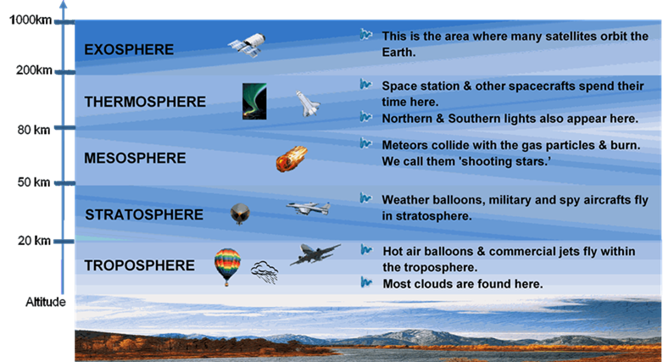
2. What led to the depletion of the stratospheric ozone layer?
Widespread use of certain chemicals has reduced ozone levels in the stratosphere, which allows for more harmful ultraviolet radiation to reach the earth’s surface.
3. What is the greenhouse effect?
Natural heating of the earth
4. What are greenhouse gases?
✓ Water Vapor- H2O
✓ Carbon Dioxide- CO2
✓ Ozone- O3
✓ Methane- CH4
✓ Nitrous Oxide- N2O
✓ Chlorofluorocarbons- CFCs
5. How does deforestation impact the atmospheric carbon?
Cutting down of plants reduces the amount of CO2 absorbed
6. Cars are the major source of CO emissions and coal power plants are the major source of CO2 emissions.
7. What causes acid rain?
Acid rain is caused by a chemical reaction that begins when compounds like sulfur dioxide and nitrogen oxides are released into the air (from coal-burning power plants, industrial plants, and vehicle emissions).
8. What is the Clean Air Act and what are some of its accomplishments since it began?
Federal Law implemented to protect public health and welfare from different types of air pollution caused by a diverse array of pollution sources known to be hazardous to human health.
Since 1970,
The six commonly found air pollutants have decreased by more than 50%
Air toxins from large industrial sources, such as chemical plants, petroleum refineries, and paper mills have been reduced by nearly 70%
New cars are more than 90% cleaner and will be even cleaner in the future
Production of most ozone-depleting chemicals has ceased.
9. What is the EPA and what are some of its goals for reducing air pollution?
▪ EPA (Environmental Protection Agency)
• National ambient air quality standards (NAAQs) for 6 criteria outdoor pollutants
• CO, NOX, SO2, SPM, O3, Pb
• National emission standards for 188 hazardous air pollutants (HAPs)
• Mostly chlorinated hydrocarbons, VOCs & toxic metals
• Toxic Release Inventory (TRI)
• Industries must tell how much they released and how they deal with waste management
10. What is the Kyoto Protocol? Do you think it is helpful?
The Kyoto Protocol (1997 International Treaty)
▪ Goal- to reduce emissions of CO2, CH4, and N2O by 2012 to levels of 1990
▪ Trading greenhouse gas emissions among countries
▪ Not signed by the U.S.
• President G.W. Bush’s reasons
• It would hurt the economy
• Did not require reductions in China, India, Brazil or Indonesia
• However, a majority of Americans feel we should have signed
▪ In 2005, countries began negotiating the second phase that is supposed to go into effect after 2012.
▪ Australia signed up for the second phase of the Kyoto Protocol that would require reducing greenhouse gas emissions to 5% below year 2000 levels by 2020.
11. What causes global warming? What can we do to reduce it?
▪ CO2, CH4, and N2O emissions are higher
▪ Main sources: agriculture, deforestation, and burning of fossil fuels
▪ There is a correlation of rising CO2 and CH4 levels with rising global temperatures
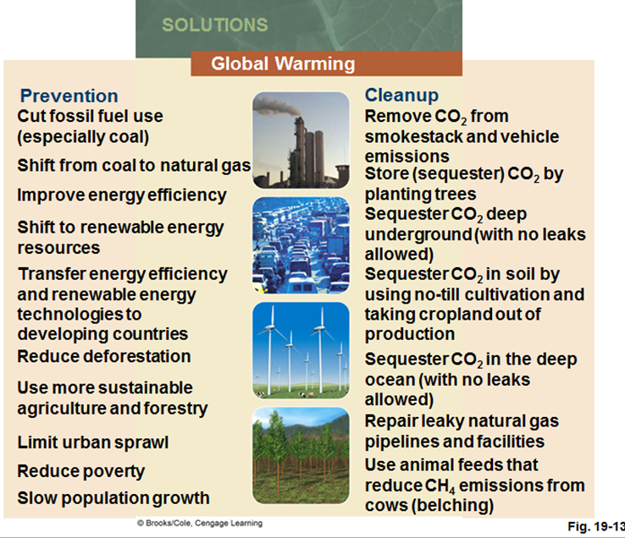
12. What causes ozone depletion? Why is depleting ozone bad?
▪ Chlorofluorocarbons: CFCs (Freon’s)
• Chemically unreactive, odorless, nonflammable, nontoxic, noncorrosive compounds that were used in refrigerants (AC/fridge) and as propellants in aerosol cans
▪ Halons & Hydrobromoflurocarbons (HBFCs) – fire extinguishers
▪ Methyl Bromide (fumigant)
▪ Hydrogen Chloride (space shuttle)
▪ Cleaning solvents: carbon tetrachloride, etc…
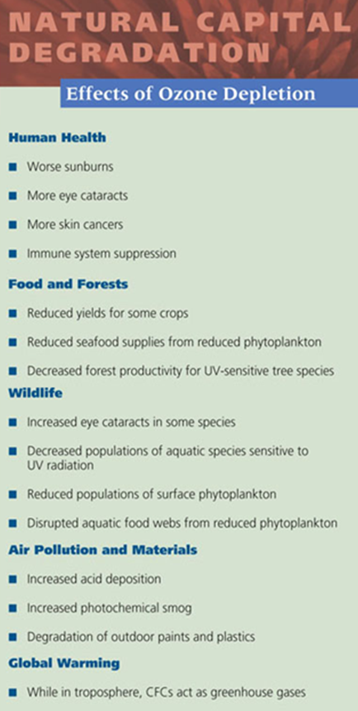

13. List some solutions for indoor and outdoor air pollution.
