ES Test #3 (Succession, Populations, and Human Impact) Review Guide

Succession -

1. Define ecological succession: A series of predictable events which occurs after a disturbance in the environment.

2. Name the two types of succession: 1. ___Primary____ 2. ___Secondary___

3. In the following table distinguish between these two types of succession

|  |  |  |
| --- | --- | --- |
| Type of Relationship | Description of Relationship | Example |
| Mutualism | Both Organisms Benefit | Honeybee and Flower  Anemone and Clownfish |
| Parasitism | One Benefits and the Other is Harmed | Flea and the Dog  Tapeworm and the Human |
| Commensalism | One Benefits and the Other is not Harmed or Helped | Barnacle and the Whale |

4. What is a pioneer species? The first species in an area during primary succession. Example is Lichen which has the ability to break down rocks into soil and begin the process of plant development.

5. What is a climax community? The final stage in succession. It is stable, meaning it does not change very much. It is also very diverse, meaning that there are many different species of plants and animals in the area.

Population -

A group of the same species living in the same place at the same time.

What is population density? Equation?

Number of individuals per unit of area. PD= (# of individuals)/(unit of area)

Factors that affect population size:

Birth Rate- Number of individuals being born

Death Rate – Number of individuals dying

Immigration - Number of individuals moving into a population

Emigration – Number of individuals moving out of a population

Niche- an organisms job or role in the ecosystem

Habitat- where the organism lives

Growth under ideal conditions is considered exponential growth and when graphed looks like the letter J.

Most populations eventually experience Logistic growth (which can be shown in the shape of the letter S), which means the environment reaches its Carrying Capacity, which is the maximum number of individuals an environment can maintain.

A population reaches its Carrying Capacity because it runs out of resources.

These resources can also be called limiting factors. These factors can be density -dependent , which means that they are only an issue at certain population sizes.

Two examples of these factors are Competition and disease.

The other types of factors are density - independent, which means that they are an issue no matter what the population size.

Two examples of these factors are Natural Disasters and Human Activity.

Show the carrying capacity.

What would a graph look like if the population was affected by a density independent limiting factor?

***Analyzing Graphs***

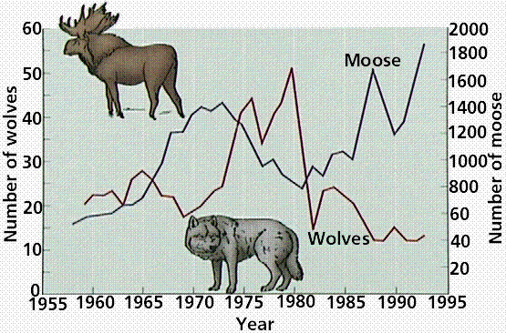

1. As the moose population begins to rise what happens to the wolf population? A few years later the wolf population would begin to rise
2. During what year did this begin to influence the moose population numbers? 1974
3. Why did the wolf population drop so drastically around 1980? Various limiting factors
4. What was the largest size the moose population reached between 1955 and 1995? 1900 Wolves
5. What was the smallest the wolf population ever dropped to during this time? 15 wolves

Human Impact-

What is the difference between renewable and nonrenewable resources? Give examples of each.

Renewable- resources that can be replenished (Ex- trees)

Nonrenewable- resources that cannot be replenished (Ex- fossil fuels)

What is biodiversity and give 4 ways human beings reduce it.

The number of different species of organisms in an area.

- Habitat Loss

- Habitat fragmentation

- Habitat degradation

- Human Activity

How is the greenhouse effect different from global warming?

Greenhouse- (Good) natural heating of the earth

Global Warming- (Bad) increase in earth’s average temperature (unnatural)

What are the greenhouse gases?

Water vapor, methane, carbon dioxide

What is biological magnification? Who is most affected?

Toxins become more concentrated as it moves up the trophic levels. The uppermost trophic levels

What is DDT? What was it used for?

Insecticide (Dichloro-diphenyl-trichloroethane) andc ollects in fatty (adipose) tissues of animals.

Used to kill insects (mosquitos)

What is ozone depletion and what is causing it?

Holes being created in the Ozone that are allowing more UV rays to enter and reach the ground. Main cause if man made chemicals such as chlorofluorocarbon (CFCs).

Soil Erosion- the wearing away of surface soil by water and wind

Desertification- the process of turning once productive areas into deserts from a combination of farming, overgrazing, and drought.

Deforestation- the clearing Earth's forests on a massive scale, often resulting in damage to the quality of the land.

Clear Cutting- cutting an entire area usually for urban sprawl

Indicator Species- or a bioindicator, is a species that provides a sign, or an indication, of the quality of the ecosystem’s environmental conditions.

Eutrophication- excessive richness of nutrients in a lake or other body of water, frequently due to runoff from the land, which causes a dense growth of plant life and death of animal life from lack of oxygen

What causes smog?

A mixture of chemicals that occurs as a gray-brown haze in the atmosphere

This is due primarily to automobile exhausts and industrial emissions.

What is the primary cause of acid rain? What pH level does it need to be considered acid rain? What is normal pH?

Sulfur dioxide (SO2) and Nitrogen Oxide (NOX)

Normal pH- 5.6 Acid rain pH- less than 5.3 (around 4.6)