ES Test #3 (Succession, Populations, and Human Impact) Review Guide

Succession -

1. Define ecological succession:

2. Name the two types of succession: 1. ______________ 2. _________________

3. In the following table distinguish between these two types of succession

|  |  |  |
| --- | --- | --- |
| Type of Succession | Primary | Secondary |
| Begins with…. |  |  |
| Examples |  |  |

4. What is a pioneer species?

5. What is a climax community?

Population -

A group of the same ______________, living in the same ___________________ at the same ________________.

What is population density? Equation?

Factors that affect population size:

_________________ - Number of individuals being born

Death Rate – _________________________________

_________________ - Number of individuals moving into a population

Emigration - __________________________________

Niche- _________________________________________________________________

Habitat- ________________________________________________________________

Growth under ideal conditions is considered ________________________ growth and when graphed looks like the letter _______.

Most populations eventually experience _____________________ growth (which can be shown in the shape of the letter ______), which means the environment reaches its _______________________ ______________________, which is the maximum number of individuals an environment can maintain.

A population reaches its _______________________ ______________________ because it runs out of ____________________.

These _________________________ can also be called ___________________ factors. These factors can be density - _____________________ , which means that they are only an issue at certain population sizes.

Two examples of these factors are ________________________ and _____________________.

The other types of factors are density - __________________________, which means that they are an issue no matter what the population size.

Two examples of these factors are ________________________ and _____________________.

Show the carrying capacity.

What would a graph look like if the population was affected by a density independent limiting factor?

***Analyzing Graphs***

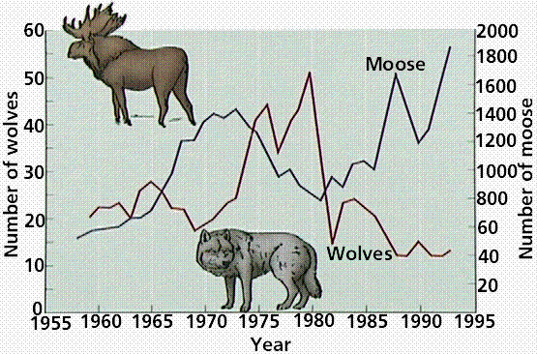

1. As the moose population begins to rise what happens to the wolf population?
2. During what year did this begin to influence the moose population numbers?
3. Why did the wolf population drop so drastically around 1980?
4. What was the largest size the moose population reached between 1955 and 1995?
5. What was the smallest the wolf population ever dropped to during this time?

What is biodiversity?

Human Impact-

What is the difference between renewable and nonrenewable resources? Give examples of each.

What is biodiversity and give 4 ways human beings reduce it.

How is the greenhouse effect different from global warming?

What are the greenhouse gases?

What is biological magnification? Who is most affected?

What is DDT? What was it used for?

What is ozone depletion and what is causing it?

Soil Erosion-

Desertification-

Deforestation-

Clear Cutting-

Indicator Species-

Eutrophication-

What causes smog?

What is the primary cause of acid rain? What pH level does it need to be considered acid rain? What is normal pH?